What is angular?

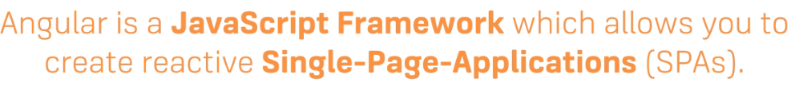

Angular Versioning

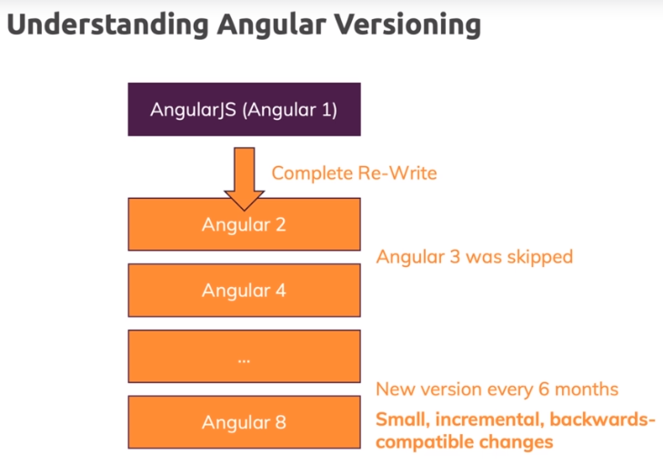

Project Set up

CLI - <https://cli.angular.io/>

Node.js – used by angular cli to bundle and optimize our project behind the scenes

NPM – use to manage different dependency that angular project has

Install NODE.js on your machine and then open the node command prompt

Install angular cli



Create a project folder. open command prompt in that folder and create a new project by following command



Once you create a new project you will get a barebone angular application which you can run by following command.



Note – Please use administrator privileges for cmd.

Once ng serve start running, use the url to run the application in the browser.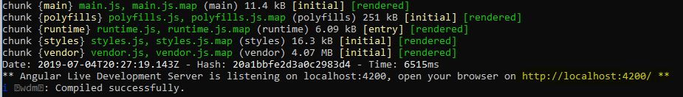

We are using following,

IDE – visual studio code and bootstrap 3 for CSS



Important angular files

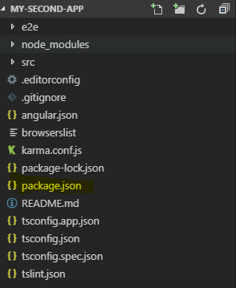

Package.json – it holds all the dependencies i.e. name and its version

E2e is related to end to end testing

Node modules – holds all the files of the dependencies required by angular application

Angular is made up of many components but App.component.ts is where you write your main logic. It has a selector which you can refer from index.html (which basically renders the whole application). =

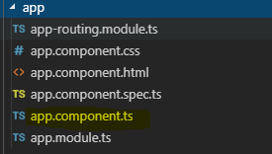

Selector name must be unique which is then use to refer the component from index.html or corresponding html files.

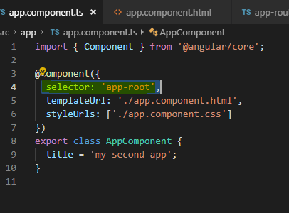

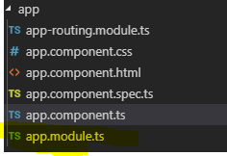

App.module.ts basically help us to manage the imports required by that component( if you have only component ), otherwise it will hold all the references of all components, services and providers that makes the angular application.

**How angular apps get loaded and started**

Index.html is get served first as angular is a single page application. In it we can injecting our component.

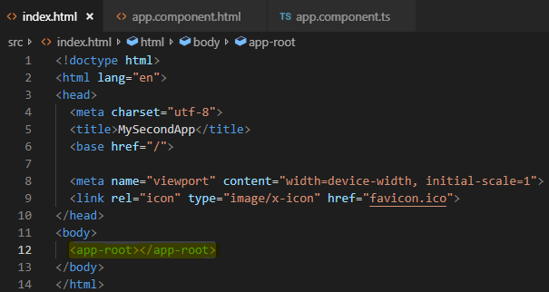

App.component.ts is where we are defining our component as following with selector. It not only creates a reference that we can use anywhere, where we want out component to be displayed.

templateUrl - tells us about the html and styleUrls – about CSS files associated with that component.

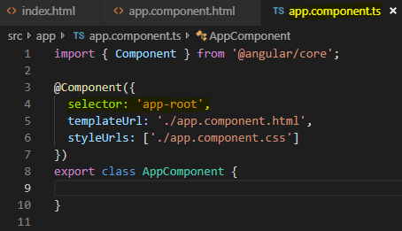

If you want to add any external libraries, stylesheets or assets that you want to implement globally then you must put them in angular.json. e.g. If you want to use bootstrap stylesheet then you must add boostrap.min in the angular.json’s style array.

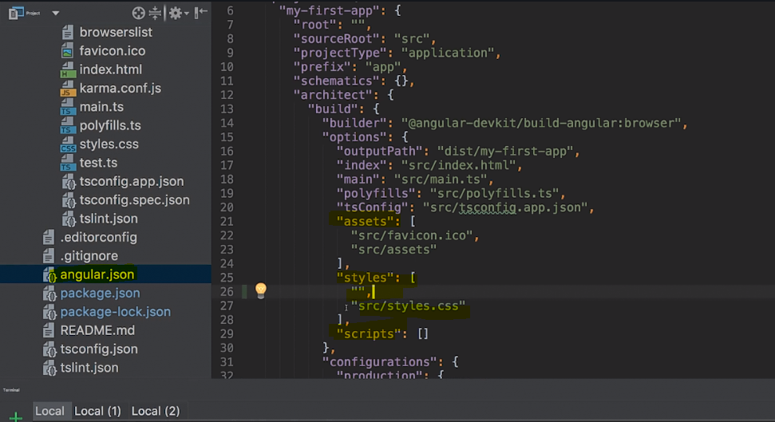

Index.html is the main file which gets fired when angular application first gets loaded. In the body you can see the <app-root> which is the component tag and loads the specific component at run time.

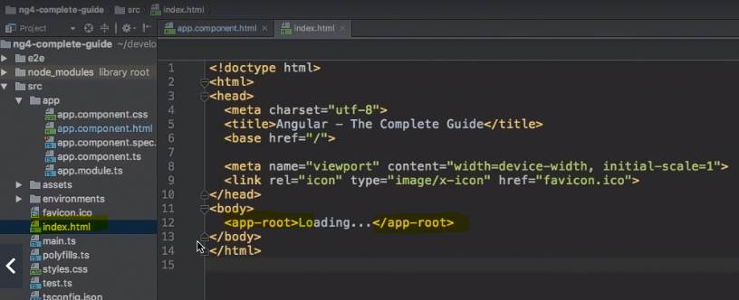

In overall startup of the angular application works as following.

Main.ts gets launched first which then bootstrap the app.module.ts. If you see app.module.ts points to the main or base component i.e. our app component. And that is how everything starts.

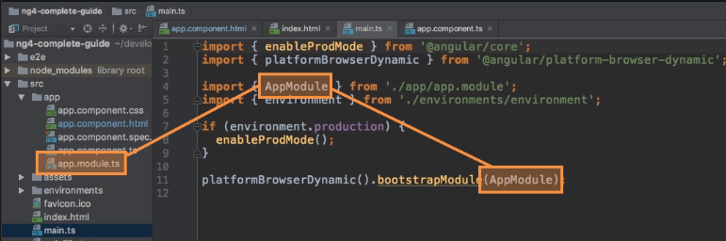

If you look inside the app.modal.ts you can see that it has bootstrap reference in it that’s how everything i.e app.module.ts and main.ts gets connected.

App module.ts where we store component definition and its required dependencies. It basically bundles all your components within your app into packages. All your new components get added into declarations and also needs to be imported. Imports just allow us to import other modules.

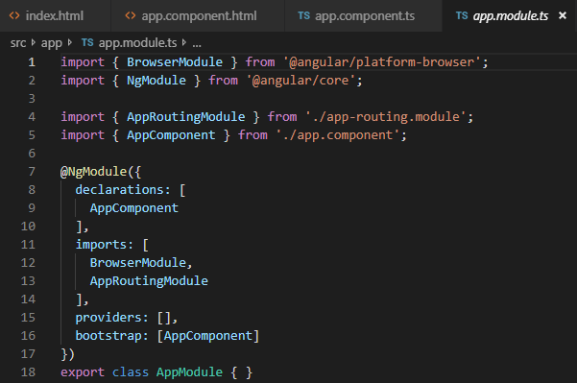

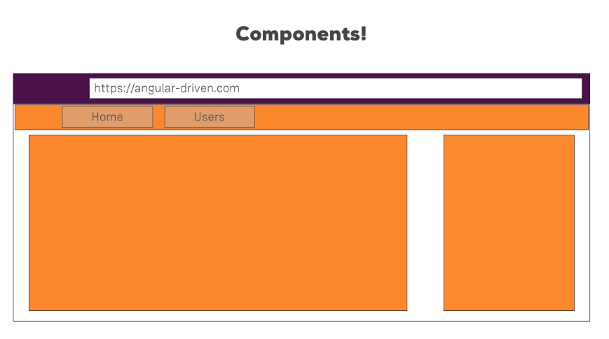

All components are reusable.

All the HTML content of the component can be placed in the template. It’s a bad practice though.

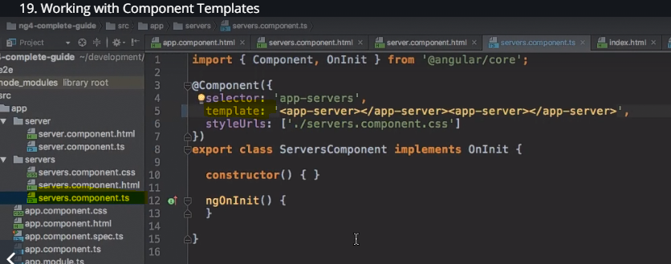

App component is the root component of all components

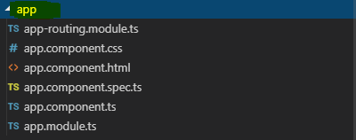

How to create a component using CLI

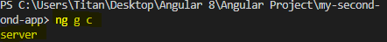

**Data Binding**

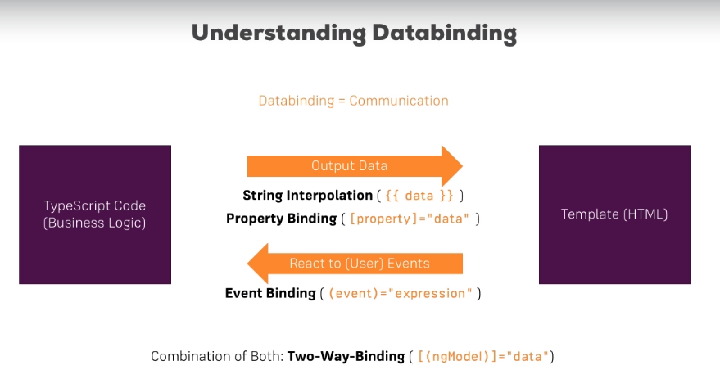

**Property binding vs string interpolation**

String interpolation – when you want to display an information

Property binding – when you want show information after processing the information through some logic

**Event binding**

Adding a click event which is referring to the method which is defined in the corresponding ts(typescript ) class

**String interpolation**

Creating a variable

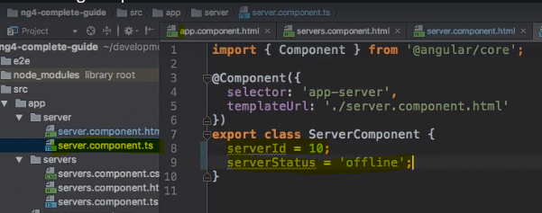

rendering them using string interpolation 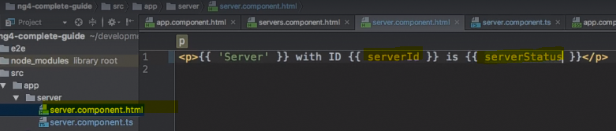

Writing a method to return variable

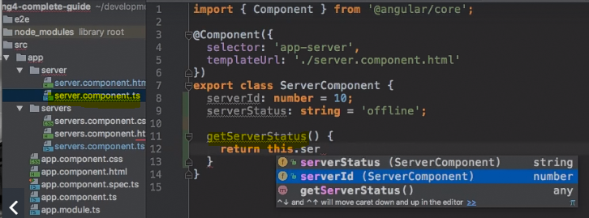

You can call the method using string interpolation

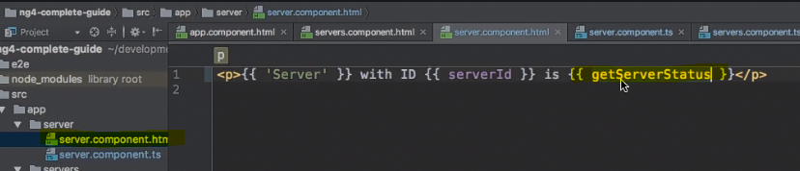

**Property Binding**

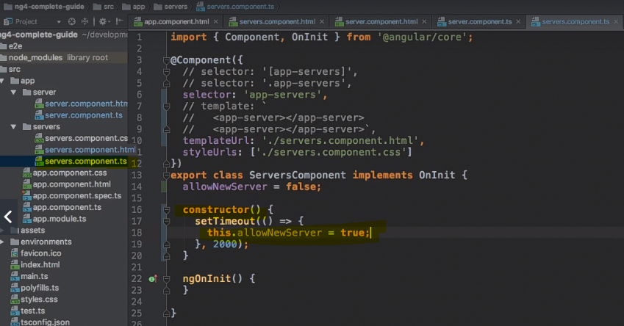

Doing property binding – adding Boolean value to the property.

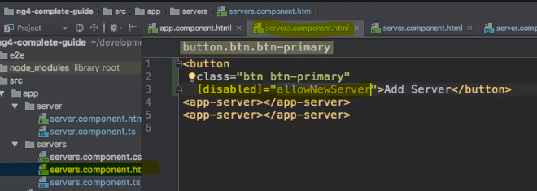

**Property Binding** [ use when you want to change content based on the value of the variable ] **vs String interpolation** [ use when you want to display some static content or data]

**Inner text –** gives you the value of the variable it referring to

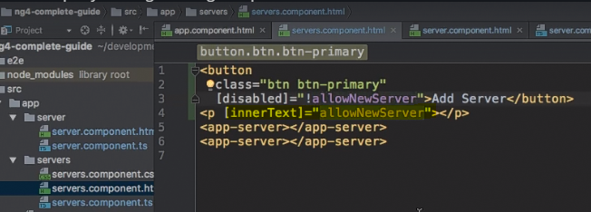

**Event Binding**

Creating a method

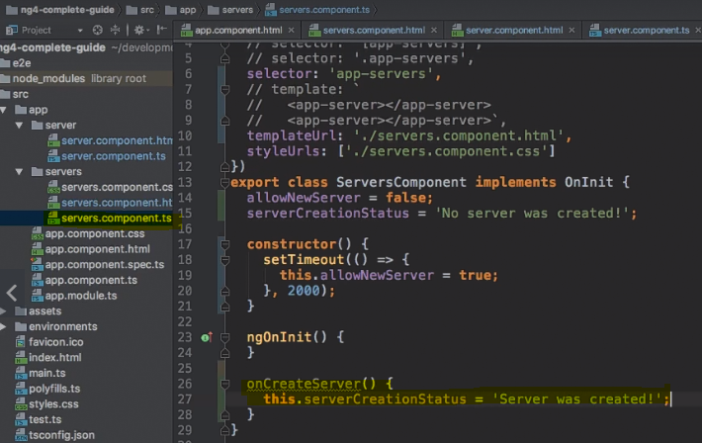

Calling the method using event binding

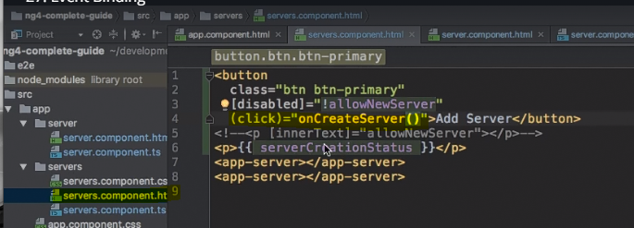

**Important**: For events, you do not bind to onclick but only to click (=> (click)).

Passing the data using event binding

Creating an event – here it will allow you to pass the data that you received from user input.

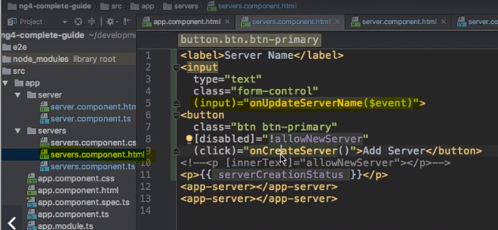

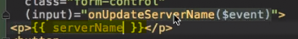

Accessing the input in the component.ts. here event.target can be found in the developer console and you can specify the type of it.

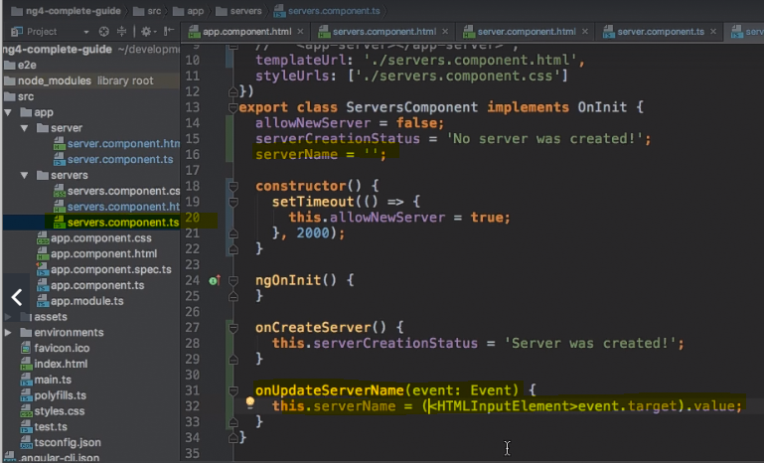

**Important:** For Two-Way-Binding to work, you need to enable the ngModel directive. This is achieved by adding the FormsModule to the imports[] array in the AppModule.

You then also need to add the import from @angular/forms in the app.module.ts file:

import {FormsModule } from '@angular/forms';

Two-way data binding – is very useful to display and change the value of the component property

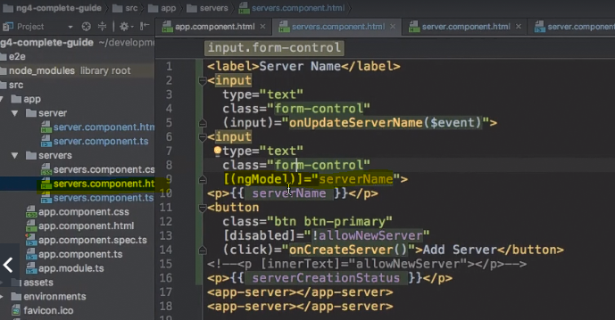

**Directives Deep dive**

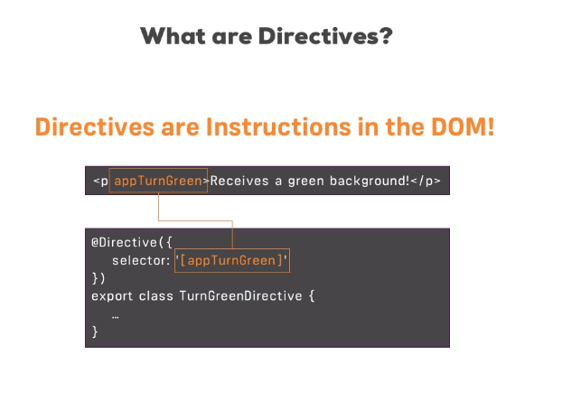

**Built in directive**

1 - ngIf = “expression or condition” - ngIf is a structural directive i.e. it can change the view of the page hence you need to put * behind the ngif to tell angular that it’s a structural directive otherwise it won’t work perfectly. Directives will add or remove an element from the dom upon execution.

**Note -** Star in front of the directive indicates that it’s a structural directive.

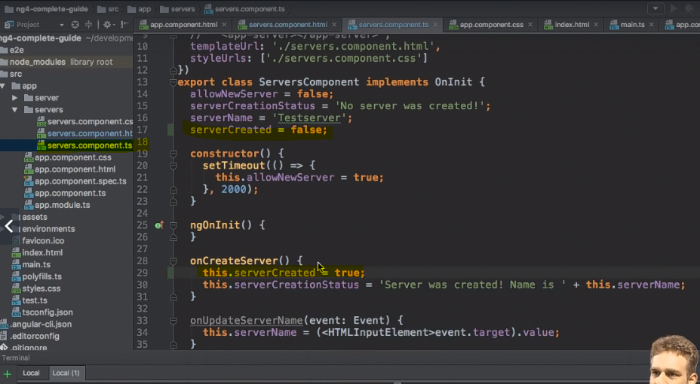

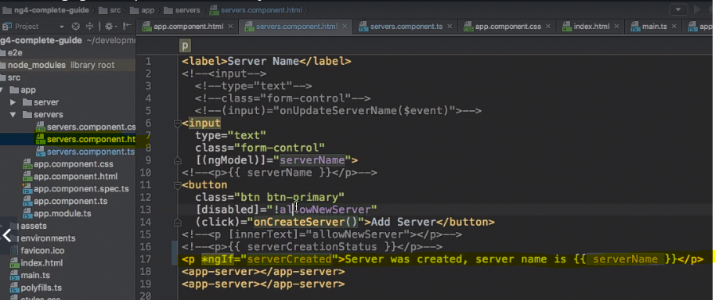

ngIf with else

**In component.html**



ngStyle directive is use to change the style of the dom elements. You don’t need to put the * behind it as it’s not a structural directive.

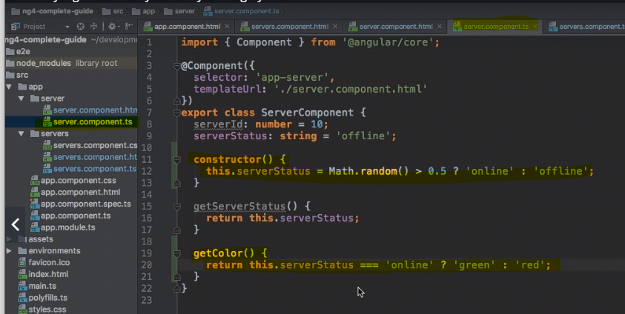



ngClass is an attribute directive, adding styles array in the component.ts and implements the property binding. It only added styles on if and only if certain condition is mate.

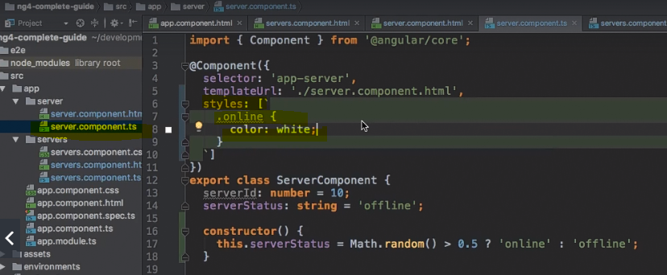

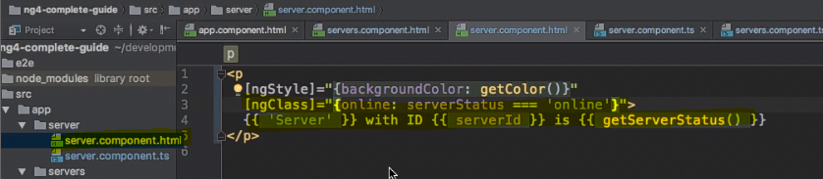

ngFor – works like a for loop.

Corresponding code in .ts file

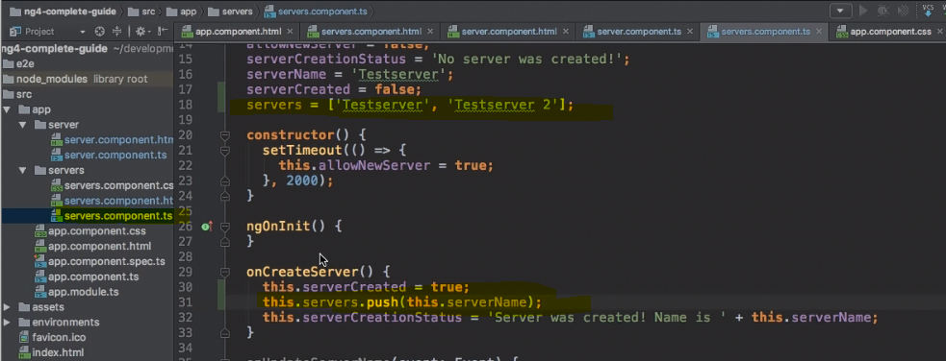

Inside the component.html



**Angular project – The basics**

Plan for the application – how many components will be there in the application?

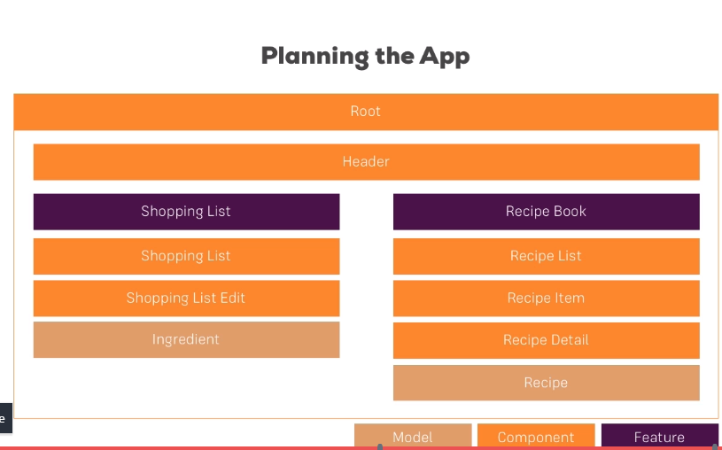

**Setting up the bootstrap version -** npm install --save bootstrap – this will install latest version of the bootstrap into your project

Once you done with installation you need to add bootstrap min.css in your angular.json in styles [] array.

Additionally, when using a project created with Angular CLI 6+ (check via ng -v ), you'll have an angular.json file instead of an .angular-cli.json file. In that file, you still need to add Bootstrap to the styles[] array as shown in the next video, but the path should be node_modules/bootstrap/dist/css/bootstrap.min.css , NOT ../node_modules/bootstrap/dist/css/bootstrap.min.css . The leading ../ must not be included.

you must install the boostrap in the project folder on which you will be working

please use the following screenshot for reference

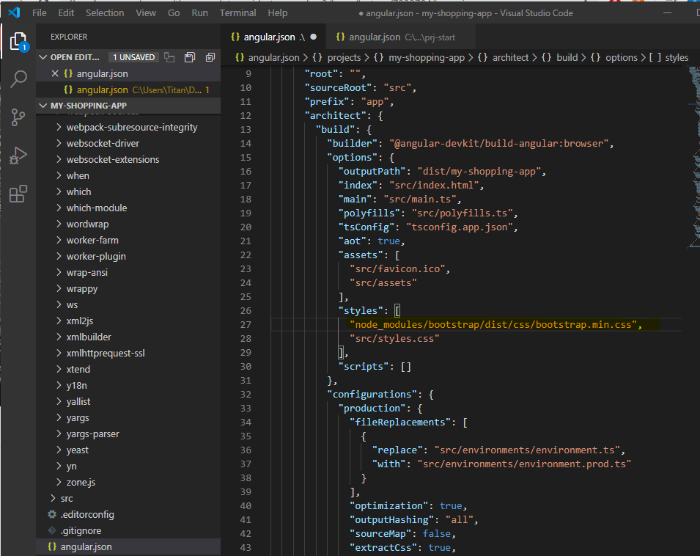

**Basic project setup**

Adding header component

Added recipe component and its subcomponent i.e recipe detail and recipe list.

Added recipe-item component recipe list

Added shopping list component and its subcomponents such as shopping edit

Adding placeholder links for the menu

Adding recipe model to set the standard/blueprint for the recipe objects

Added ingredient model which acts as blueprint for all the ingredients

**Angular Debugging**

In case of debugging you need to use google chrome developer tools where you can find exact angular files over here

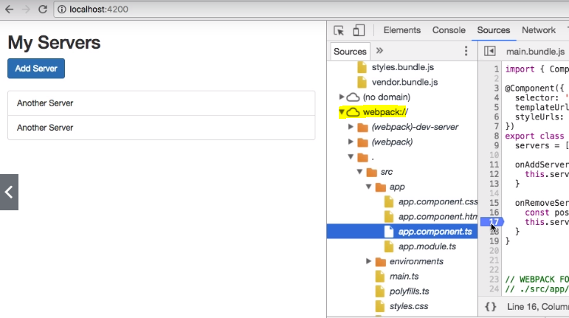

Augury is the best extension you can use to debug angular application

**Troubleshooting**

**Facing an issue with** @angular-devkit/build-angular ?

Run the command - npm install --save-dev @angular-devkit/build-angular

Followed by ng update

If you face an issue with typescript

- npm uninstall -g typescript

- npm uninstall typescript

- npm install -g typescript

- npm install typescript@2.7.2

Make sure to use the right version of the typescript

**Property and Event binding**

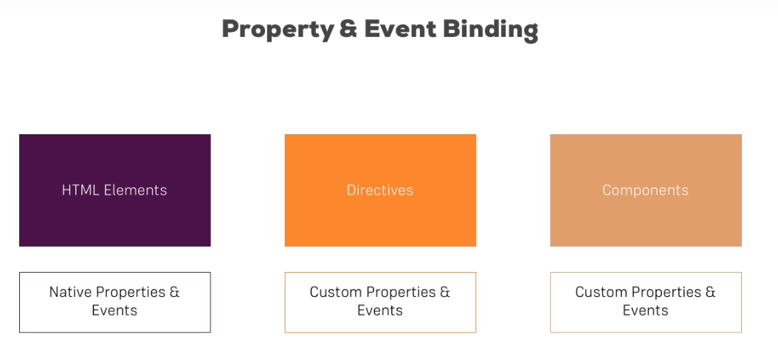

By default, all the properties of the components are accessible only within that component, so you need to be explicit about which properties you want to expose to the outside. you can do that by using decorator

E.g. Defining a js object and its properties inside the server-element component

custom property binding

Server-element component has following properties

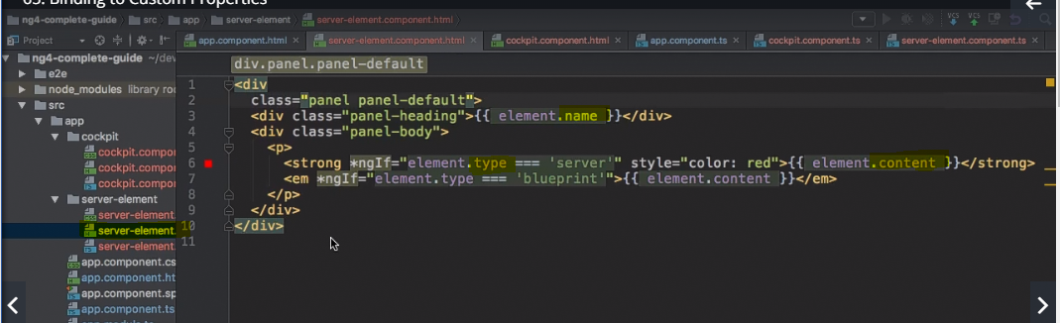

You must have to have an element.js object in your component.ts file

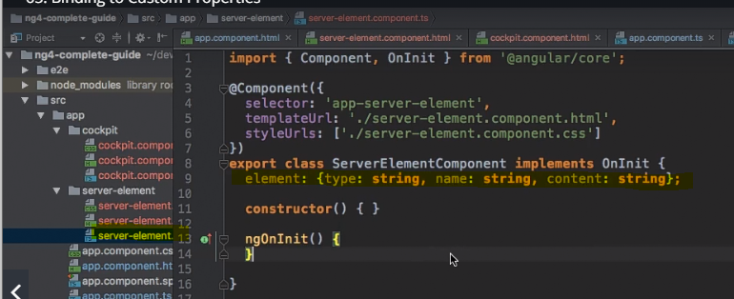

So far, all the properties of the js object are accessible only within that component. What if you want to access them from outside? Ans - Create an element array in the main app.component.ts. Now, you can access that array or matter of fact any properties from any component.

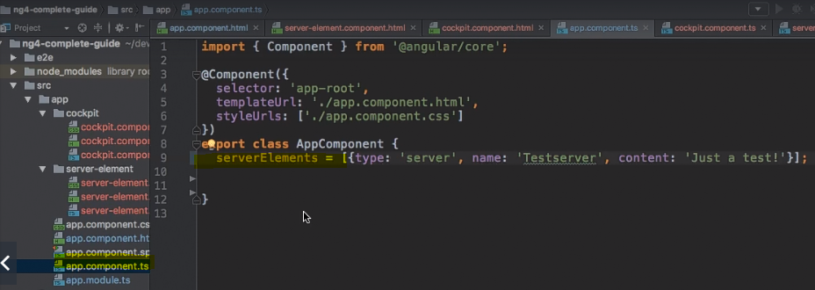

If you access the array elements like as following, then it will throw an error as Why because element it not accessible from main app so you need to add a decorator to the property of that component which expose it to the outer elements

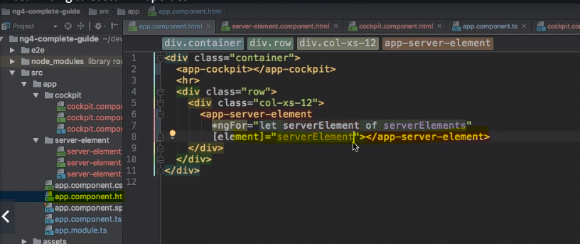

@input is a decorator which exposes the js object to the global level

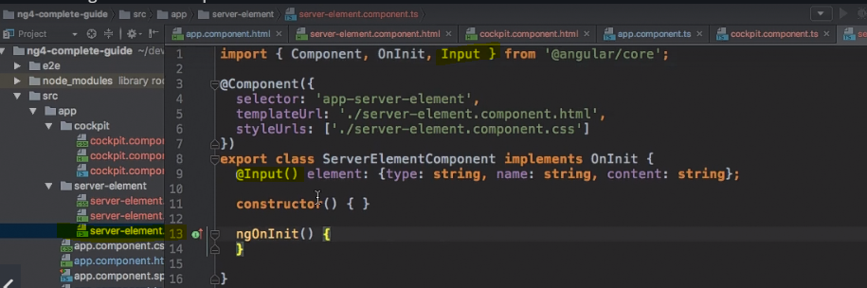

Now setting the values of the js object in the root component – name can be different

You can use the alias name to properties like ‘srvElement’

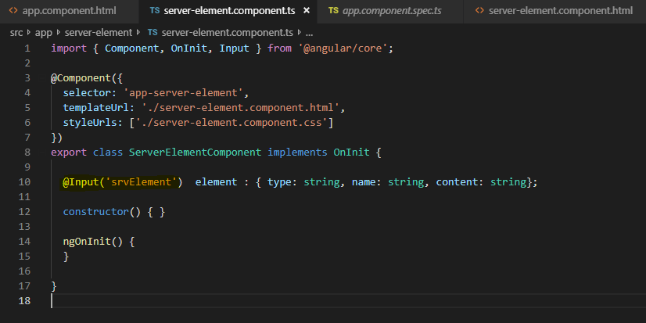

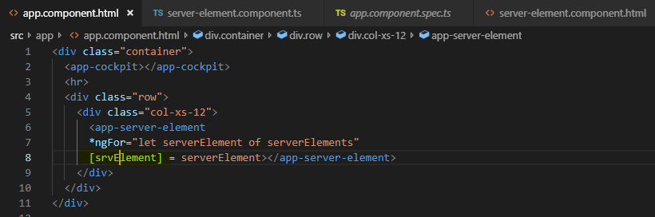

**Binding component to custom events so that they can listen to each other**

How to pass the data from the child component to parent component

E.g. First create a method in the app.component.ts file

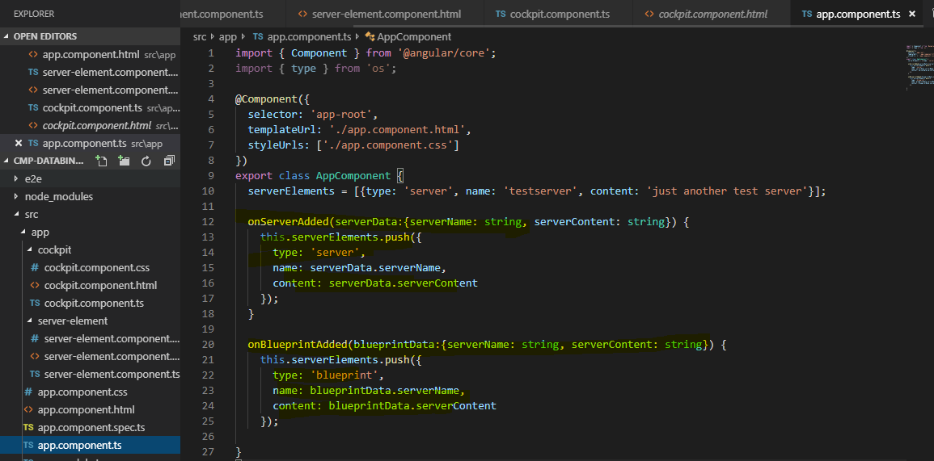

In app – html file you can capture that event

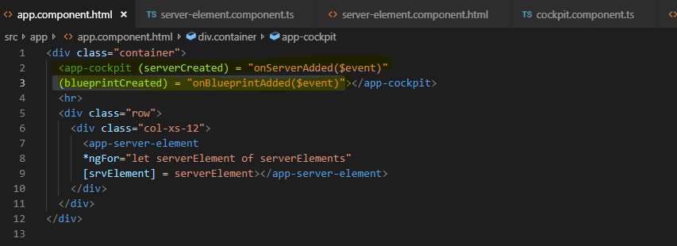

This event is coming from the cockpit component.html. I am creating an event emitter from there to emit an event.

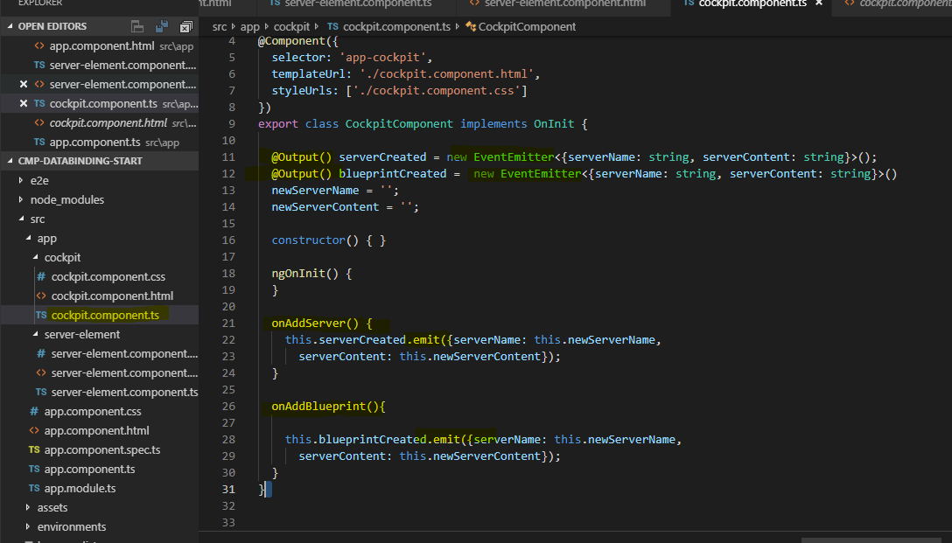

Update the comoponent.html

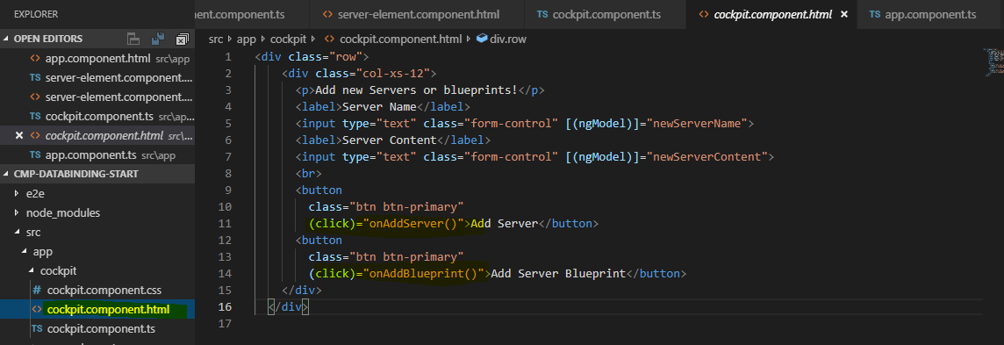

This is how component communicate with each other parent to child using input and output decorator.

Adding alias to output component



**What is view encapsulation in Angular?**

If you applied a css property to the root component it does not mean that it will be applied to all its child components automatically. This is a behavior of angular which Is also called as shadowDOM.

How to deal with this -> need to apply that root css properties to respective components css file.

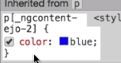

It will add an additional attribute to that component specific css at runtime. It’s also called as style encapsulation.

**How to override by default Style encapsulation** ?

Just define the encapsulation in that specific components type script file.

There are three types of view-encapsulations i.e. emulated (default ), none ( Don't provide any template or style encapsulation. ), native (Use Shadow DOM to encapsulate styles)

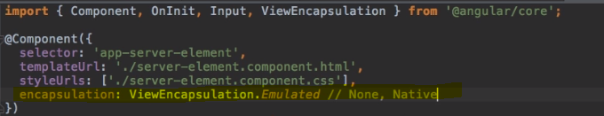

If you use none – then you will not see strange attribute like this



And whatever styles you will define in that component will be applied globally. Always use emulated which use shadowdom. Native is browser specific so try to avoid it as much as possible.

**Local references within templates**

Instead of using two way binding you can use local references in the template i.e. it starts with ‘#’.

Note – local references are applied to html file only and not it typescript file.

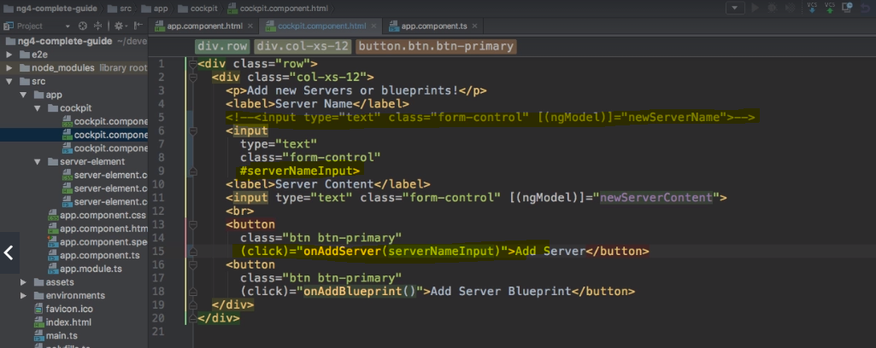Now you can pass the entire template element to the typescript method as shown below and can access the properties of that element.

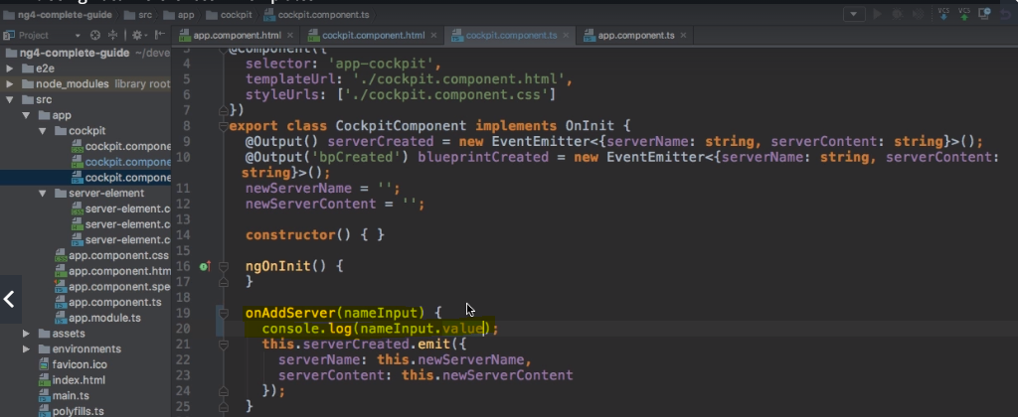

Enhancement i.e. you can be more specific about it.

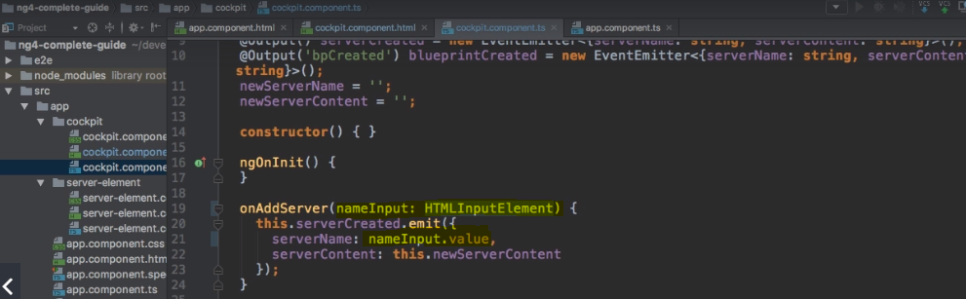

How to solve the error of Failed to find module: "os", relative to: app/tns_modules/

Ans - Use - npm i os –save

@ViewChild() in Angular 8

In Angular 8, the @ViewChild() syntax changed slightly:

Instead of: @ViewChild('serverContentInput') serverContentInput: ElementRef;

Use @ViewChild('serverContentInput', {static: true}) serverContentInput: ElementRef;

The same change (add { static: true } as a second argument) needs to be applied to ALL usages of @ViewChild() (and also @ContentChild() which you'll learn about later) IF you plan on accessing the selected element inside of ngOnInit(). If you DON'T access the selected element in ngOnInit (but anywhere else in your component), set static: false instead. This is a temporary adjustment which will NOT be required anymore once Angular 9 is released!

Another way of getting access to template element from our typescript code.

**ViewChild ()**

Here you can define the local reference in component.html

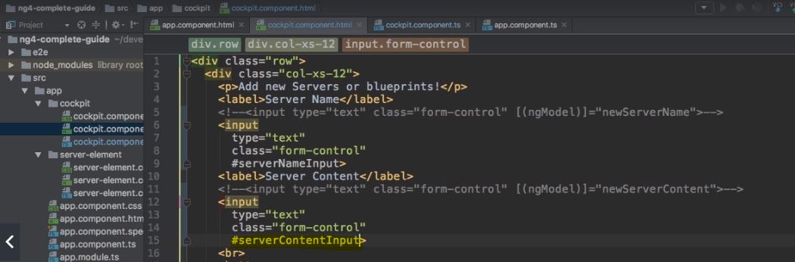

And then You can use the viewchild() to get the hold of that template element

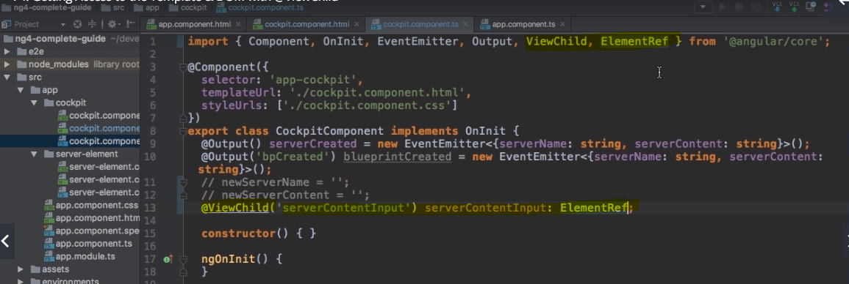

You can use elementref’s, nativeElement to get the content of the underlying content of that element

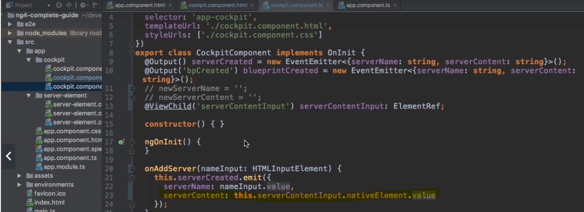

This is certainly not a recommended way as you achieve the same results with directives.

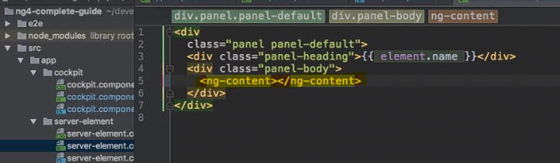

Directives acts as a hook for the content defined within the tags of the component where it has been used.

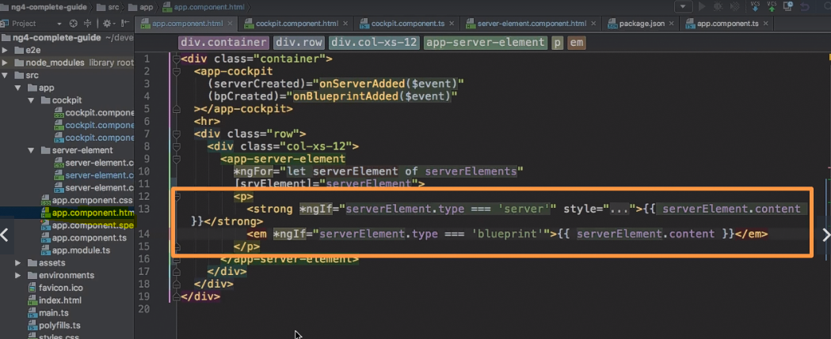

Angular Life Cycle Hooks

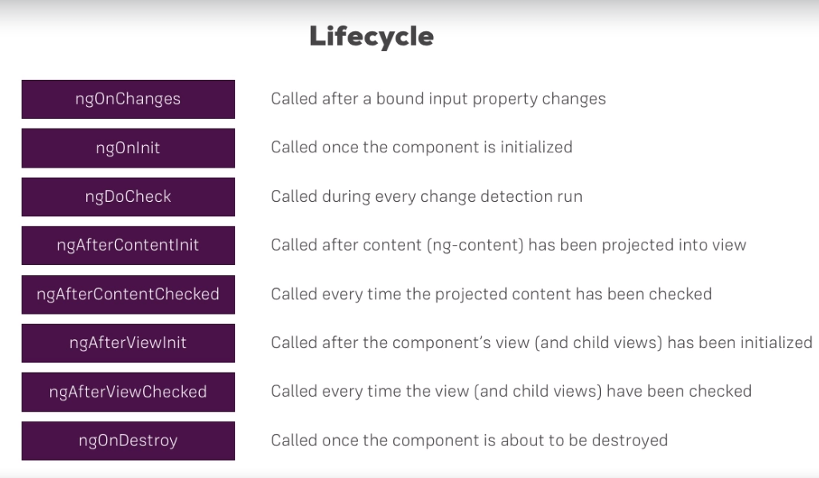

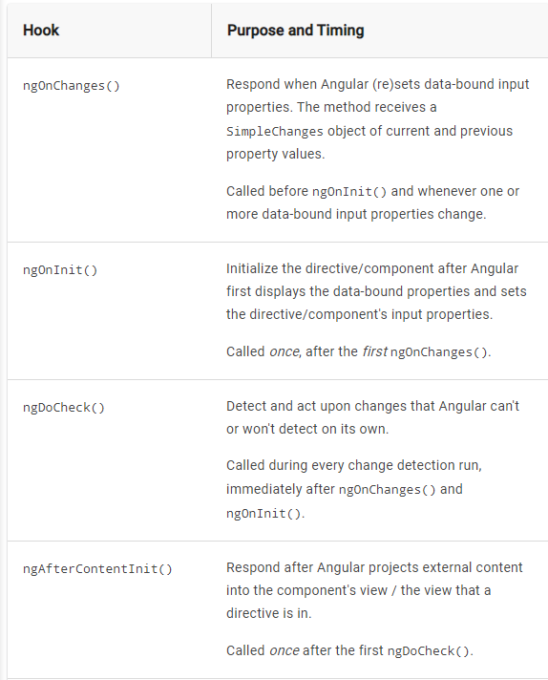

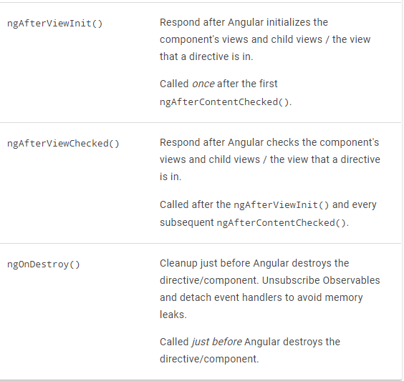

@ContentChild() in Angular 8

In Angular 8, the @ContentChild() syntax changed slightly:

Instead of:@ContentChild('contentParagraph') paragraph: ElementRef;

Use: @ContentChild('contentParagraph', {static: true}) paragraph: ElementRef;

The same change (add { static: true } as a second argument) needs to be applied to ALL usages of @ContentChild() if you use the selected element inside of ngOnInit (as we do it in the lectures).If you DON'T use the selected element in ngOnInit, set static: false instead.

**Project – part 2 components and communication i.e data binding**

**Troubleshooting**

If you get an error while initializing an event emitter i.e. “eventemitter error expected 0 arguments but got 1” then check your imports. By default eventemitter gets imported from ‘events’ instead of that import eventemitter frim angular/core i.e. import { EventEmitter } from '@angular/core';

**Rendering features/components based on ‘ngIf’ condition.**

Adding onselect method on the click for the header menu items

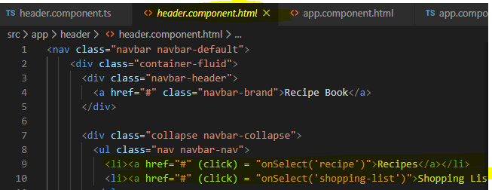

Create eventemitter from header.ts file with @Ouput annotations.

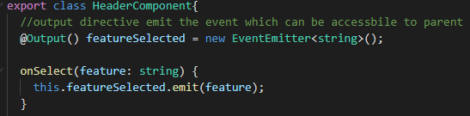

Update the app.component.ts to receive the event and pass that event to the corresponding html file to display the feature.Putting the code related to recipe item into its separate file i.e. from recipe list to recipe-item.html component

Refactoring the code

Looping over the recipe list and then passing each item of the recipe to the recipe-item component with the help of ‘ngFor’ directive.

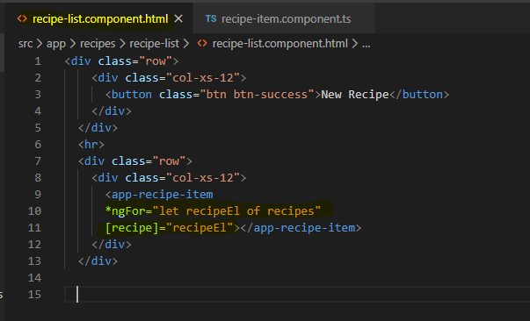

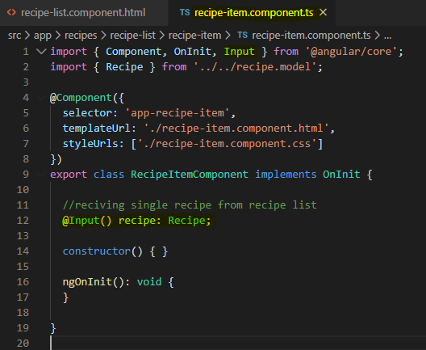

3 – passing the recipe details so that we can have that information in recipe details section. Here we are passing event from one component to other which is also called as event chaining.

Avoid event chaining as much as possible. It injects code complexity as your application grows.

‘Recipeitem -> recipe-list component -> recipe component to recipe-details’ this is a long way to send data from one component to other hence we need to refactor the code in next iteration of the project.

4- Accepting user input for shopping list and make it workable

**Directives deep dive**

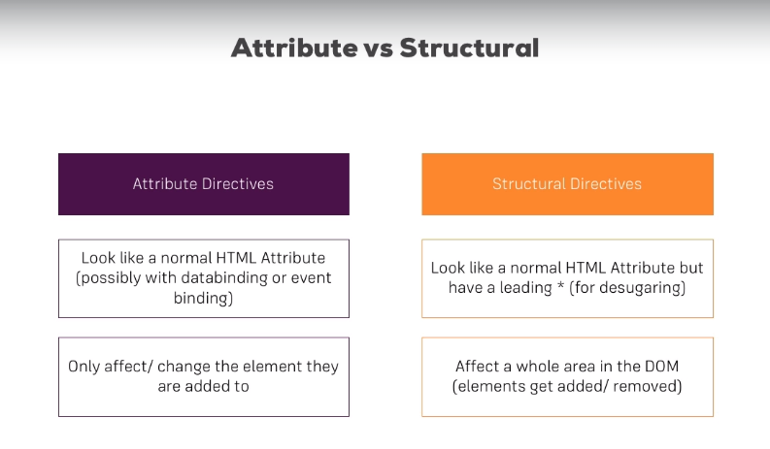

You cannot have more than one structural directive on single element as it will throw an error while compilation.

**Ng Class and Ng style**

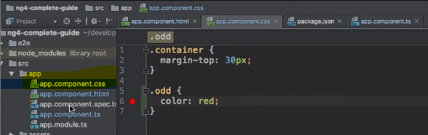

Here odd: is a class

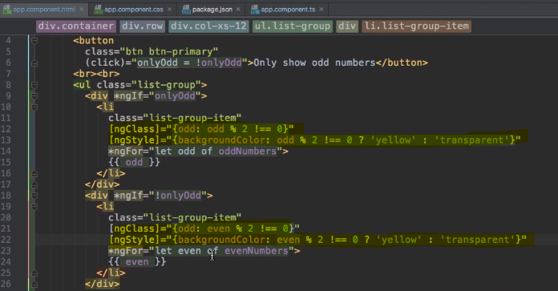

**Creating an attribute directive through CLI** – ng g d ‘name_of_the_directive’

Note - Always put directive in its separate folder.

**What is render?**

Renderer is a class which is a partial abstraction over the DOM. Using the Renderer for manipulating the DOM does not break server-side rendering or Web Workers (where direct access to the DOM would break)

**How to use renderer within custom directive?**

elementRef is used to get an access to the underlying element Directives has ngOnInit() lifecycle hook on them.

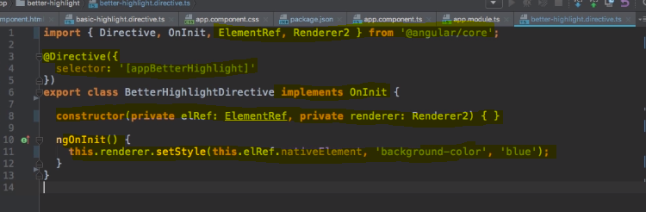

You must register all the directives in app.module.ts. you do not need to take care of all these if you are using the CLI to create directives.

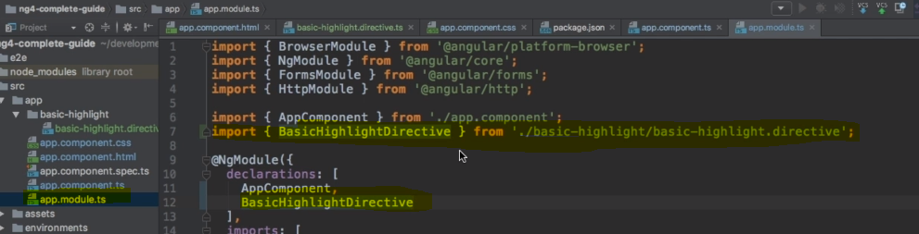

Once you are all set then you can implement the directive as an attribute to any element for an e.g.

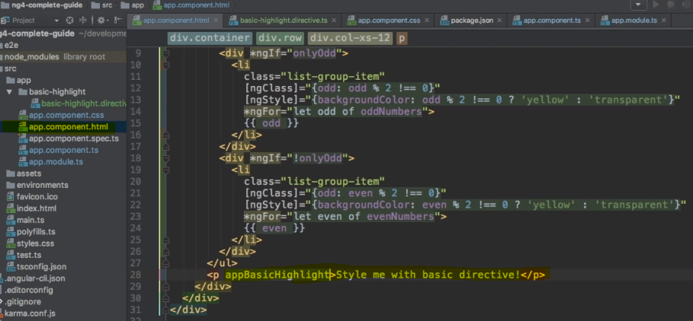

Using directive in the above manner is not recommended and certainly not considered as a best practice. You can use renderer for that.

Using renderer provides a way to change the property values if your application is being used by the service workers. Most of the time it won’t affect the application flow even if you use directives as it is, but it may create some complication in the service environment.

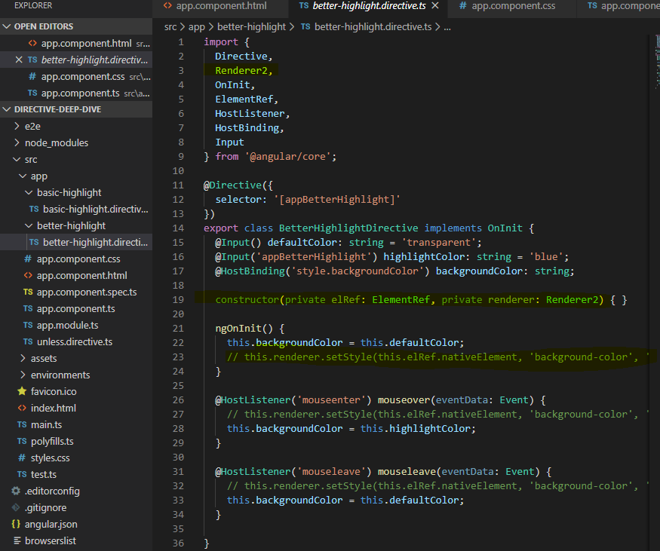

Moving forward…renderer is a good option, but it is not most interactive option. Well that’s where @hostlistener directive comes into the picture.Using Hostlistener to handle events – this will allow directive to behave according to the event that are happening.

Syntax - @hostlistener(‘eventName’)

Host Binding – it is an easy way since you can skip the use of renderer. @HostBinding(takes the styles from the css file –similar to ). Style.backgroundcolor is referring to the style of the component which is triggering that event.

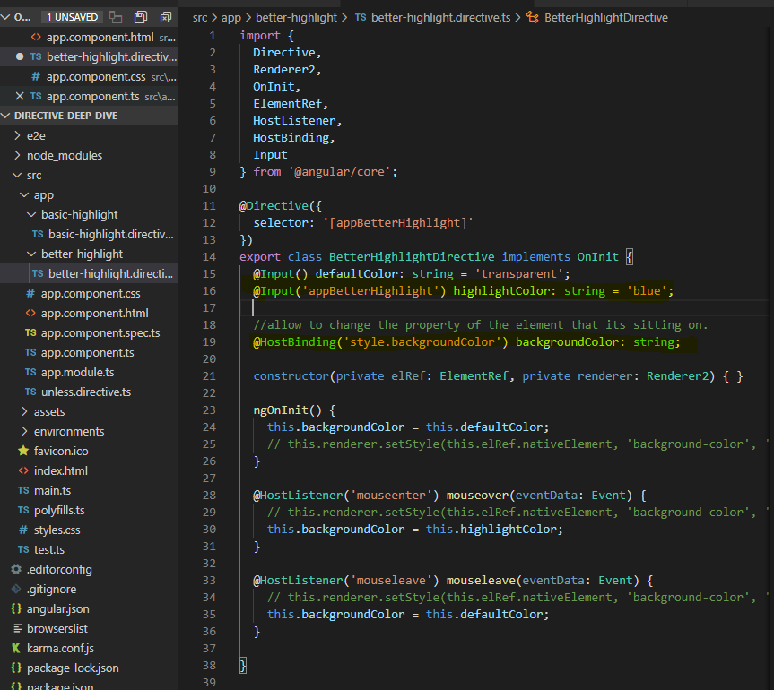

**Custom property binding**

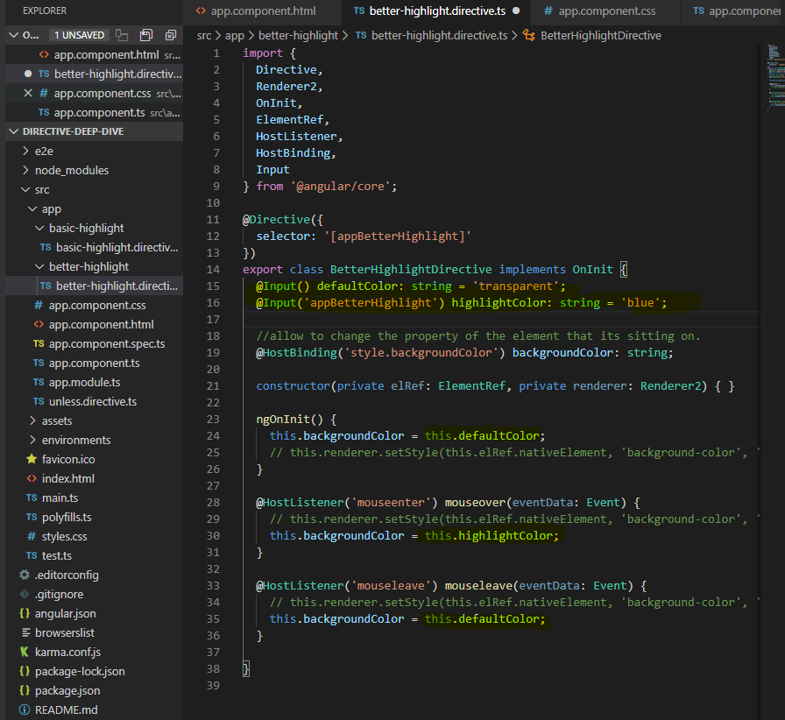

With @input you can implement those properties from outside of the file too.If you want your css properties to be set to the element before you perform any intended actions like mouse hover etc then you can initialize them in the onInit method.

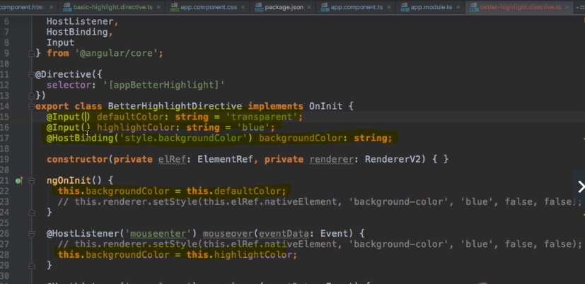

**Building your own structural directives**

You can create a component using normal CLI command and then you can modify it further to add your own business logic. It will automatically get registered in the app.module.ts

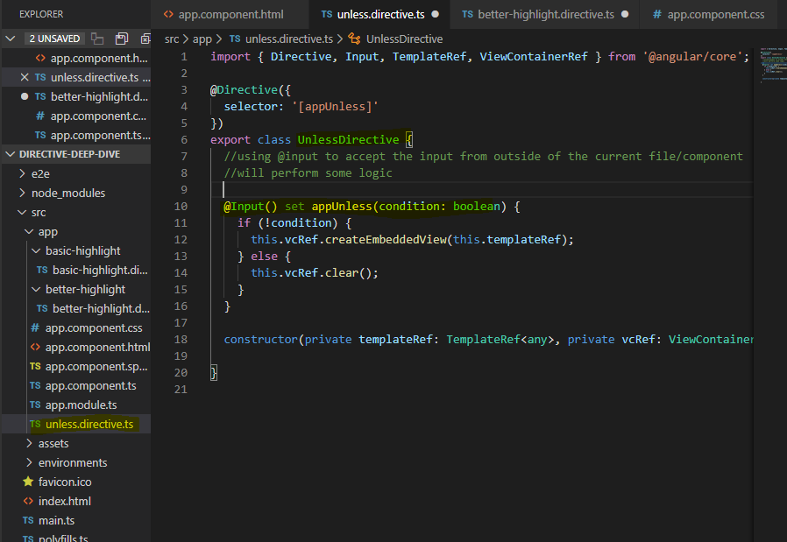

**Implementation**

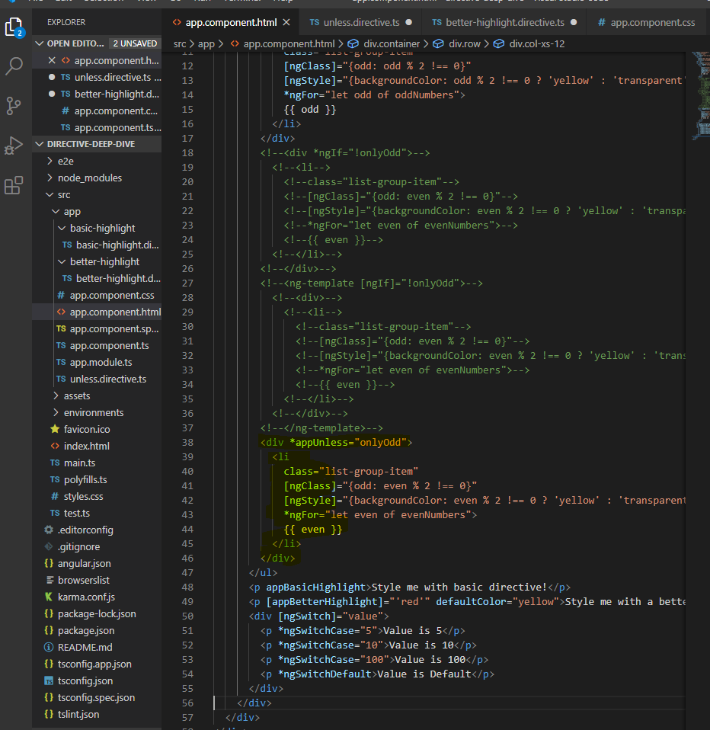

**ngSwitch**

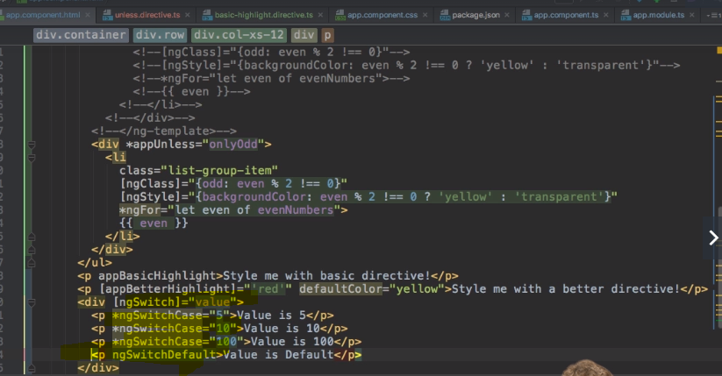

**You must pass the required parameter value from corresponding component**

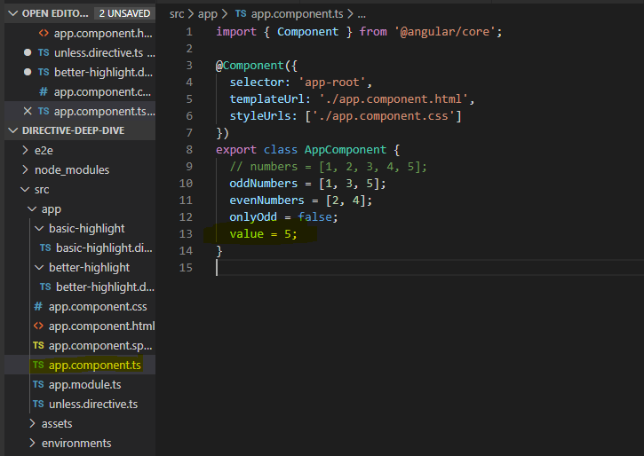

**Course project part 3 - directives**

Services and Dependency Injection

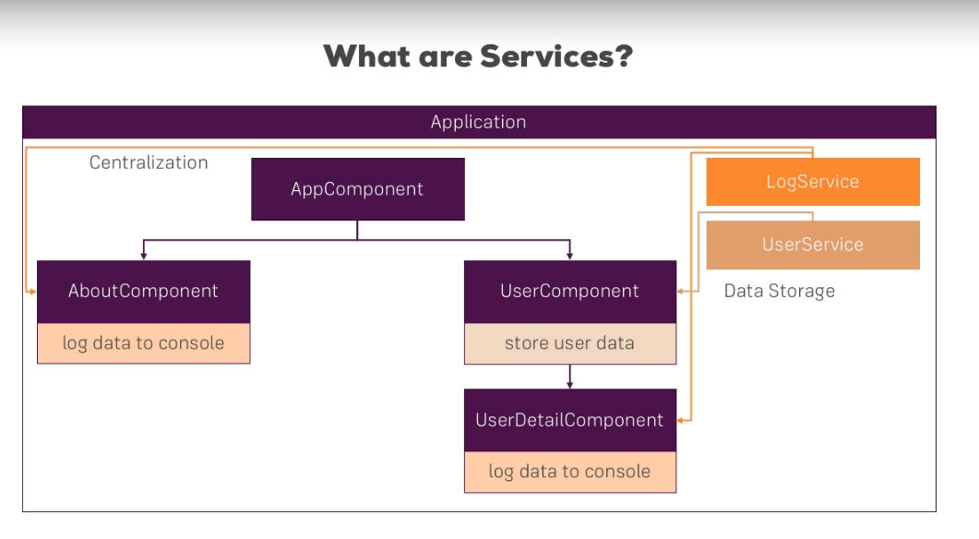

Create a shared folder for services. It contains bunch of methods that perform repetitive task and event specific tasks.

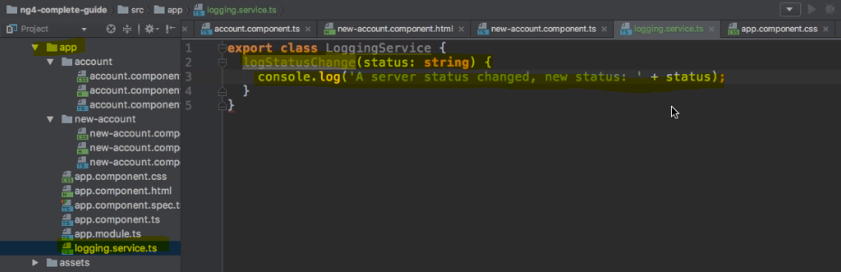

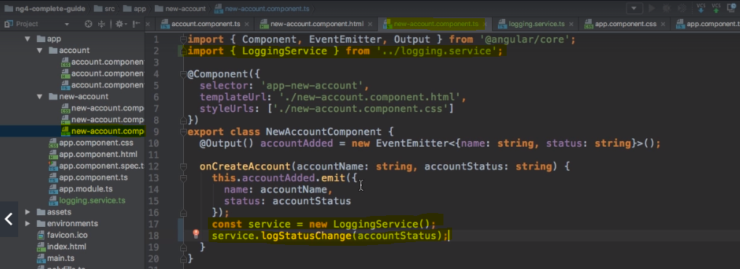

you should not use services like this. Creating an instance for using service works but it’s certainly not a recommended way as it forces you to write more code.

You can use dependency injector to use services as you avoid the instantiation of the service. This approach is considered as a best practice as you can stay within the angular eco system and Angular exactly knows what your application is doing.

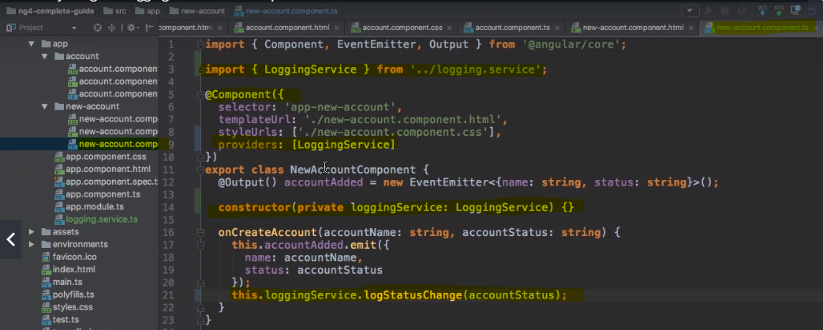

Creating data service – please follow the commented application code – service-demo-app

**Service Availability Hierarchy**

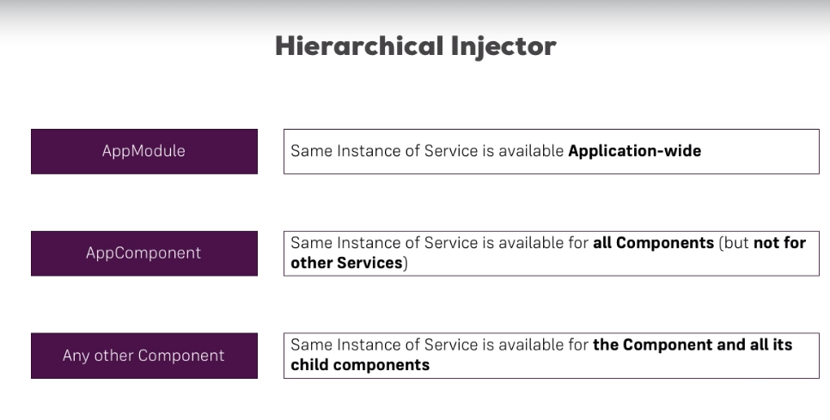

If you want an instance of your service, then you need to remove that service from the providers array and put it in the app module’s providers array. [ See the hierarchical injector chart ] It helps to solve the service overriding.

In our application we are having instances of accountservice at 3 places – in app module and in its child components which causes overriding problem as child component tries to override the implementation provided by the parent. To avoid that you can remove the service from the providers array while leaving import and constructor intact.

Follow the following example. You need to be careful here.

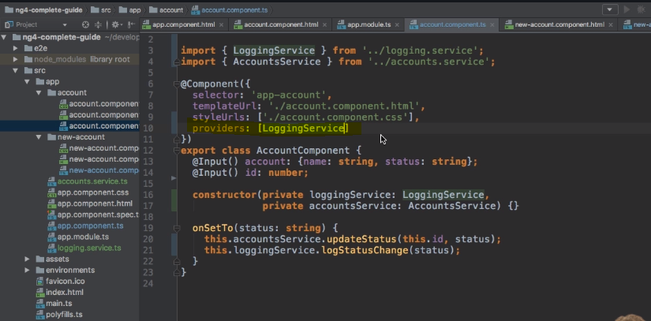

**Injecting Service into Service by using @Injectable**

If you want to use service inside service then you can do it by using @injectable because you need to provide some metadata to the angular to show that we are accessing service inside other service otherwise it will throw an error as following.

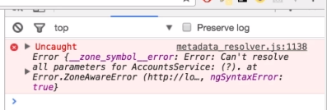

Please follow the Steps are shown below.

Add @Injectable to the service in which you are adding another service. You don’t need to do that for the service that’s working standalone.

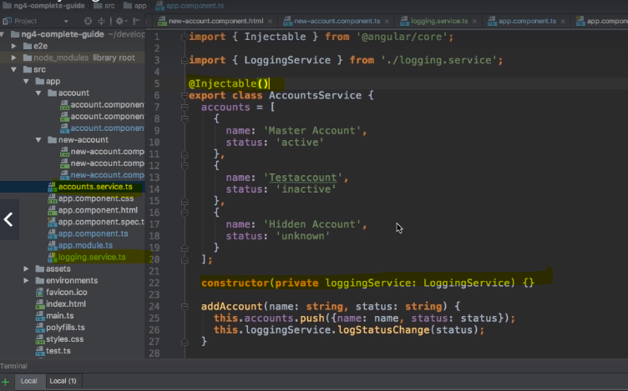

**Cross component communication using services**

Step 1 – create an event emitter in the service

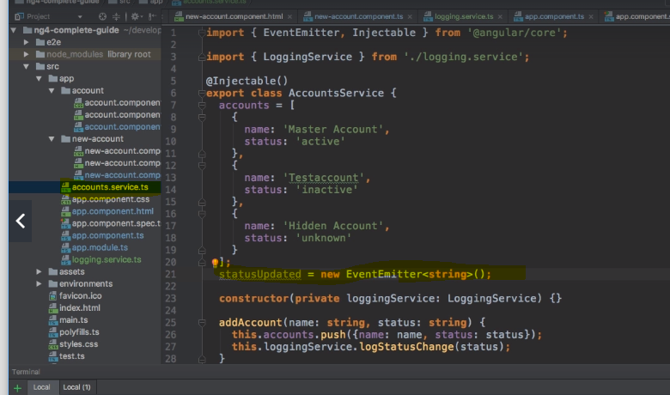

Step 2 – emit the event from another component

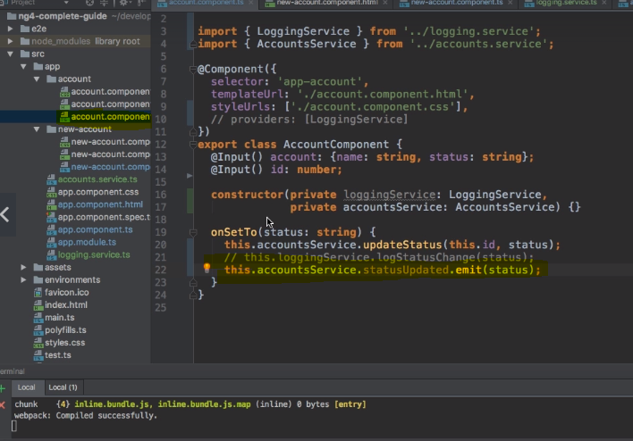

Step 3 – you need a subscriber for event, which we are creating in following steps. In above we created event emitter in two places.

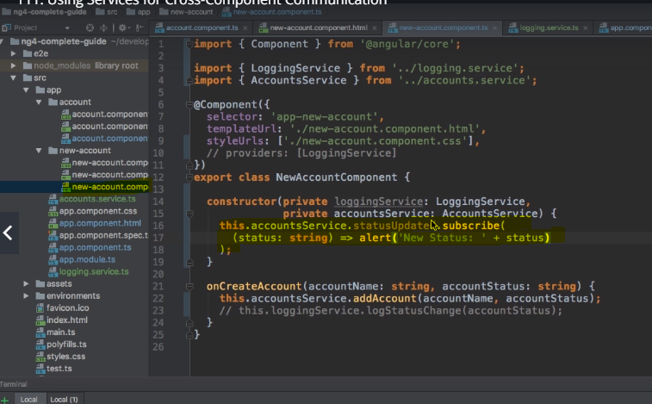

You can remove the event listeners from the html code of the corresponding component.

**Project part 4 – implementing service and dependency injection**

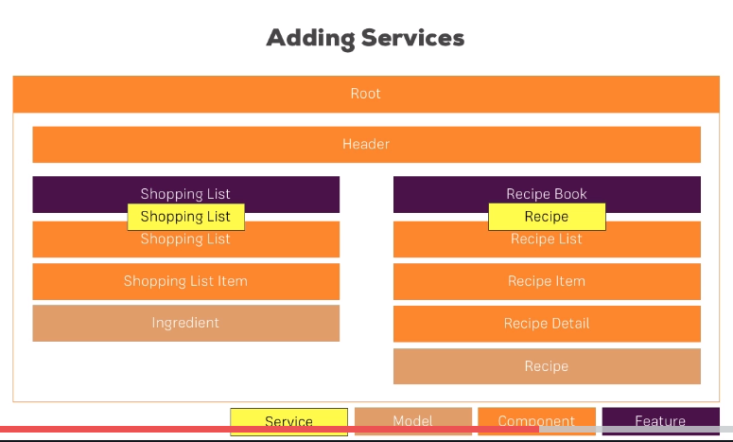

**Adding a recipe service.**Create a recipe service file – in which you will add recipe array from the recipe list components and add ‘getrecipe’ method

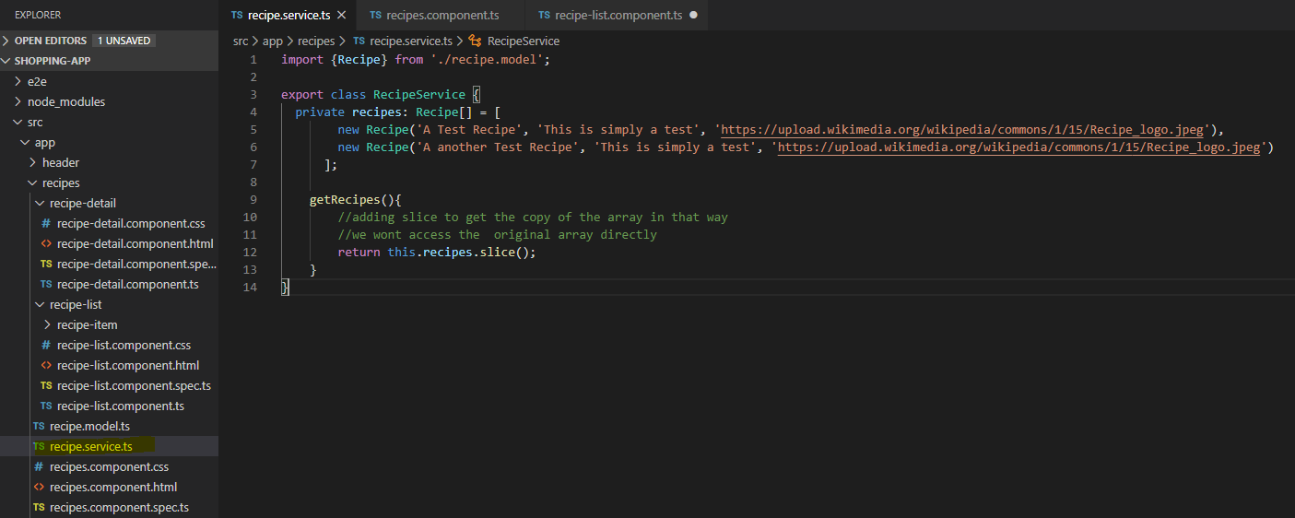

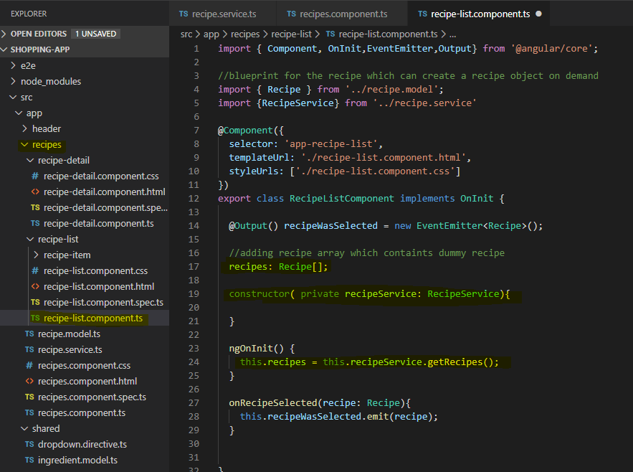

Adding provider to the recipe component so that service will be available to all the components within recipes component.

2 – implementing cross component communication by removing event and breaking the long chain of communications. Updating recipe service. Implementing the service in recipe item component. Removing the event listener recipeselected from recipe-list componenet.html

3 – adding ingredients to the shopping item details section

**Routing**

**Always keep all the routes used by your application in app.modul.ts.**

**Example project structure**

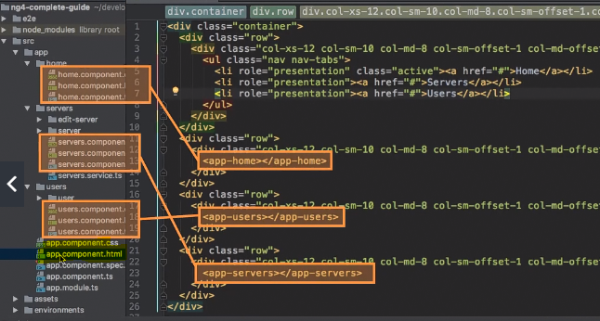

Routes must follow the following highlighted syntax.

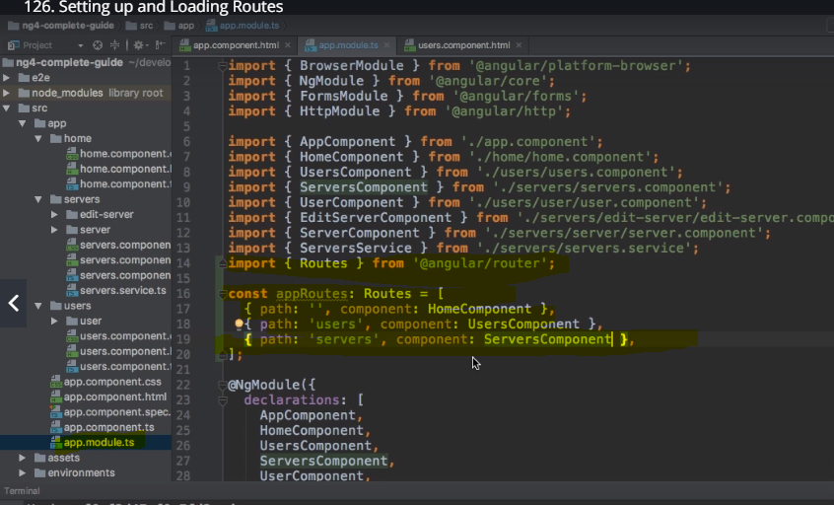

You have to register all the routes And need to import ‘route’ and ‘routerModule’

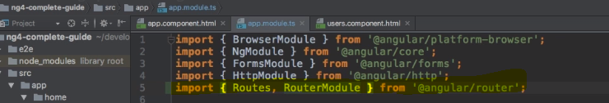

Pay attention to forRoot. There we are passing approute which holds all that routes of our application. It registers all the routes that angular needs to knows about the application.

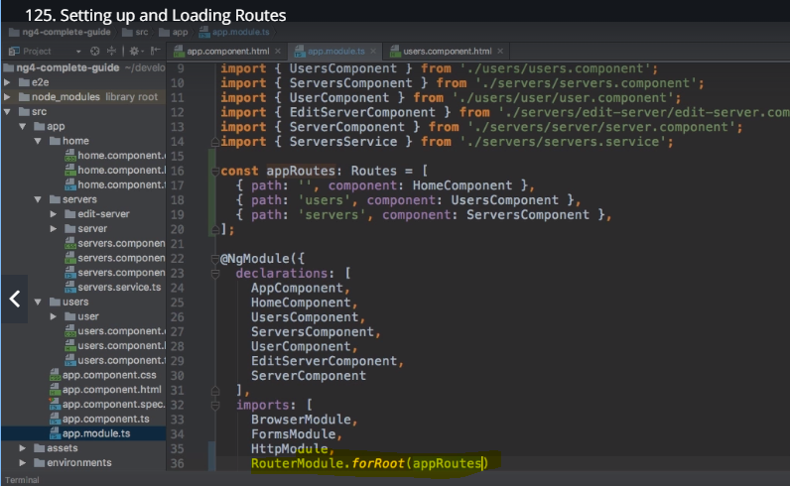

you need selector shown below. It will give you the currently active route and component corresponding to it.

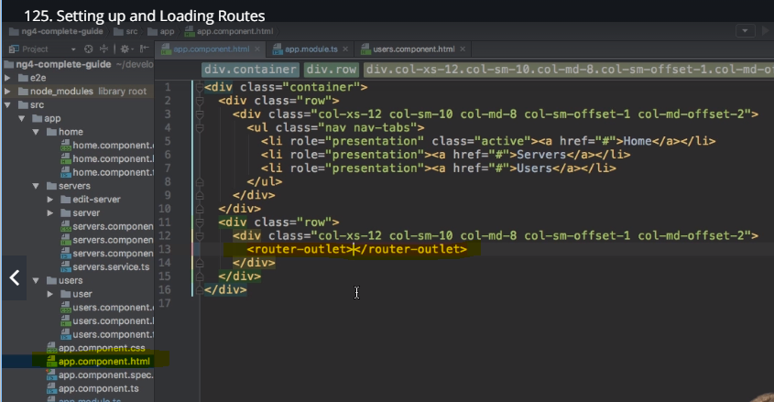

But to navigate you need keep changing url in the browser which is not so convenient to overcome that we need to add links to your application.

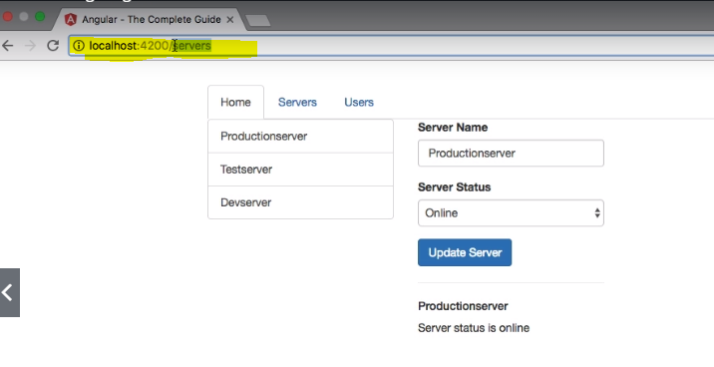

Here is the way to add navigation routes. We can use the special directives given by angular i.e. ‘routerLink’. If you are using routerlink with [] then you need to put urls in the [] please see the highlighted code below.This approach makes your angular application truly single page and improves overall performance.

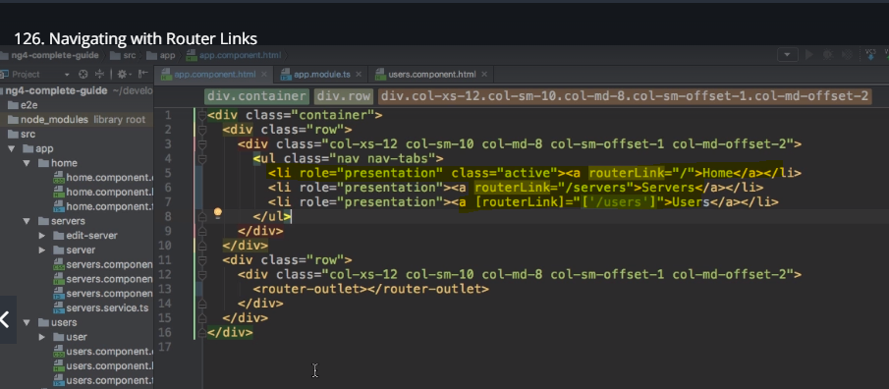

Absolute path / at the beginning. Relative path without / gets added to the currently loaded path that means it appends the required path to the current path.

**How to style the active route?**

Angular provided special directive for this i.e. ‘routerLinkActive’. Which can be used as the following.

Routerlinkactive has bootstrap class applied I.e. routerlinkactive= ”active”

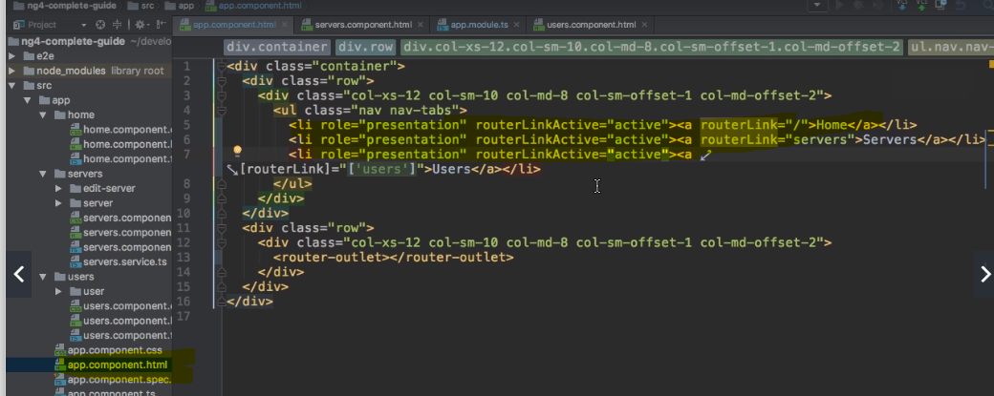

**If you go with above way, then you will basically get the home page active all the time. You can fix that by adding {exact: true} which will make only one route as an activated route at all time.**

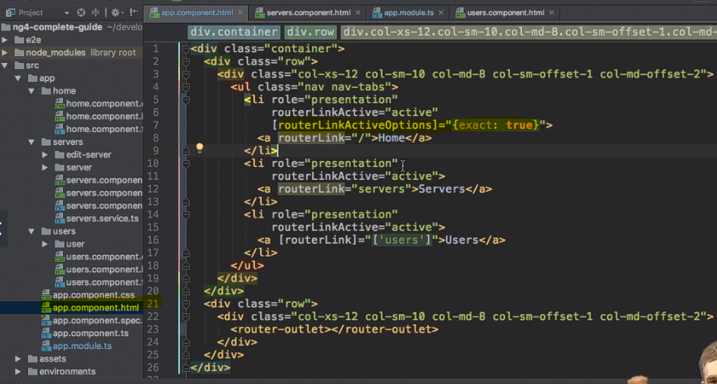

**Programmatic navigation**

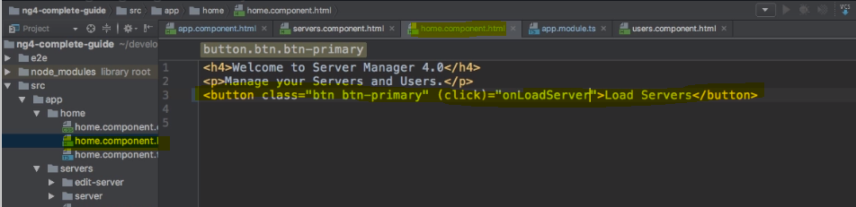

Here you are using router as a service which has a navigate method which you can use inside your component to perform programmatic navigation.

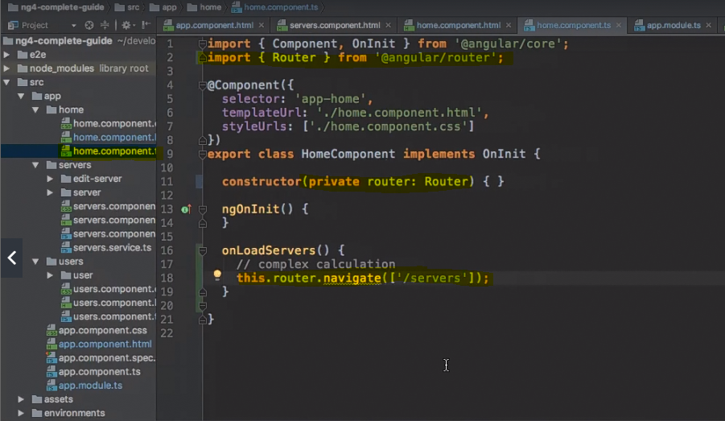

**Relative path navigation**

Here activated route will give you active route. Now ‘relativeTo’ gives you a way to define how you want your url relative to.

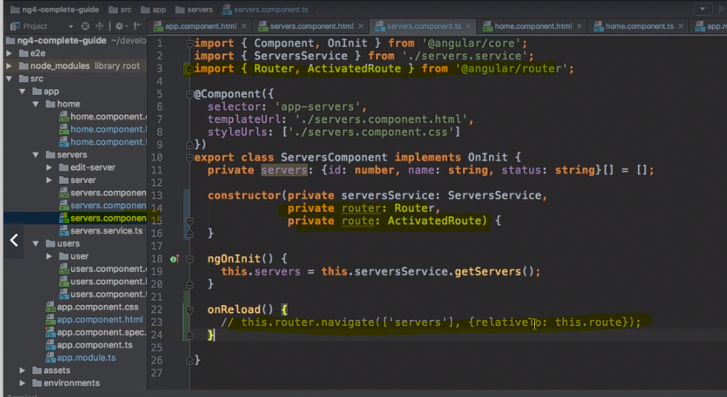

**Passing parameter to the route**

**Let us assume that we want user id in the url how can we do that?**

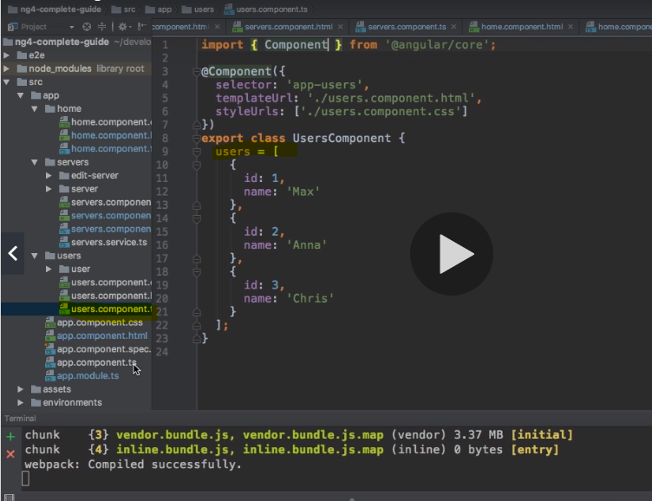

You can’t make all the routes dynamic by adding /: parameter in your path.

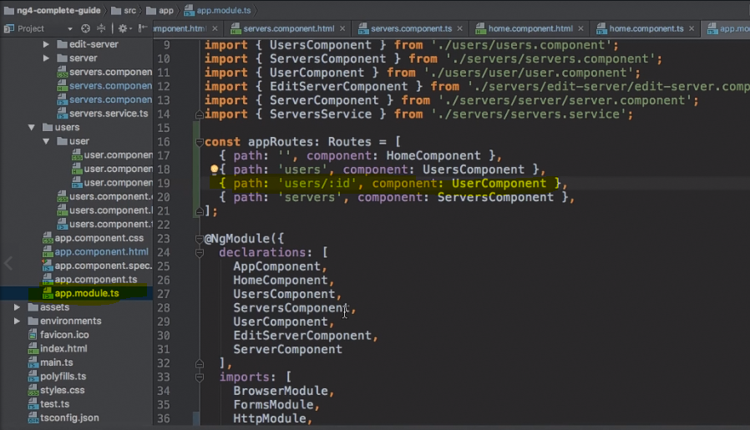

You can add multiple params in the same url but its not a good practice.

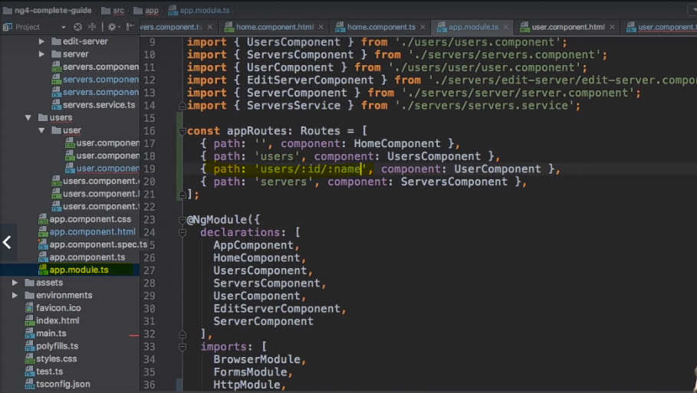

Fetching route parameter – how to access the parameters from the URL. ActivatedRoute will give you that as it holds the JS object with tons of matadata. You can retrieve the information from that metadata.

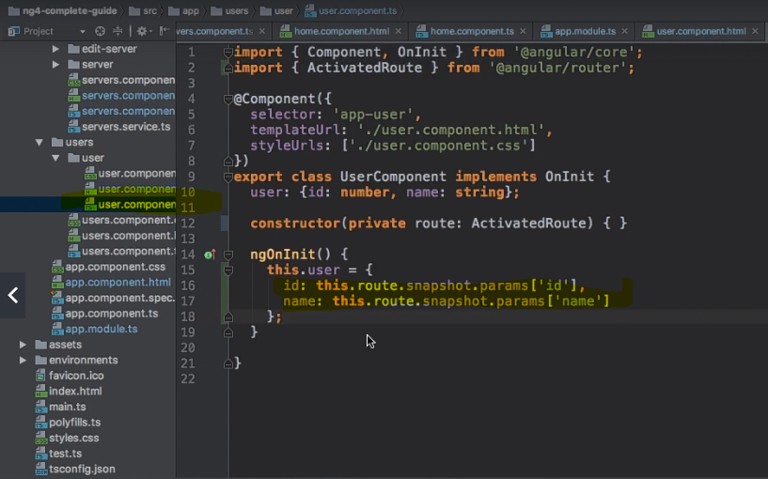



**Fetching route params reactively**

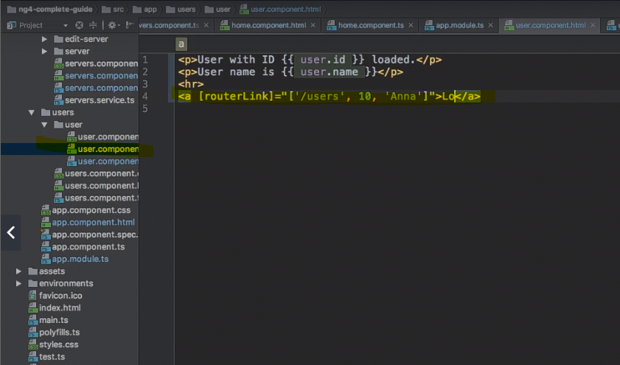

If you are on the same page as the link then you wont be able to reload the page even if you want. Parameters then can be handled by the subscriber of that coponenets in .ts file. You can use the snapshot method but it wont work where you don’t have a link on the same page

**Like**

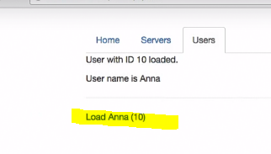

In all other cases snapshot will work

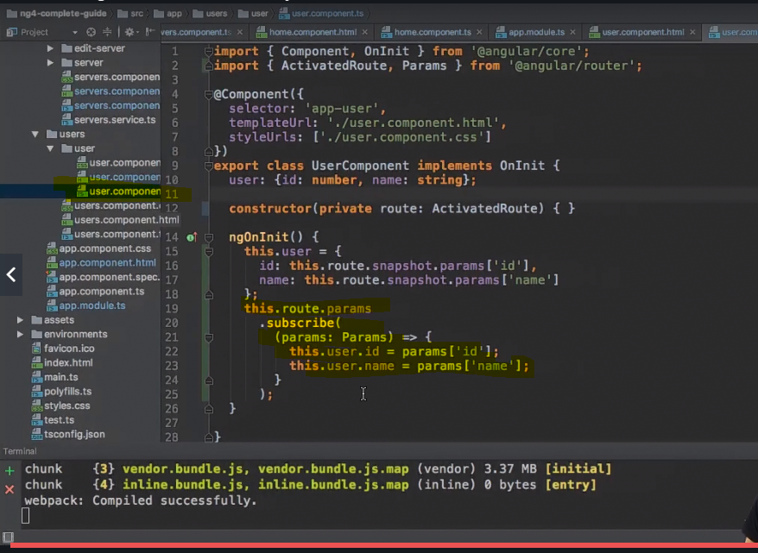

Here angular clears the subscriber after destroying the component but it will be useful if you use Ondestory to do it manually. This method is useful only if you are using your own observables otherwise angular will handle that and you do not need to take care of it.

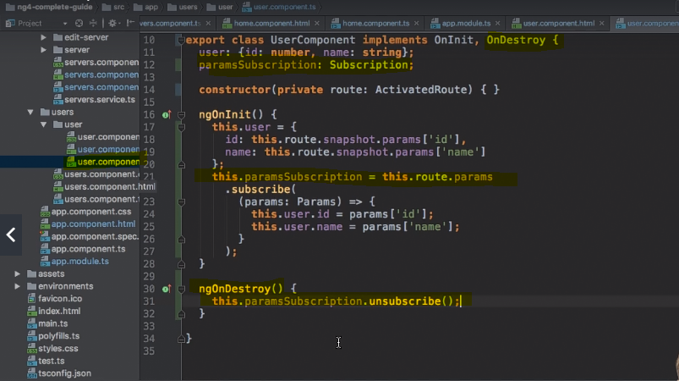

**Passing query parameter passing them using router links**

Adding another route

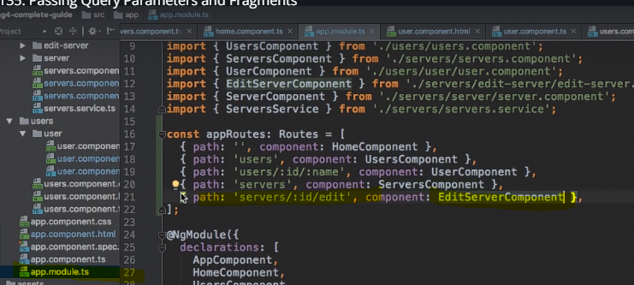

We add queryparams property also we added fragment. Both query param and fragments are properties.

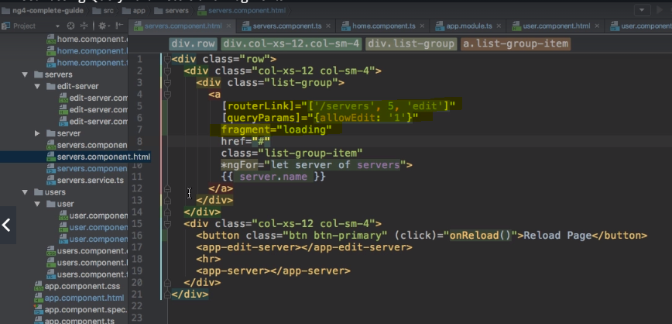

Routerlink – take you to the desired page

Queryparms – passing the params in the router link

Fragment – gets added at the end of the route with #

**Now lets see how to do it programmatically**

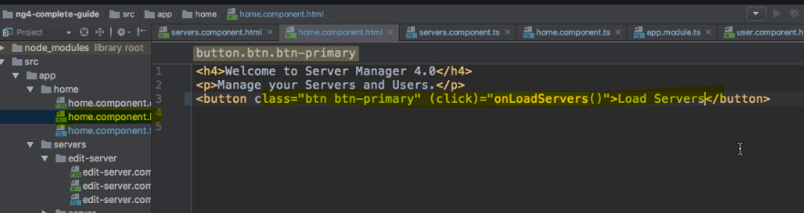

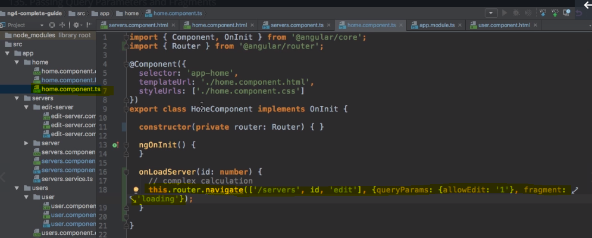

**Retrieving the query params and fragments**

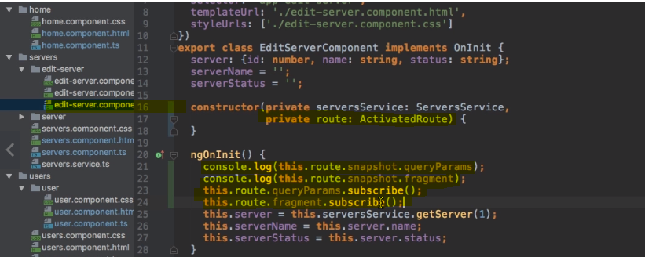

As before if you are staying on the same page then don’t use this approach as here snapshot will only work when the component gets loaded first time.

If you want to convert string to int you can do it using + sign

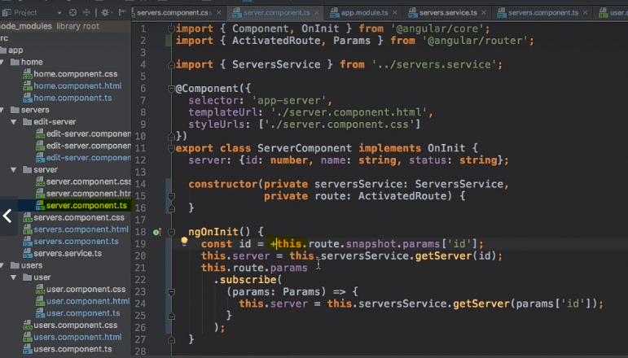

**Nested routes**

You can do it by adding child property in the route in this case servers which act as a parent and then children [ holds an array of routes] or we can call it as a nested route. you need to treat children of routes as relative routes as they are getting appended to the parent route.

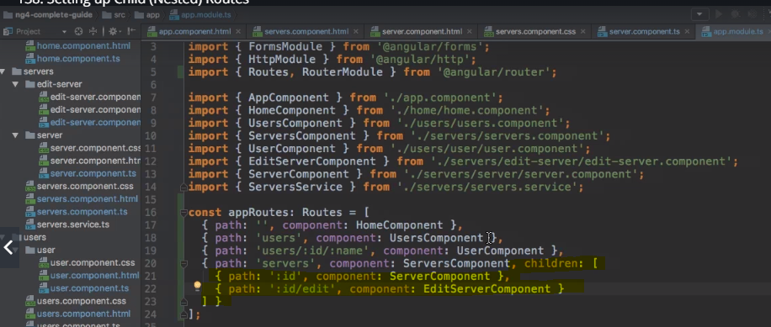

If you use the routes like we defined above, then it will throw an error.

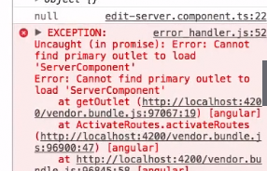

This is because in the main app.component.html you can add router outlet which acts for the parent route but not for the child route.

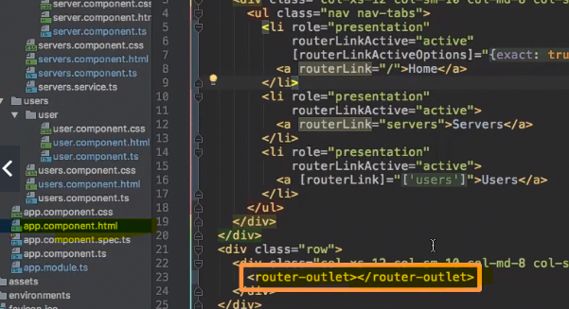

To avoid this, you can add router-outlet tag inside the child component too which eventually link up everything.

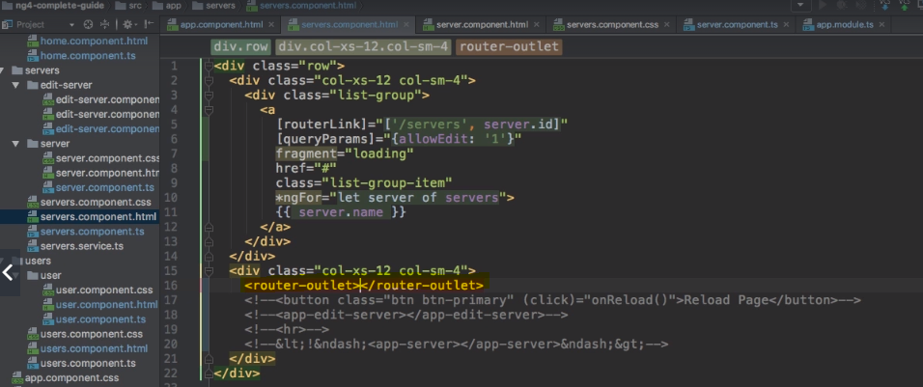

**Configuring the parameter handling**

To keep the information, of the query params of the previous url or route you had before you need to

Use another property Queryparamhandling.

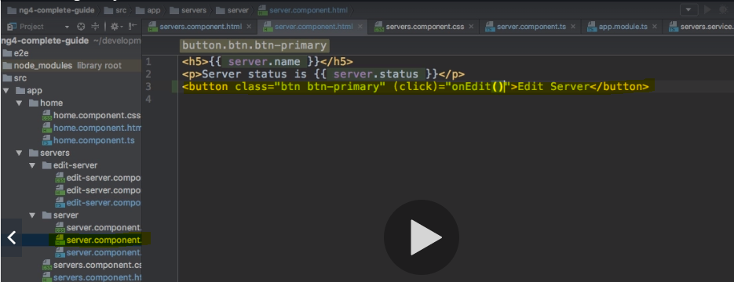

Queryparamhandling is used to a merge the old query param with new one

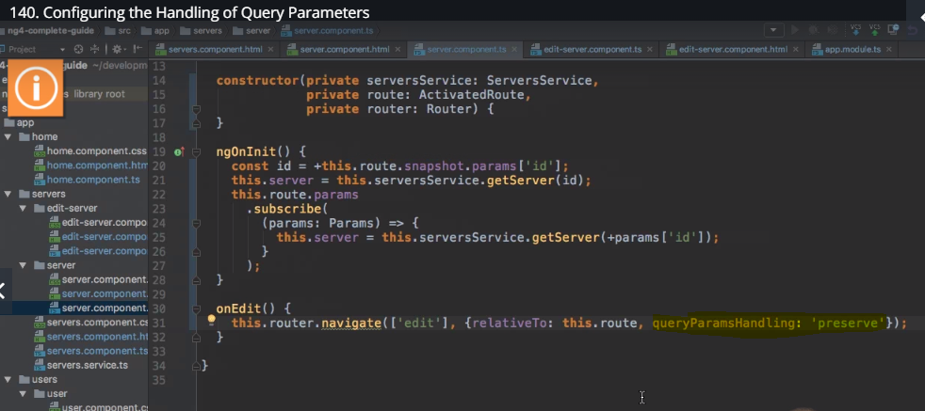

**Setting up the permissions for accessing certain components/actions**

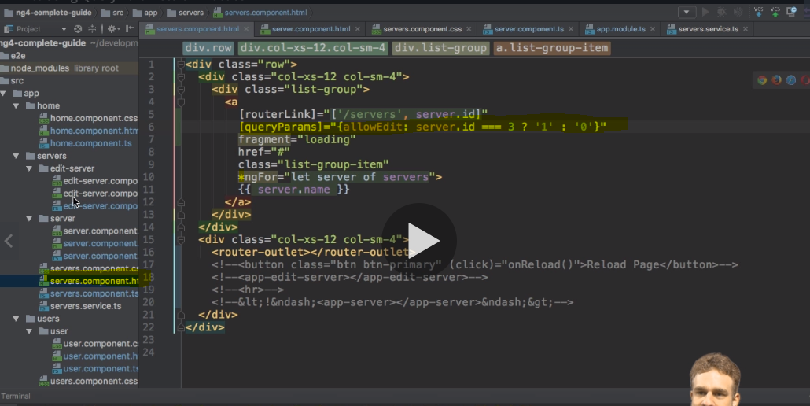

Adding corresponding logic

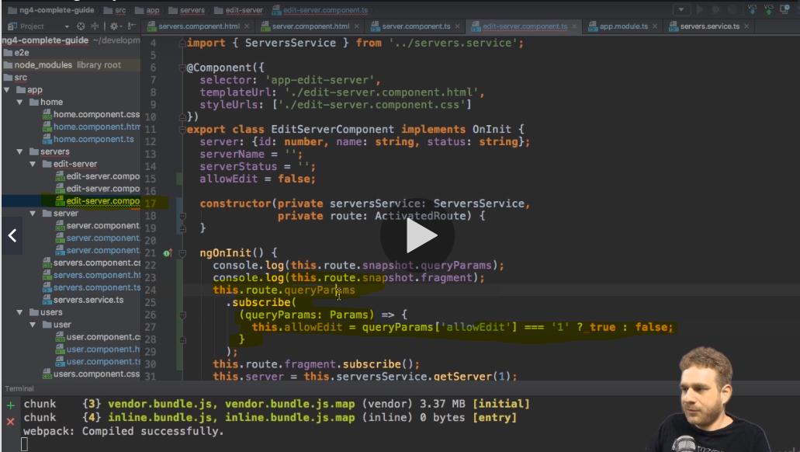

Refactoring html to implement the conditional statement which then determines if user has permissions or not.

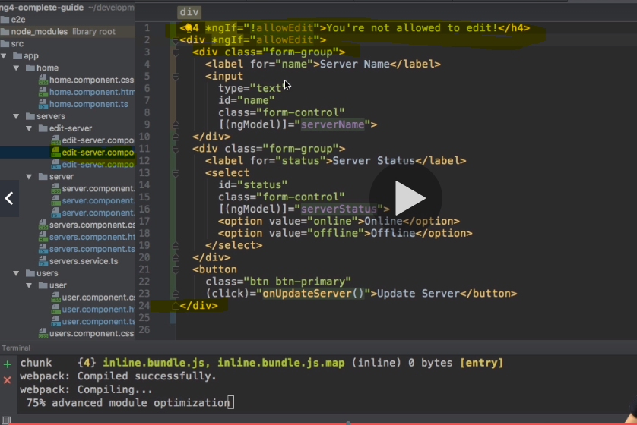

**Redirecting and wildcard routes with error handling**

Adding a new component for error handling

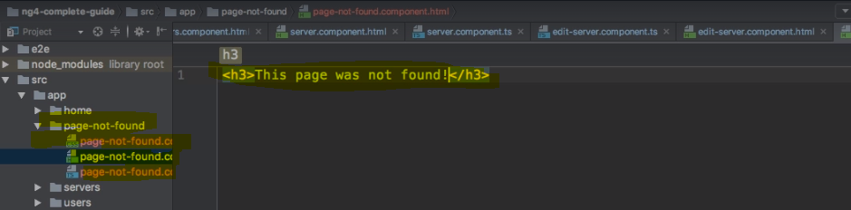

Adding a route in to the routes. Here we are defining a path /not found but it’s not recommended to use it as it in the application. What you can do is set another path with wildcard which can accept all the unnecessary inputs and then point out to the target path designed to show the error. Also if you have any wild card routes then put them at the bottom of the routes otherwise it wont allow any other routes to load.

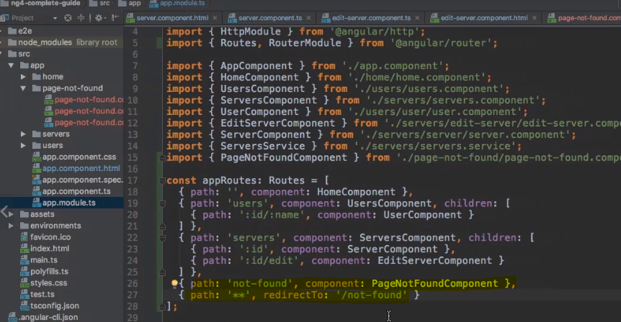

If you have more than 2 to 3 routes, then you need to have it in a separate file. ngModuel is must and along with that you need export to make it available to the outside components.

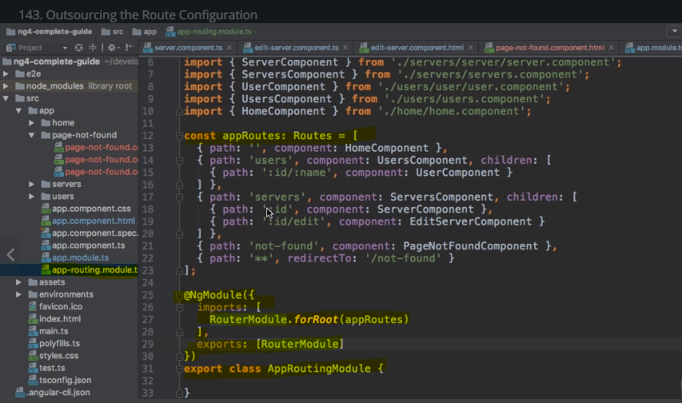

Import it in module i.e main app.module.ts to use it in the application

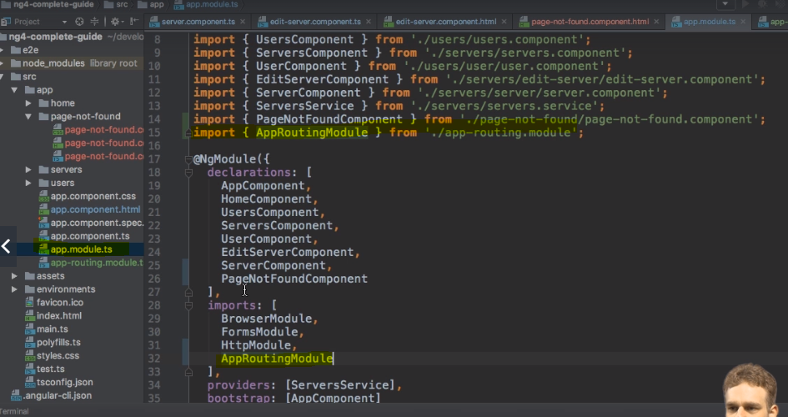

**Route Guards – restricting access to certain component**

You need to use canActivate interface and implement canActivate method here. Now how we get the data? We get it by allowing this service to run before application launch. Create an auth-guard.service.ts. you need to add activatedroutesnapshot and routerstatesnapshot to canactive method. canActivate run both async [returning observable or promise] and sync based on the customer requirements.

Create auth.service.ts – which has base authentication

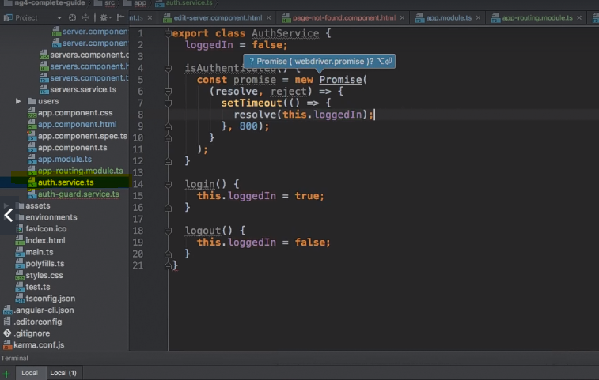

Auth.guard uses auth.service for checking

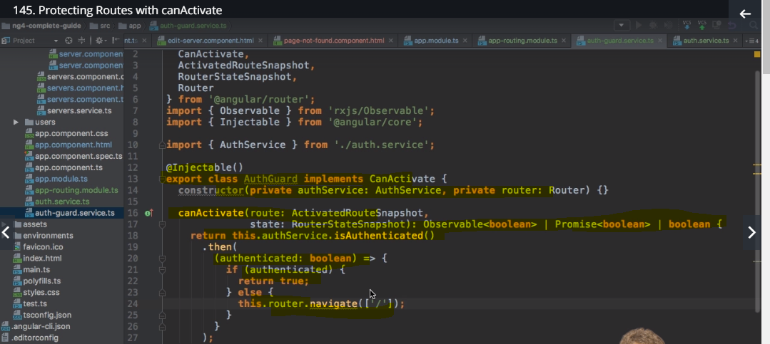

Add guard to the route that you want to guard this way you can expose the parent route but protect child routes.

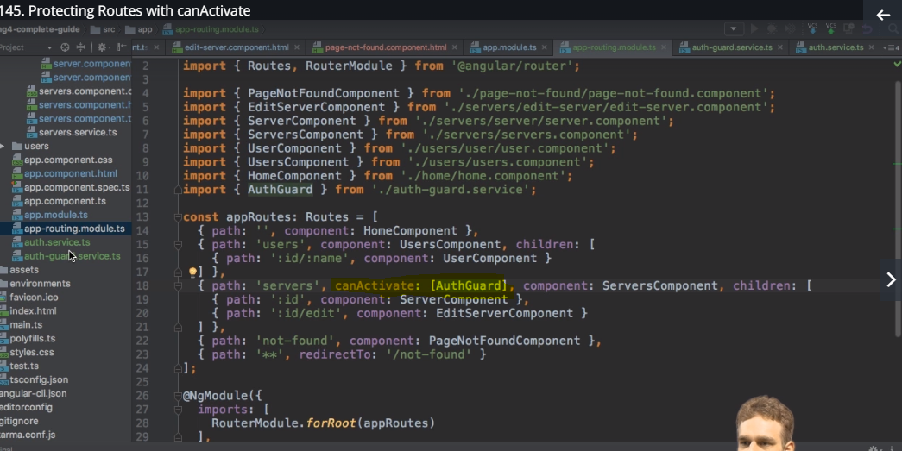

Since guard is a form of a service add it to the app-module which is a best practice.

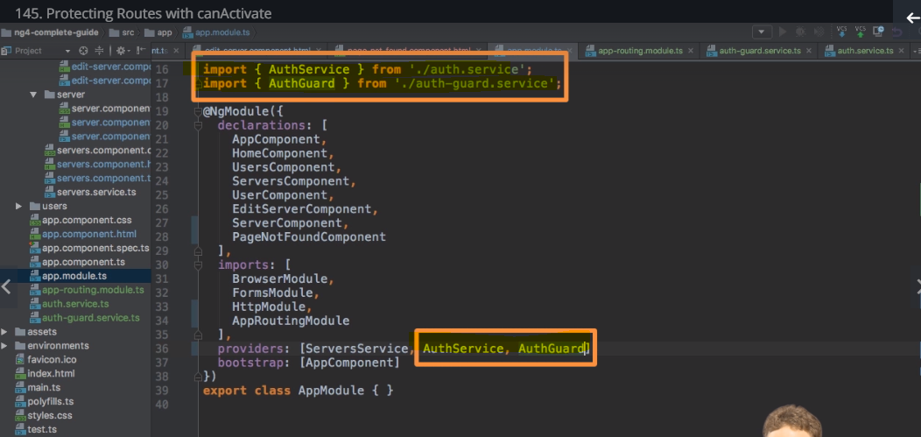

Guard added to the parent will be applied for its child too

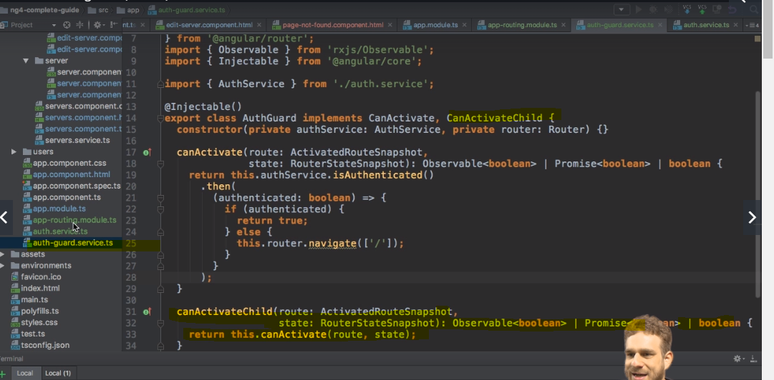

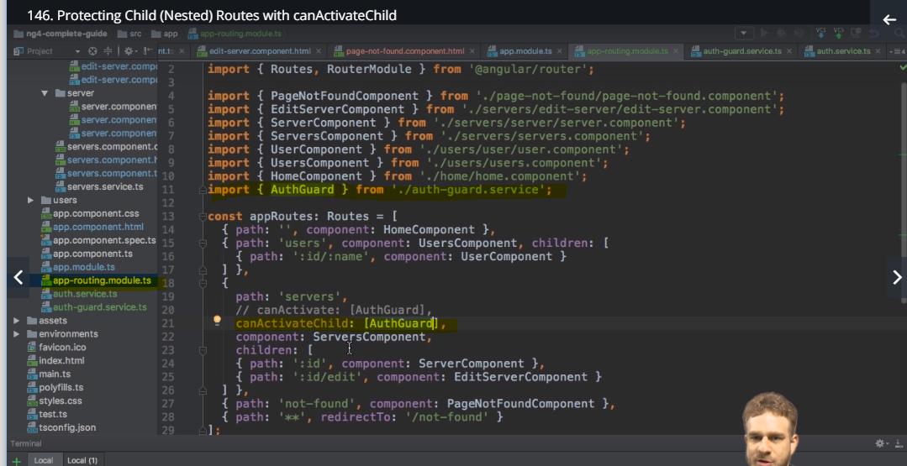

**You can apply it to child route or to the whole route**

**Controlling navigation with canDeactivate**

We can define the interface with our guard canComponenetDeativate which you can pass to the canDeativate interface.

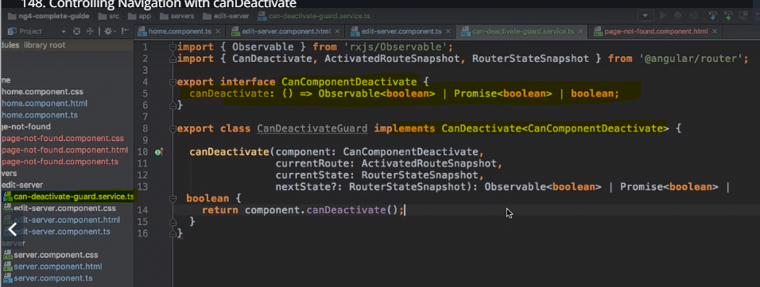

Now add the component into app-routing.module.ts

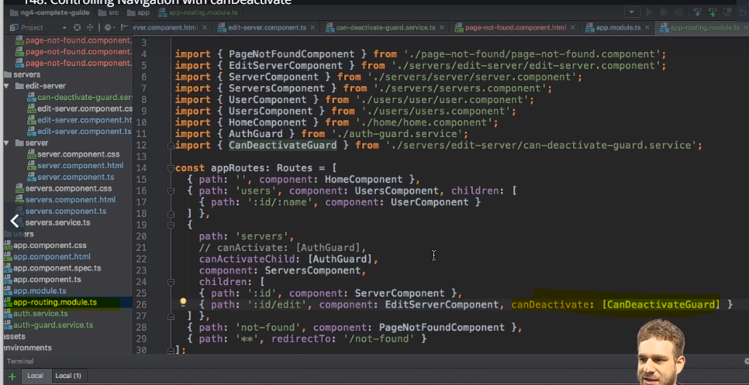

Add you gurd in app.module.ts

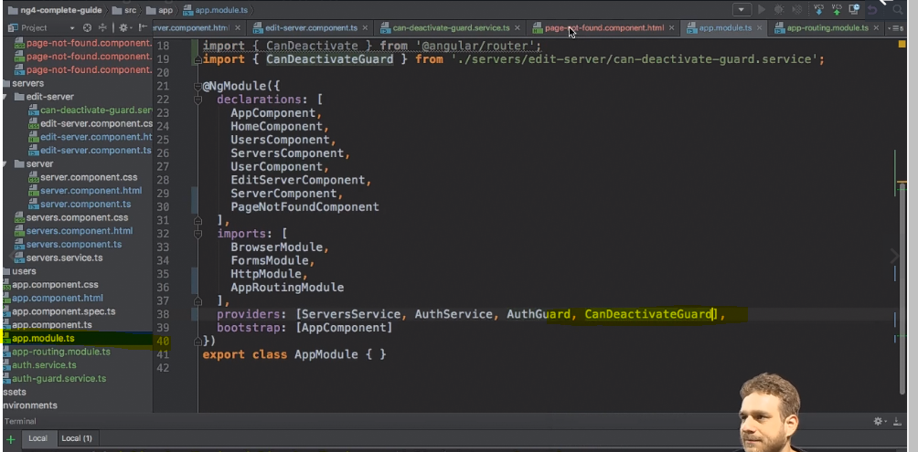

Now you can use that gurd wherever you want

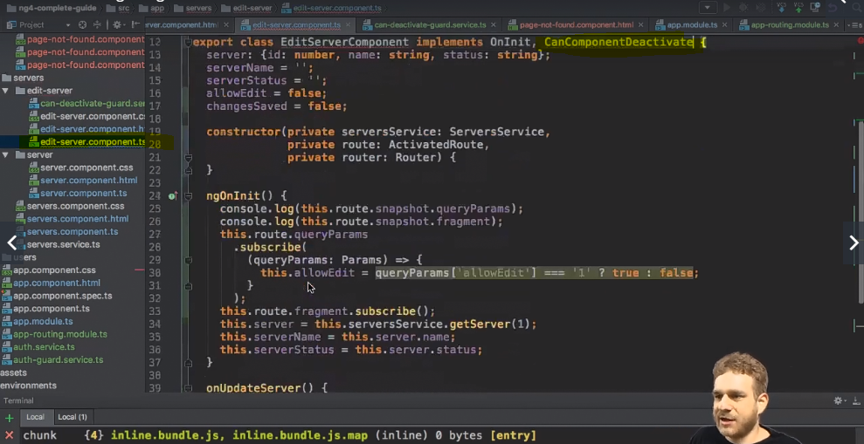

**Project – routing implementation**

We are going to implement following routs for the following services

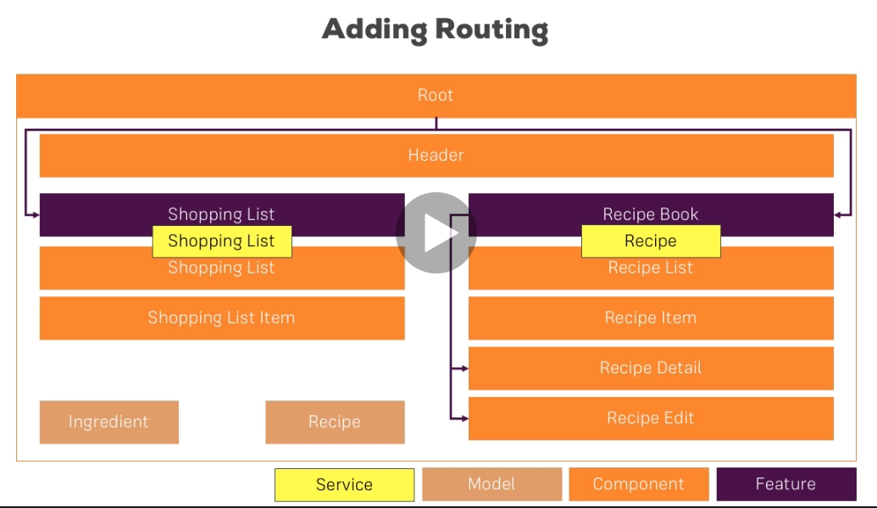

Implementing routes for recipe and shoppinglist . Add app-routing module.ts

Setting an empty path may require for the application which is then consider as a application default path. But you just cannot use it directly like this.

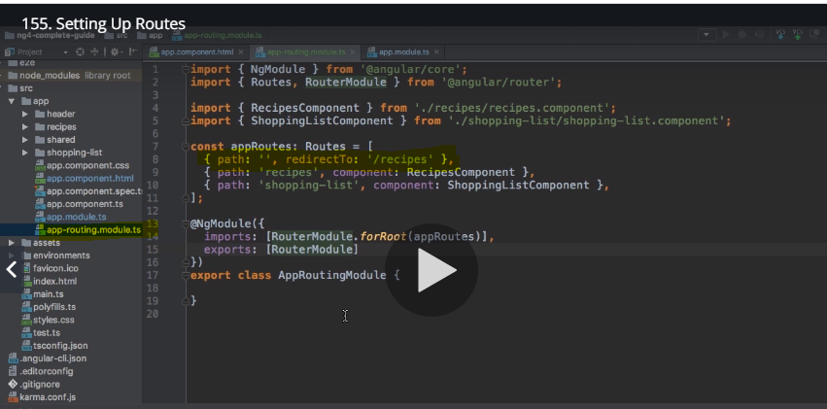

It will throw an error in the console and ask you to fix the path by adding pathmatch

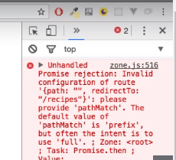

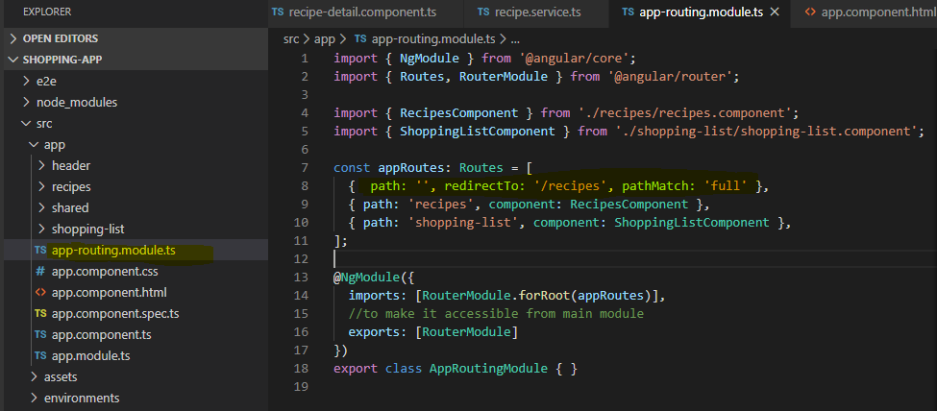

What pathmatch says is – if full path is empty then only redirect which was redirecting if we had any part of the path empty.

2 – adding routerlink to header menu item by removing onclick method

3 – updating the recipe-item html which prevents the reloading of the page. If we you can’t, see the hand cursor then you need to add following line in your html file.

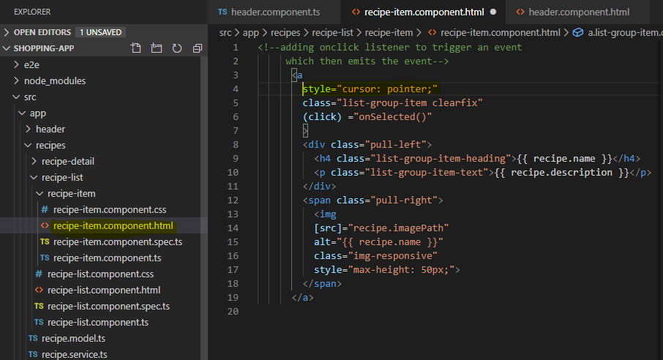

We need to do the same with recipe-edit and manage dropdown in the header

4 – adding the child routing to the recipe component.

Adding recipe start component to handle the empty path with recipe component

Updating the recipe-edit component to handle the changes that we made by incorporating recipe-start component. Updating the recipe service to give us the recipe based on the id. If you want to cast a number to string then add + before like 

Adding recipe-edit component

Code refactoring – The (featureSelected)=“...” event listener is a relic of our "old" navigation approach using ngIf. We no longer need it, so feel free to change this template to:

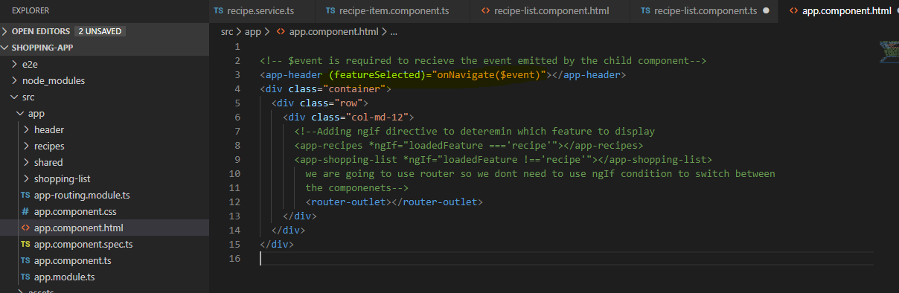

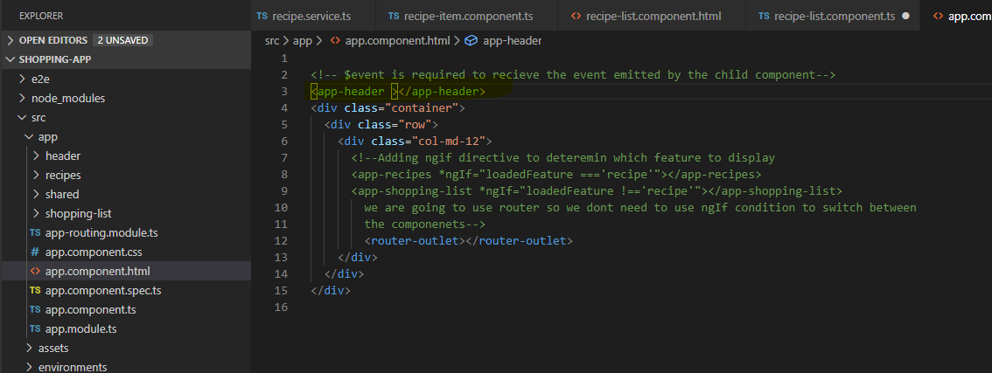

**Observables**

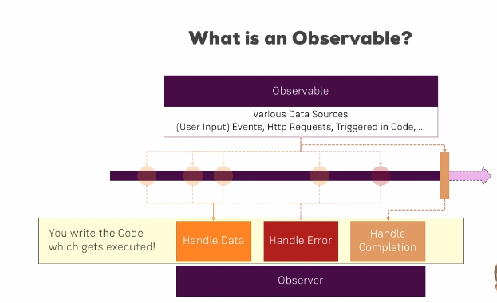

Observables are constructs that you can subscribe which will give you information when data changes.

**Building your own observables**

Observables are not native to the angular or JavaScript they have been imported from rxjs. That’s why we have dependency of rxjs in package.json. they are available in package – rxjs. Observables can be created in many ways, but easiest way is by using interval method provided by rxjs. Interval takes one parameter i.e. time period. During that time frame interval emits an event which is basically an observable on which we can use subscribe method.

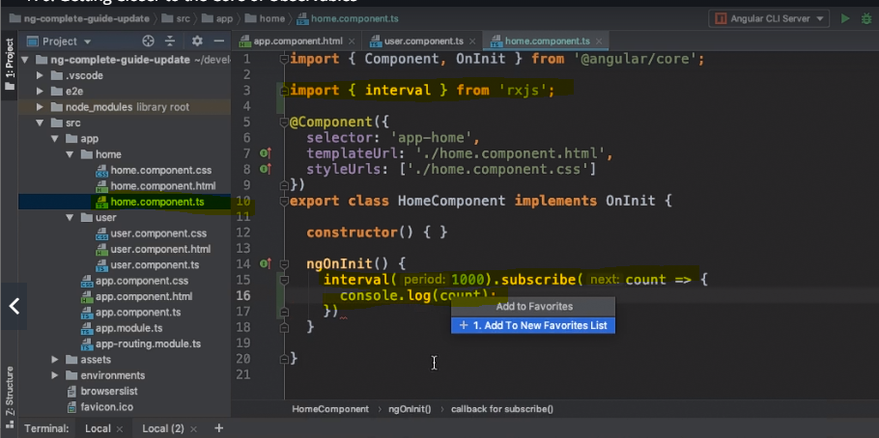

Now it’s very important to unsubscribe the observables because they will keep running in the background and introduce memory leak. Do unsubscribe manually unless that observable is provided by angular in which case it gets automatically destroyed.

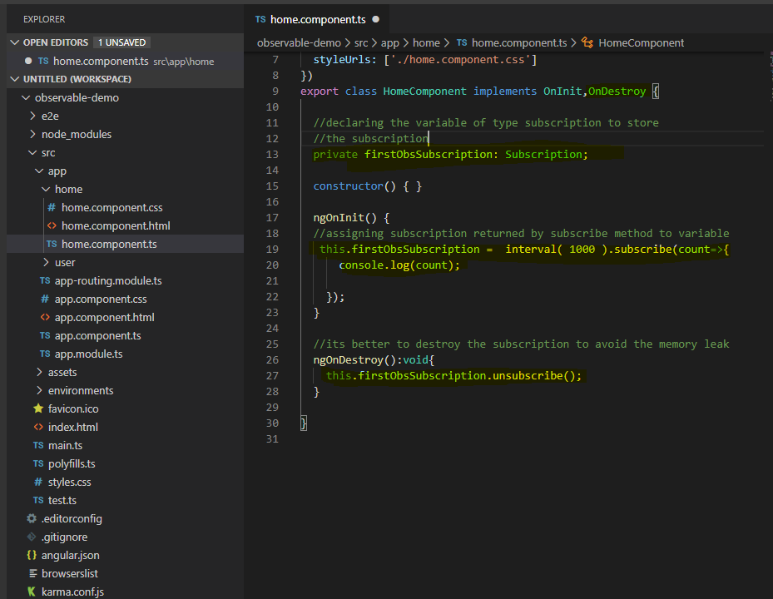

Here params is an observer provided by angular hence you do not need to worry about unsubscribing it.

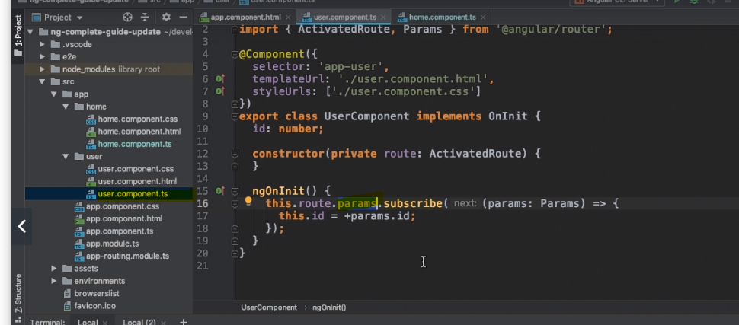

Building custom observable. You need to import observable. Observable has created method. We do not need to tell observer to listen because its already listening. we need to tell observer what to do with the after listening i.e. we need to write out business logic in it. Observer has next method which can be used to give the next value.

Here observer is a listener and has all the change data.

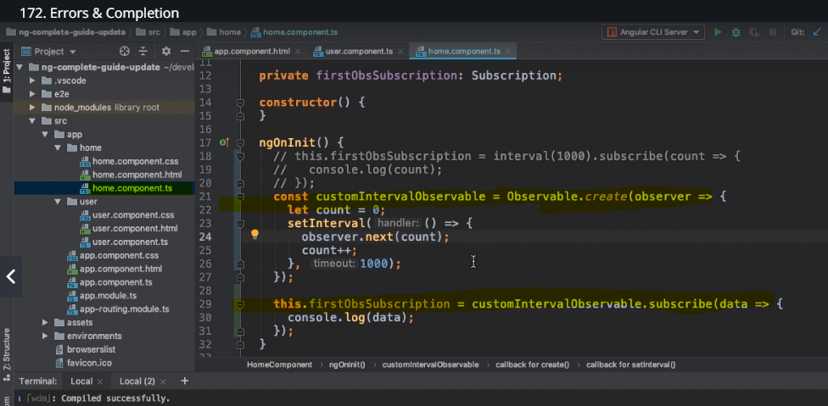

**Error handling with observables.**

Observer has error method which is used to throw an error. When observable throws an error, they die or stop working. You are not limited to use only one argument i.e. data ( in this case ) but you can pass error as an argument which you can use to either show the error message as it is or can show the custom error message.

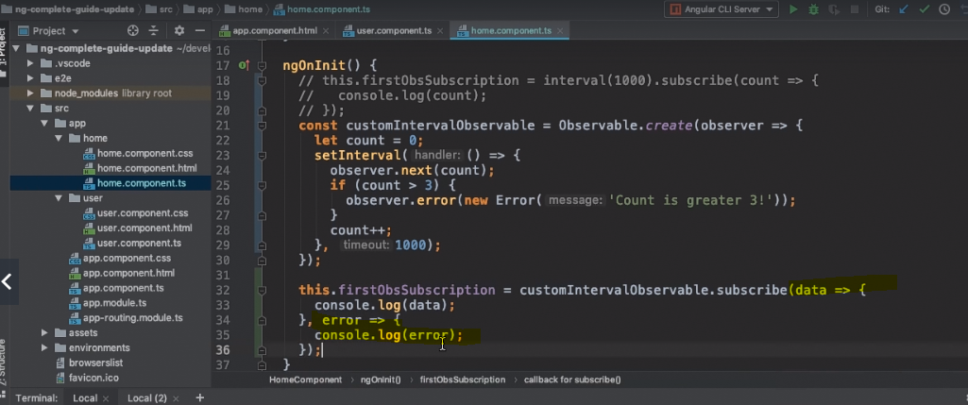

Observer has a complete method which completely stops the observer and it wont able to emit anything thereafter.

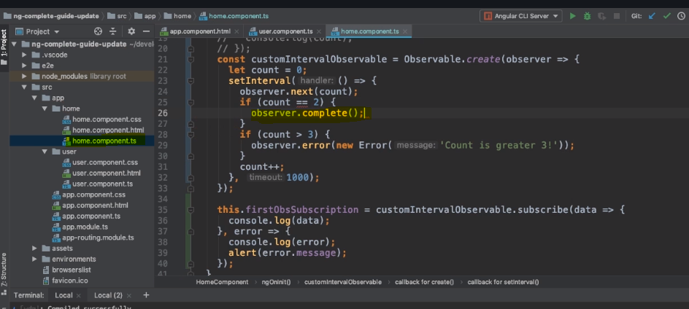

If you want you can implement the complete in subscriber method which takes no argument. There is one exception though if observer caught an error then observer abruptly terminates and in that case completion wont work and if you have complete () method in the subscriber then it wont get executed.

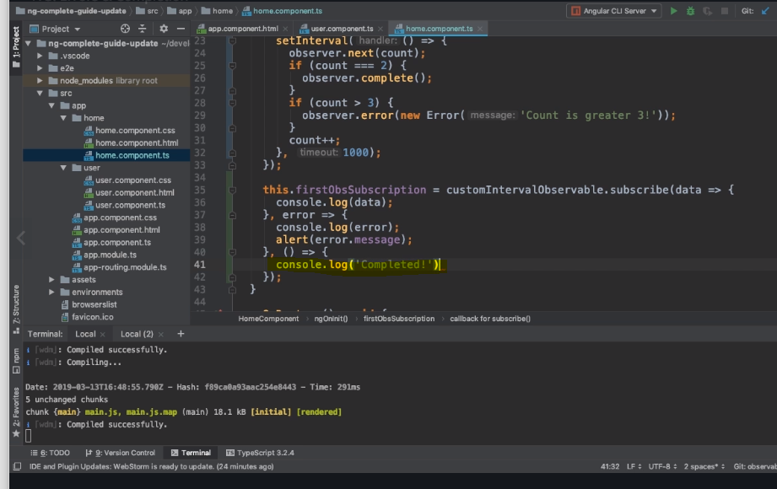

Operator is a part of rxjs library and must to know thing. Operator basically process the data and then send it to subscription so that it won’t get the raw data. Besides that, operator comes with many build with functions that we can use directly.

**Best site – academind.com**

**Operators**

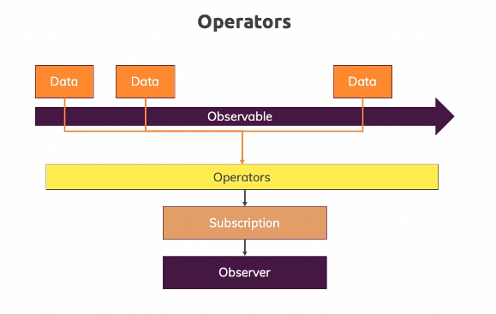

You can import operators from rxjs/operators

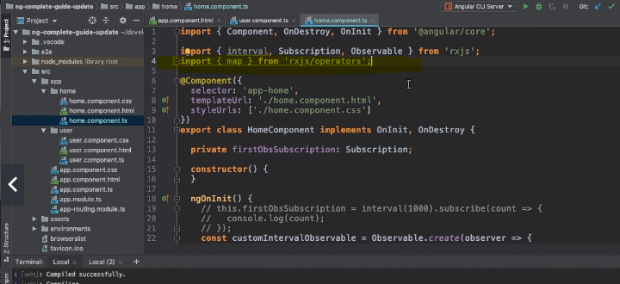

E.g. map operator. See the following example where we implement pipe before subscription.

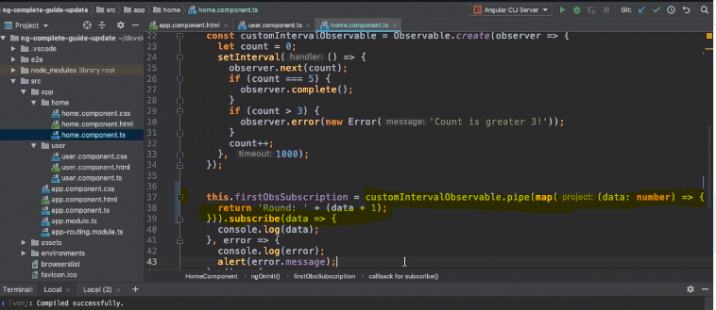

**Subject –**

you can import it from rxjs. Subject is special type of observable. You can call next on subject from outside which you cant do with observable as you have to use next from the inside.

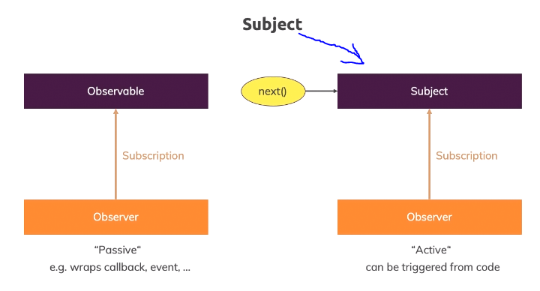

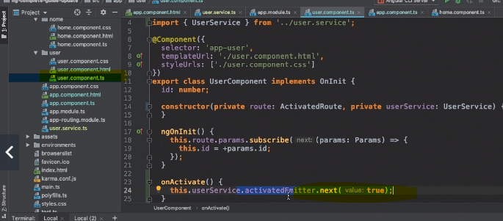

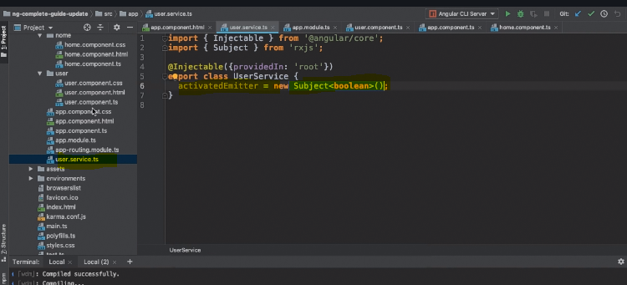

You can now subscribe to the eventemitter from any other component. You must unsubscribe them after using them**.**

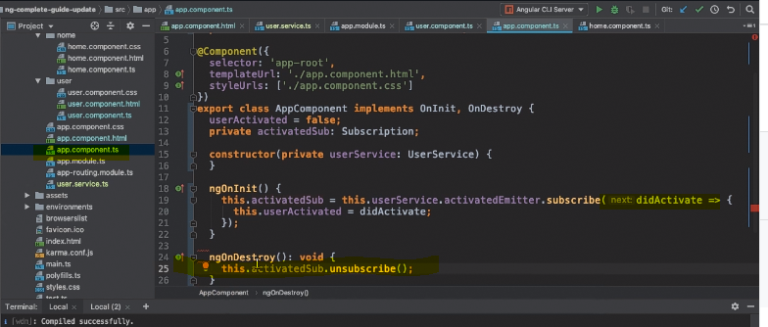

**Project – observable implementation**

Replacing all eventemitters with subject. Implement subject in shopping list service and corresponding componenet.ts file. It’s a good practice to assign a subject to a variable so that it can be manage easily. Refactor the recipe.component.ts to remove the subscribe since we have no use case in that module.

**FORMS**

Angular is a single page application hence you will not send the form data directly to the server hence you need to handle that through angular. Angular gives you JavaScript object notation which allows us to work with data submitted through form.

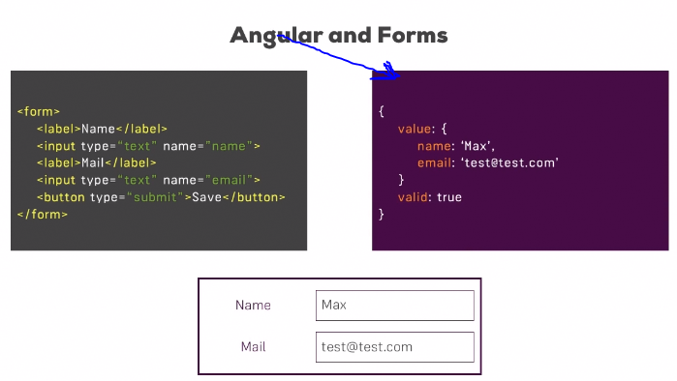

Angular provides two approaches to process the form

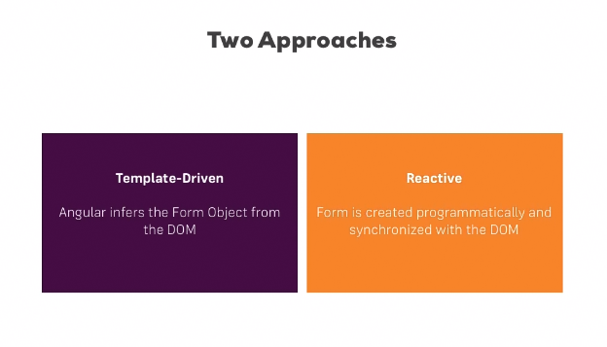

Template driven means HTML form - easy

Reactive means form made with typescript and then programmatically controlling all the pieces of it.

**Template driven approach**

You should not put any action item on the form tag because you want angular to handle the form submission.

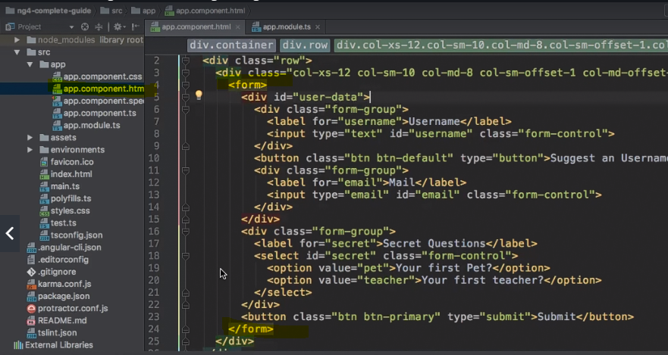

How angular creates a JS object in template driven approach. For that you need to import forms module in app.module.ts.

The form tag tells angular that it’s a form and angular creates a js object by reading that tag with the help of formsmodul in the app.module.ts file. There is one caveat though, angular doesn’t know about all the control elements in your form such as inputs etc. so as a developer its your responsibility to tell angular how your form should look like.

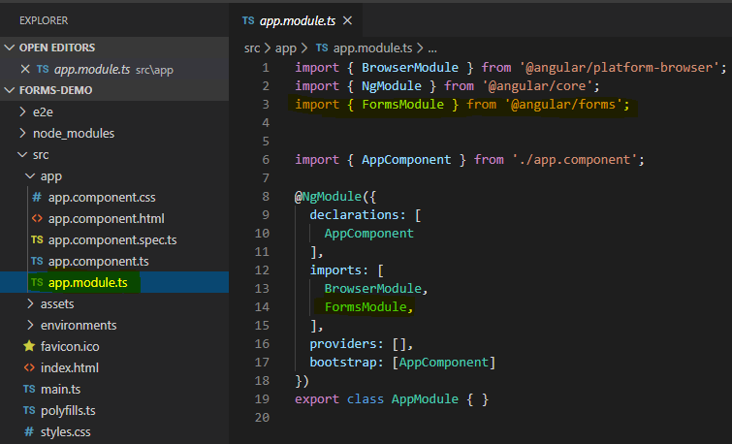

You can tell angular by using ngmodel and name so that angular can register that element and create a js object with it.

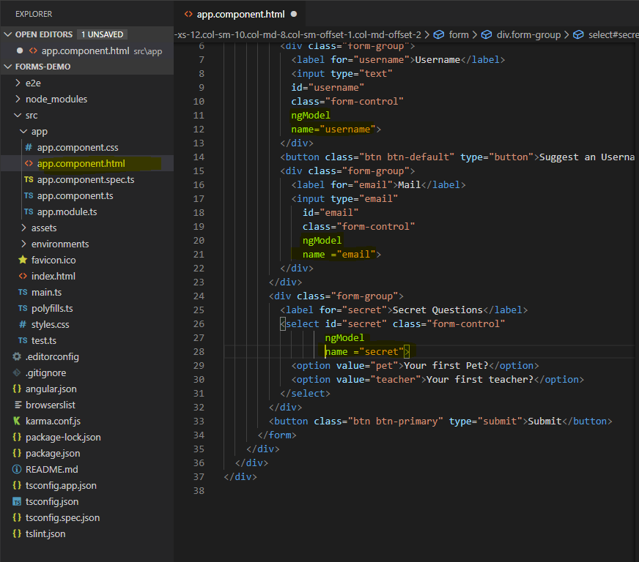

**Submitting form and getting elements of the form.**

If you have a button in the form, then it’s a not a good place to place submit () call as its in html it will trigger an js submit event along with sending the request. With angular you can do that in a following way.

As shown below you can use ngSubmit on form tag to get the data which allows the target method to get trigger and perform the required operation.

ngForm tag helps you to get the control of form. #f holds as a reference for the form which you can pass to the method handling that form.

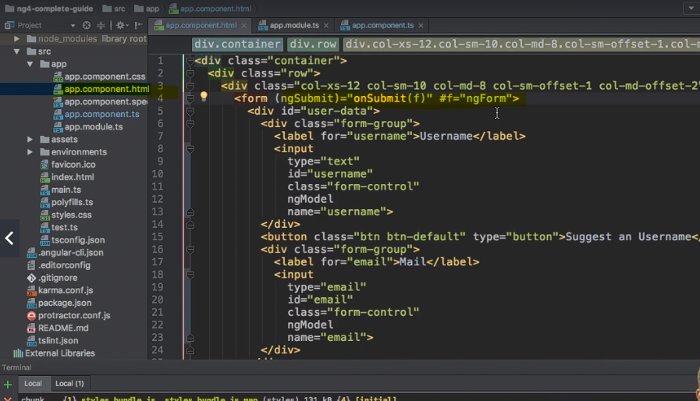

You have to import ngform tag in the app.component.ts too and pass it as an argument to the method now this will give you the json object of that form that you needed. Most of the time you will get the required data from value object of that json object.

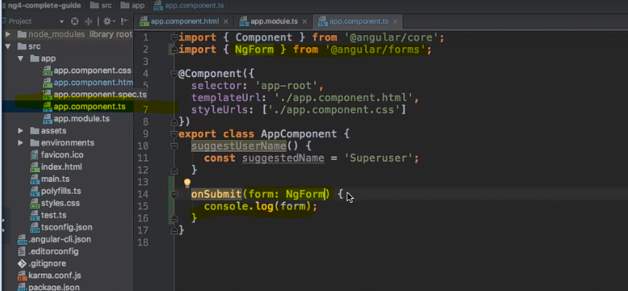

The other approach is using @ViewChild – no changes in html form that we have used so far. Signupform( is a placeholder name ): NgForm . this way is useful if you want to get the form data before submitting…otherwise it works the similarly as before.

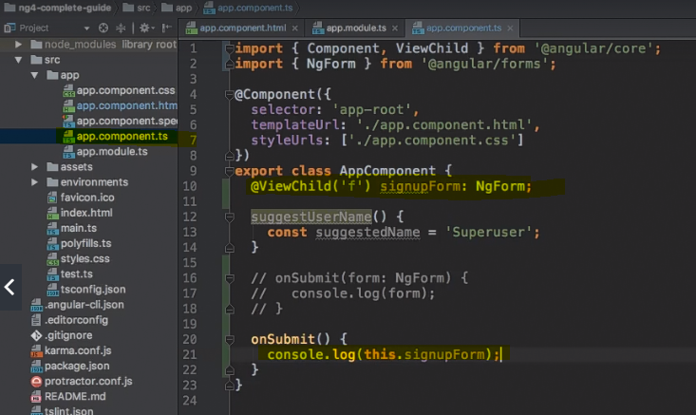

Adding validation to input field – by using html directives on the fields. Angular fires the inbuild validator with them to perform validation. since you are using template driven approach only you can use it in the html template only.

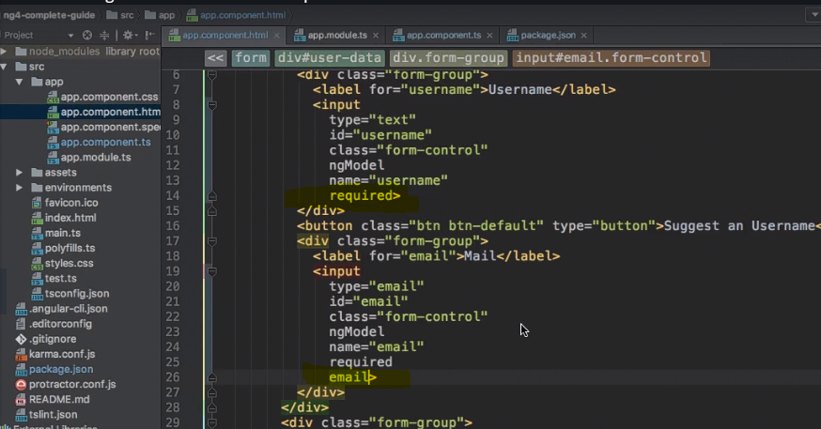

If you put wrong email then you will see the following in the console.

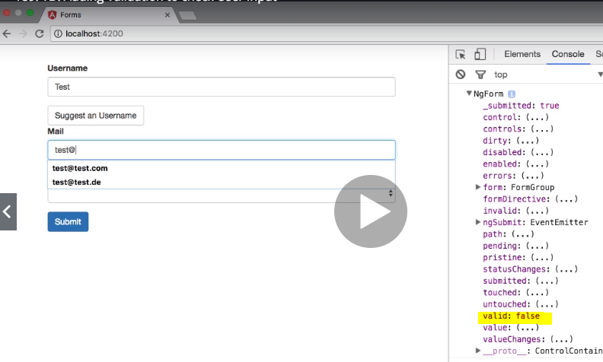

**Which Validators ships with Angular?**

Check out the Validators class: https://angular.io/api/forms/Validators - these are all built-in validators, though that are the methods which get executed (and which you later can add when using the reactive approach).Using the form state – you can use the form state to control the functionality of the form

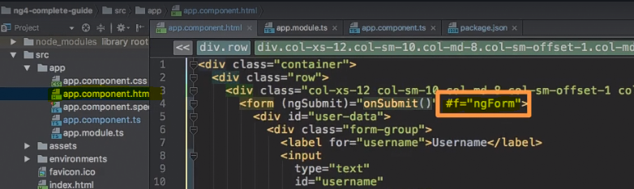

Disable the button if form is not valid

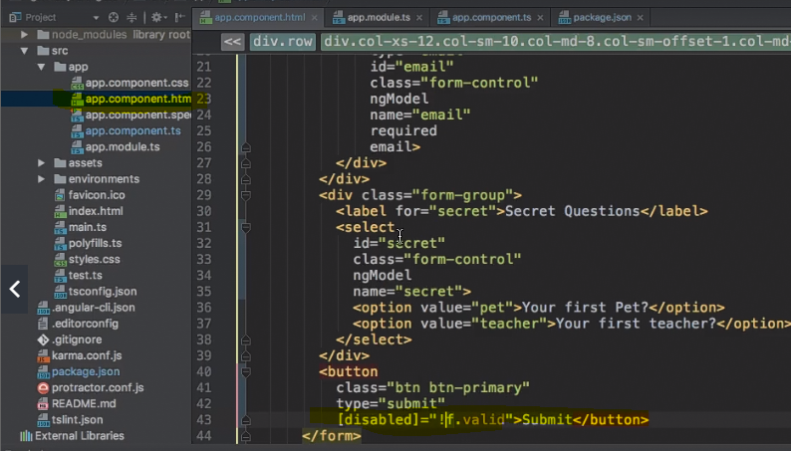

Angular adds bunch of classes on the form elements, which you can use to change the style properties of that element. But its not a recommended way as all the styles will get applied to all elements of the form. So you have to be specific

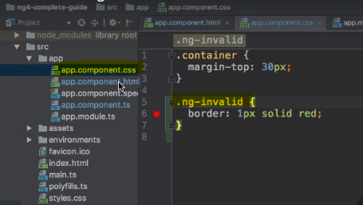

Specific

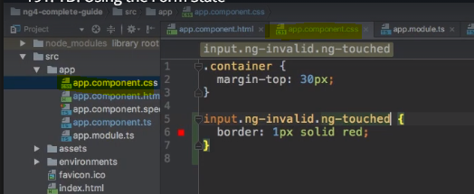

**Setting error message if the input data is wrong**

Displaying error message by using the state of the form. Attached the directive to the field and then validate it. You can add ng- touched to it to check if the user has touched the field or not.

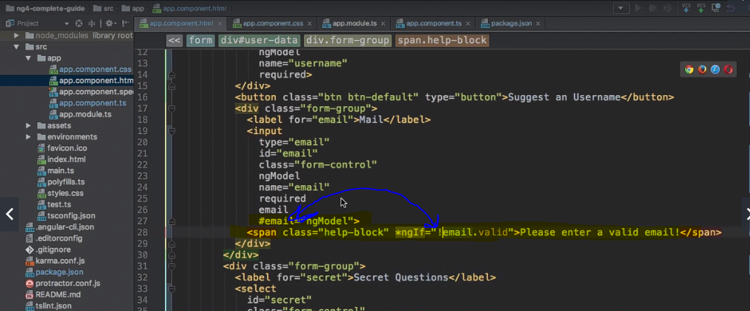

Setting default values on the form fields using [ngmodel]. Here the question in the form has two value to set the default value you can use ngmodel

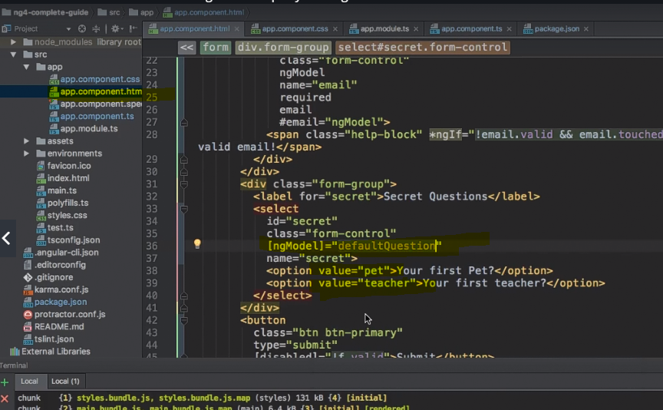

in the app.component we can define the property which we then assign to the ngmodel.

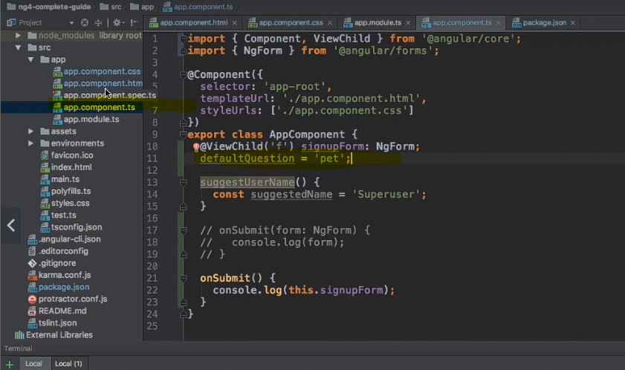

Using two-way binding on forms.this approach is very useful when you need to access the data dynamically i.e. for validation.

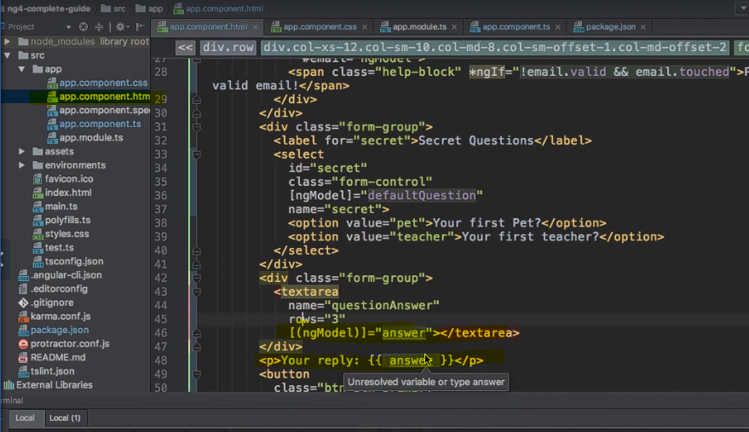

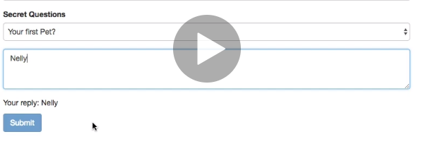

You need a property in component too

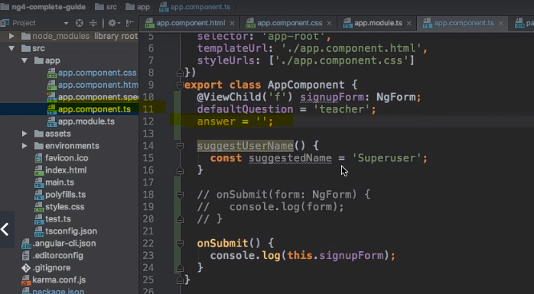

You can use one-way binding to set the default value while two-way binding use to get and process the data.

**Radio button – easy twostep process**

Step 1 – add property in component

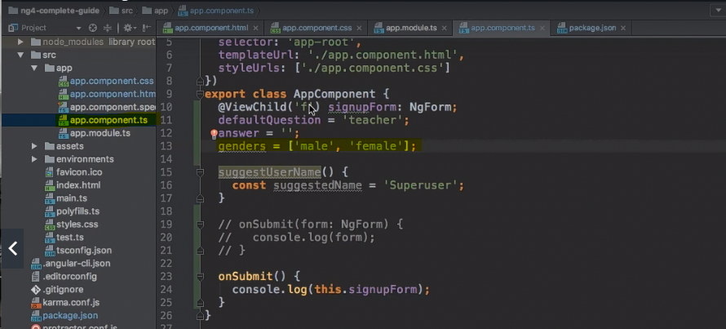

Step – 2 add template in HTML to display the radio buttons

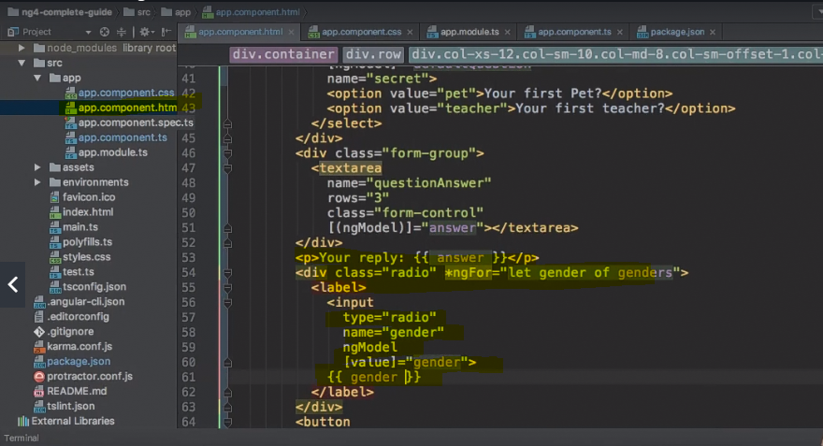

Accessing form data – here we created a form data array as a property which holds the values of form input field.

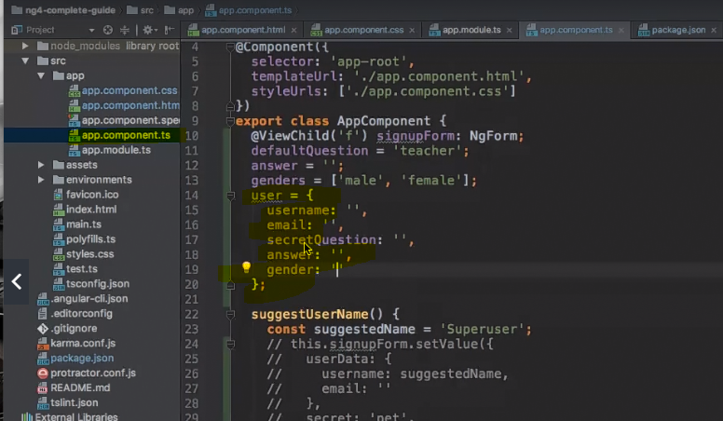

Now on submit you set the values of the array field. Here patchvalue is use to update certain fields of the form where as setvalue method can be used to set values for all the fields. It will override the default values if you have them in place.

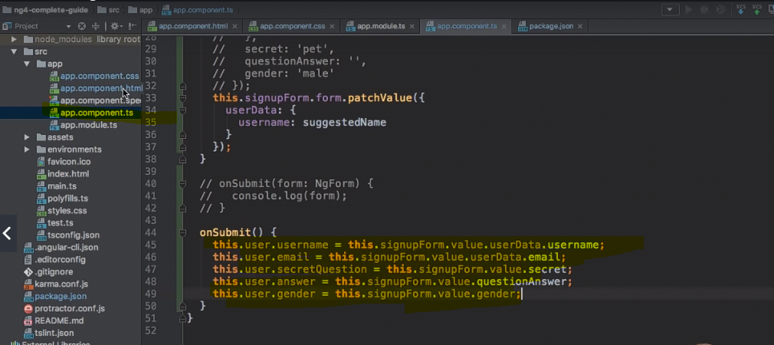

Now using data binding, we can display/use the data on the form

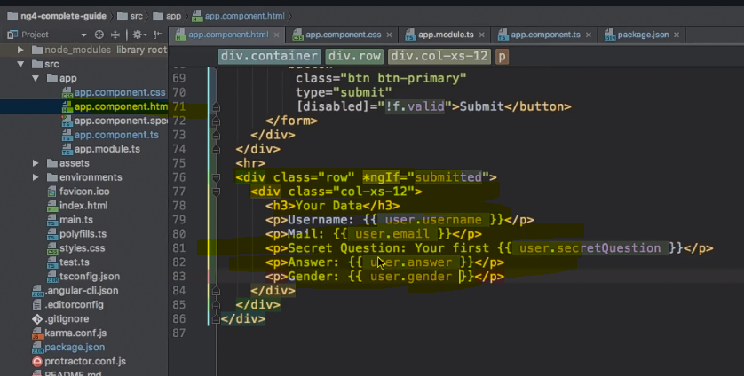

Resetting the form to clear all the field of the form.Just use reset()

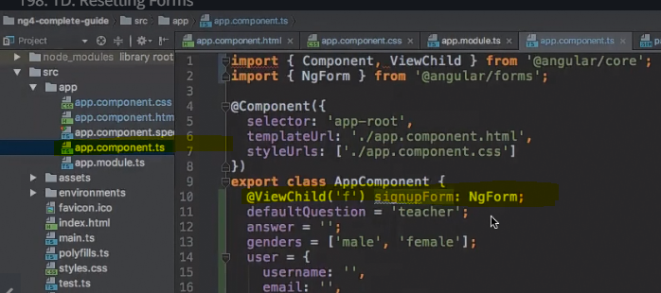

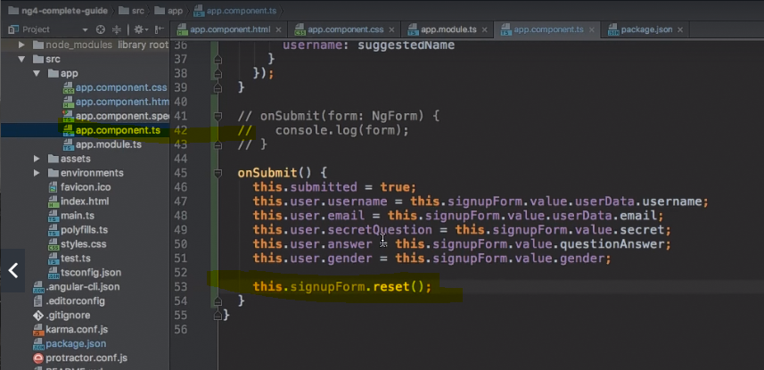

Reactive Approach of handling form. To get the reactive approach working you must have to import ReactiveFormsModule in app.module.

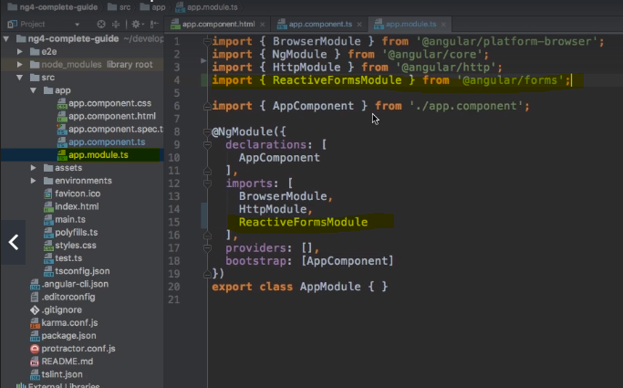

Here signupForm is a property which will hold our form because at the end form is just a group of controls.

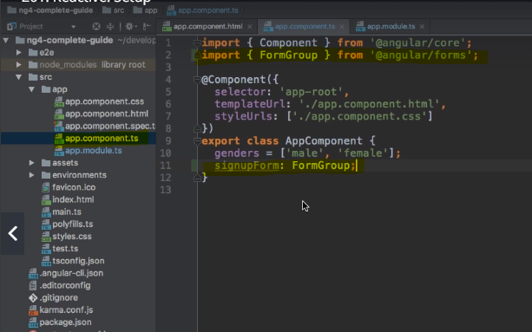

**How to create a form?**

You need ngOninIt hook to initialize everything before loading the form. You can use formControl to create a control field. Check the highlighted field which indicates fields that controller can accept as a parameter.

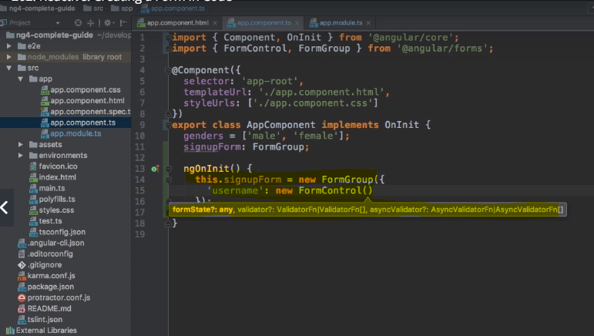

Similarly, you can add all the controller fields.

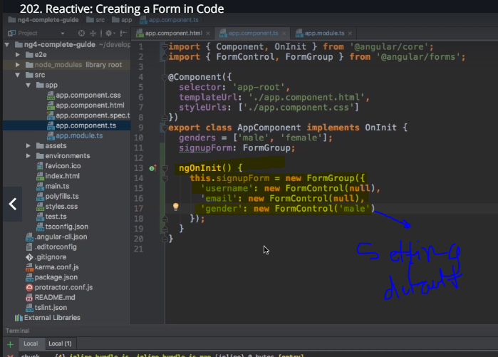

Once we create the controller form fields in the typescript, we can connect it to the html form created. And we can do that by using directive formGroup ( this will tell angular to override the default form provided by it ),formControlName ( it will connect the formcontroller created in ts file to the html form controller )

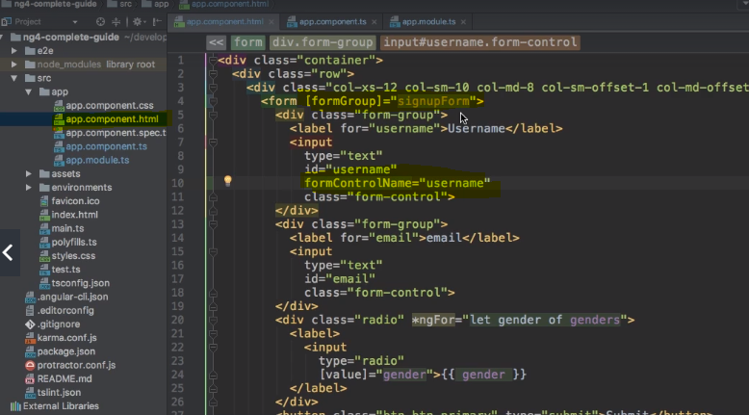

Now if you check the developer console then you will see all the form controllers are in sync with the html form by seeing that all the default style classes has been implemented to the controllers.

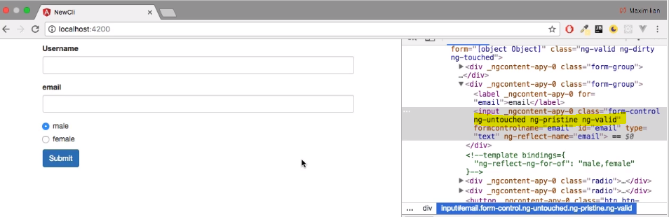

**Submitting the form**

You need onSubmit directive for that. The difference between template driven and reactive approach is that you don’t need reference to submit the form like template driven approach.

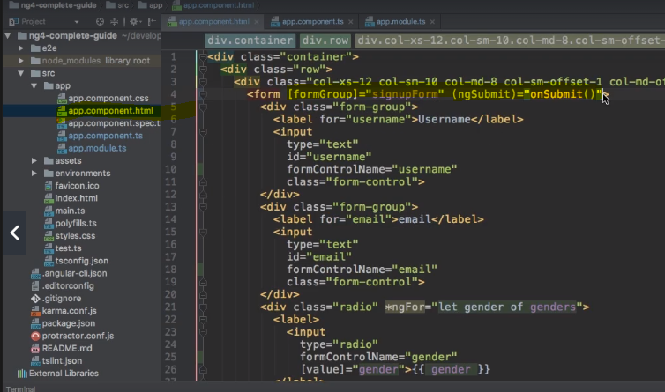

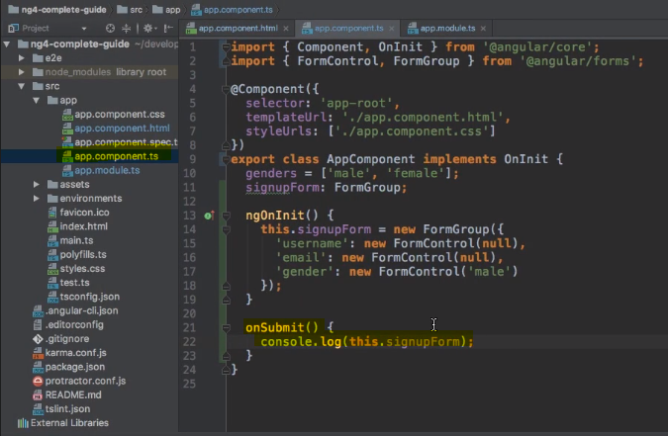

**Adding form validation**

You can pass the validators in the controllers that you created in the ts file. You can pass either one or array of validators

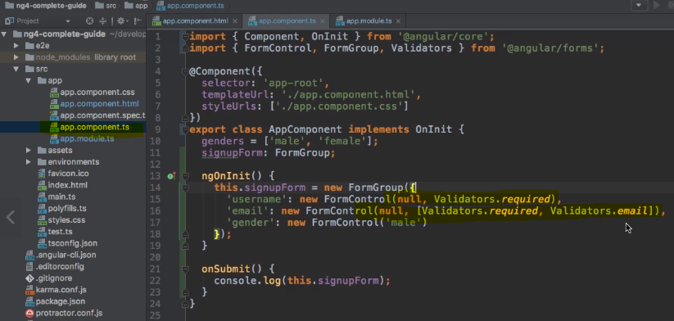

How to get access to controls to display default message

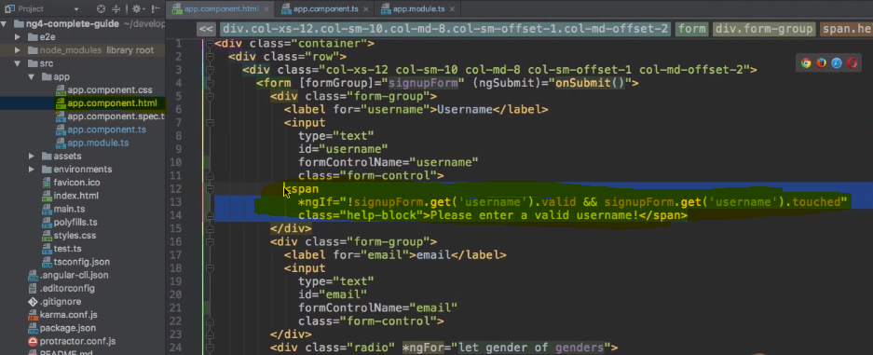

**Grouping controls**

you can use formGroup at the form level as well as a controller level. At controller level it maintains parent child relationship.

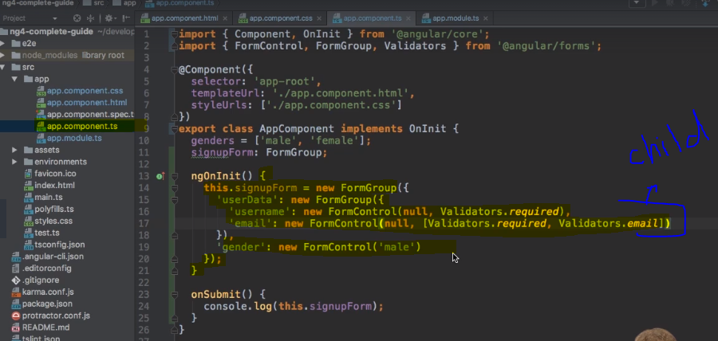

As you did above you need to put all the controllers In separate div tag where you can implement the formgroup tag. Inside it if you want to access any controller then you have to follow the parent.child format eg – userdata.username

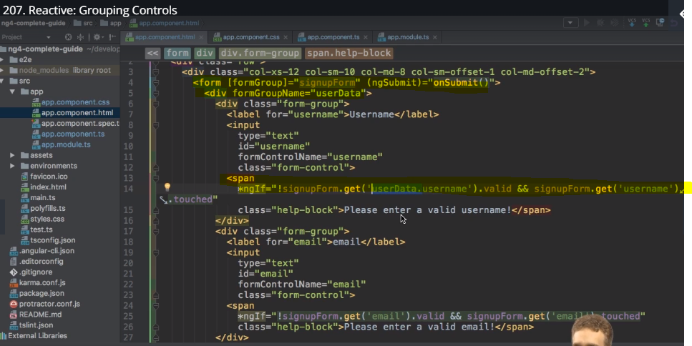

Arryas of form controller. It basically allows user to add formController dynamically for which we can use. **FormArray().**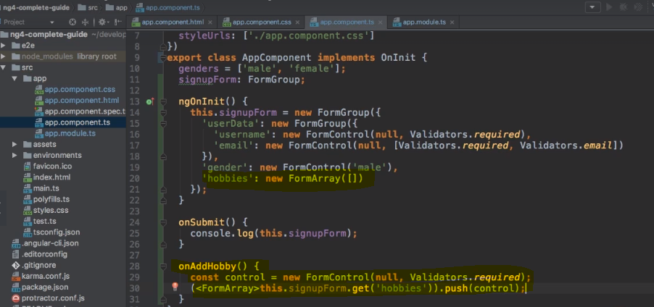

You must have to use the formArrayName to sync the ts code with html also you need to user formControlName to sync newly created controller for hobbies with the exiting formControl.

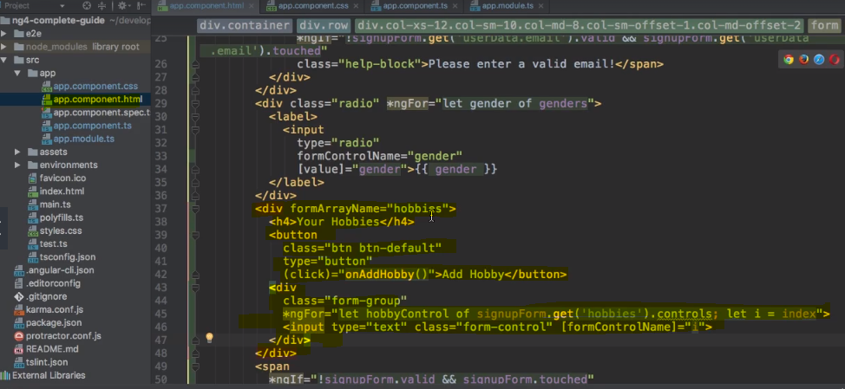

Creating custom validator. You don’t need to build one unless its absolutely required as most of the cases are coved by default validators provided by angular. If you are using the custom validator then you must pass ‘null’ if validation is passed. Check -> bind() error handling.

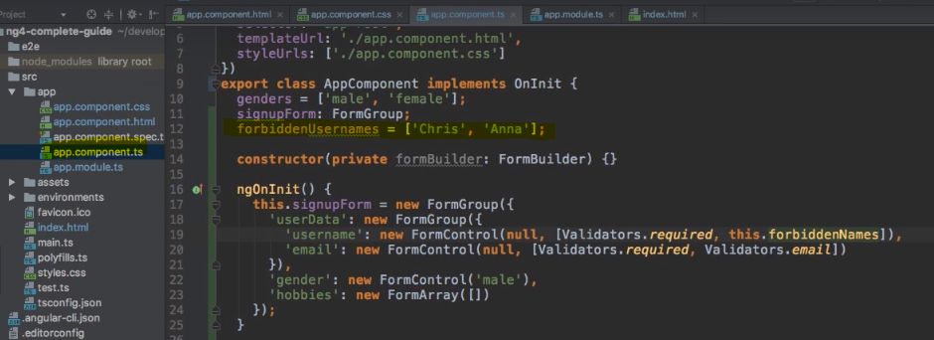

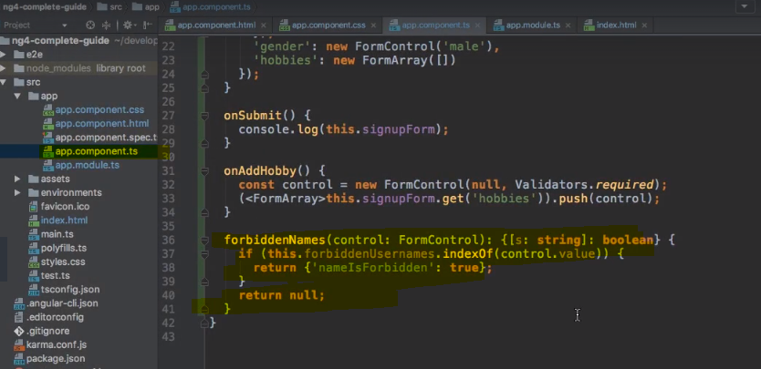

Using error codes – we get field by default with each element i.e error.nameIsForbidden which we can use to set the error code

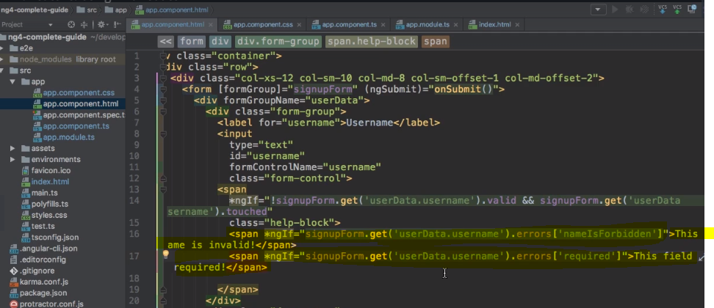

There is an also a version of async validator. We need them if we are performing the validation on the server side.

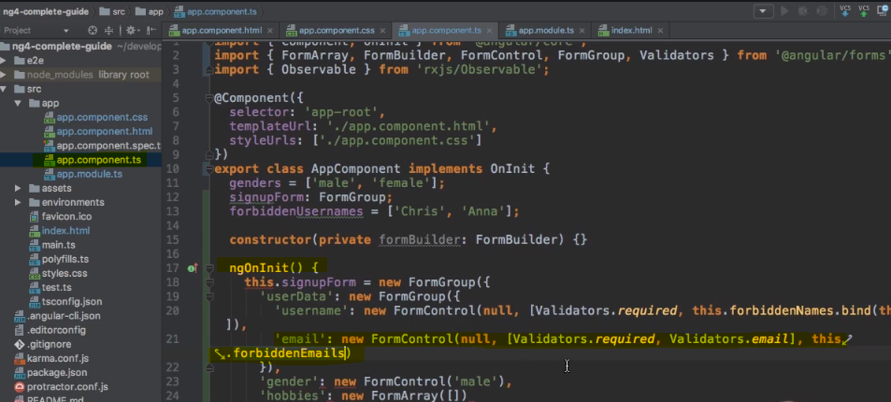

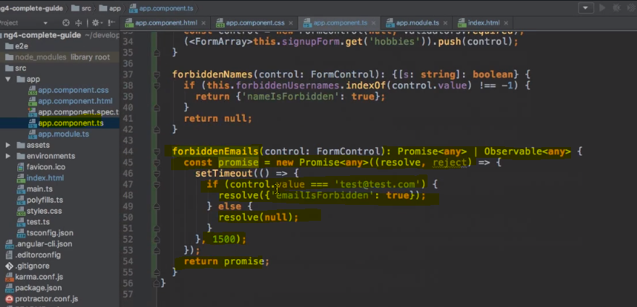

**Reacting to status or value changes**

You can process the status and value changes by using the formcontroller as following

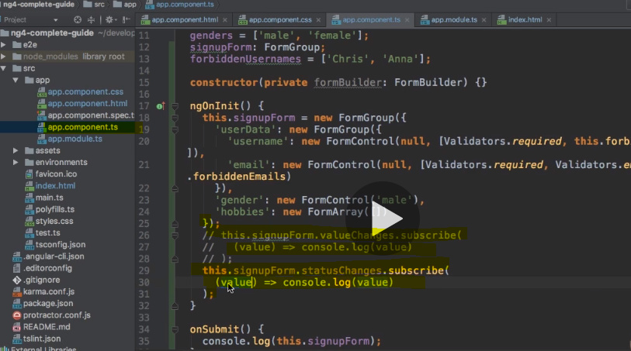

**Setting and patching values**

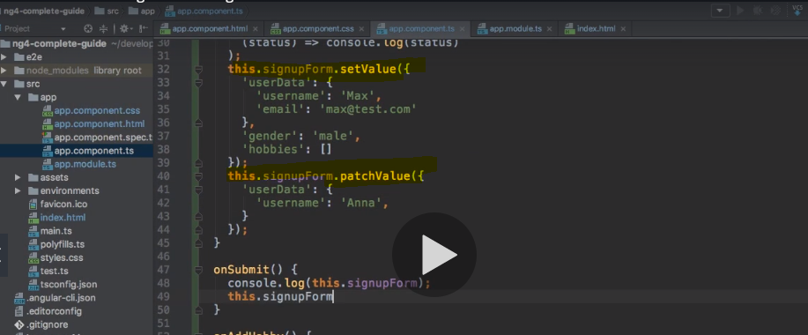

You need to add a parameter to the controller where you want to add it.

Project – forms

Shopping list – template driven approach with shopping list component

Refactoring the code

Making button works – delete and clear

#eg-name – indicates the local reference i.e pay attention to the # sign

ngModel in the form register it as a controller in the angular

2 – implementing basic validation with patterns

If you want to apply regex for validation, then you can do it by using patterns

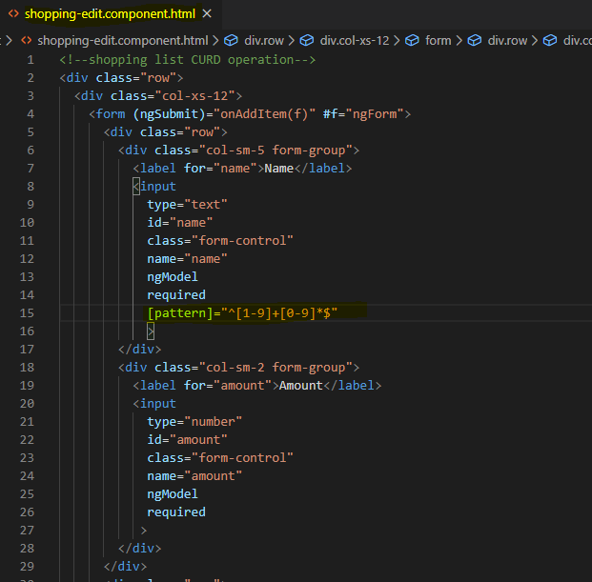

3 – make shopping list selectable . Add subject to shopping-list service to get the single item. Consume subject through subscription from shopping list edit component

4 – adding method to get ingredient in the shopping-list service. You can use viewchild to access the html form written for another component from one component

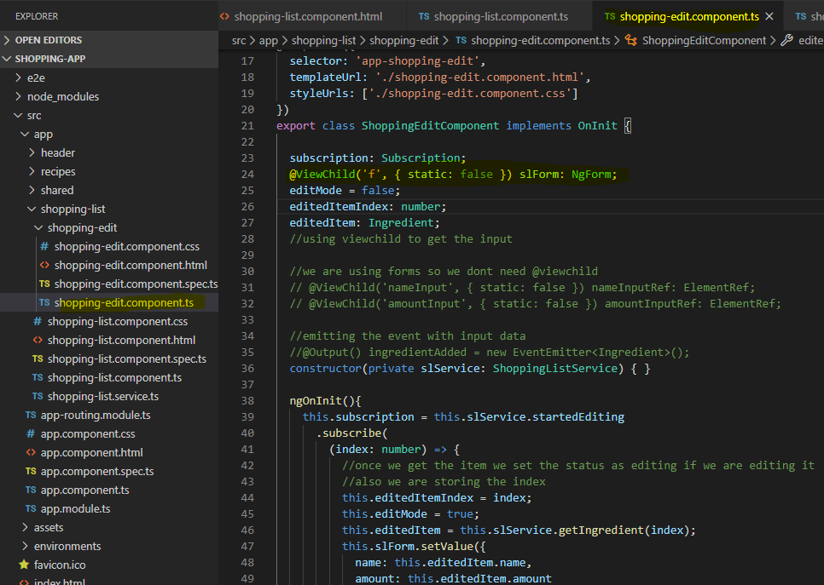

5 – changing the button ‘Add’ based on the status of the application. Adding ternary operator to decide the status of the button. Adding updateingredient method in shoppinglist service. Adding check in shopping-edit compoenent to check if we are in edit mode or not and perform the operations required.

6 – making add button work properly by setting edit mode to false.

7 – making clear button to work

8 – making delete button work – by adding deleteitem method in the service

Implementing reactive approach – need to add reactiveformmodule in the app.module.ts

9 – adding recipe edit html

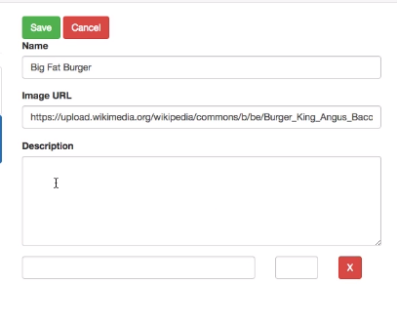

10 – initializing the form in the corresponding ts file. We are using recipe service over here. You must initialize the form through ngoninit otherwise it won’t be available.

11 – connect created form from typescript file to html form

12 – adding ingredient control to form array

13 – adding form validators. If you want to add pattern in typescript file then you don’t need to put the pattern in the ‘ ‘ marks instead you have to do like this

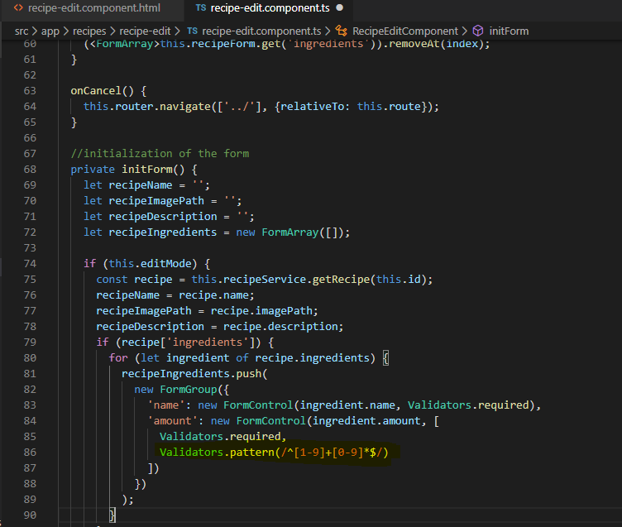

14 – adding custom css property to highlight the fields which are not valid.

15 – adding methods to recipe services to add, update and delete and make them work

16 – managing the navigation of all buttons of the recipe form

17 – bug fixing and making x button work

**PIPES**

They transforms the data from input to output as per your requirement

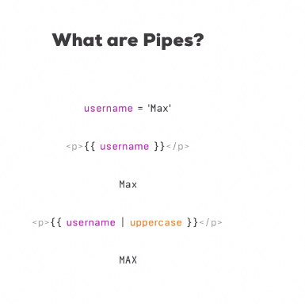

The best place to use pipes is template. Uppercase and date pipe Used in HTML template.

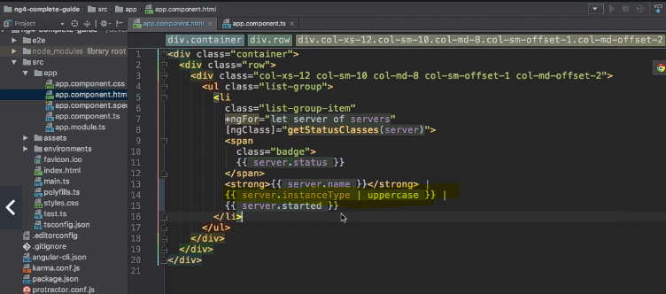

**Date Pipe**

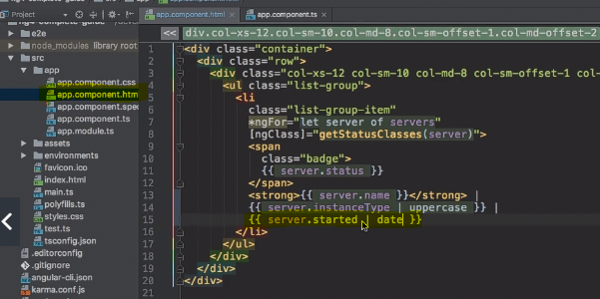

**How to configure pipes**

Parameterize pipe – you can add more parameters by adding ‘:’ . check the example. You can chain the parameters in similar fashion like : pipeName :pipeName etc

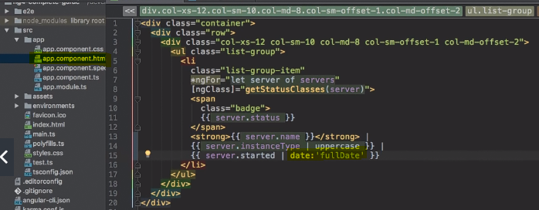

You can take some help from angular documentation to get more information about it.

**Pipe chaining**

Execution order is from left to right

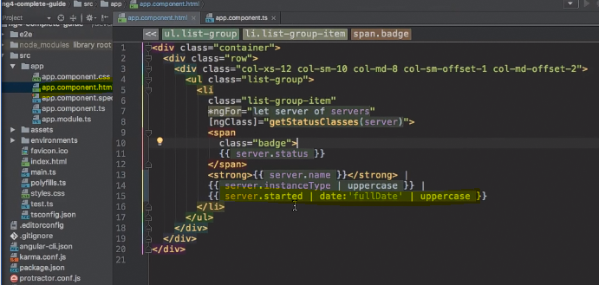

**Creating your own pipe**

Step 1 – create pipe file. You must have to implement the interface pipeTransform and also override the method transform to create pipe.Once you done with that you must need to add. You must need to add @pipe decorator on top of the class to mark it as a pipe.

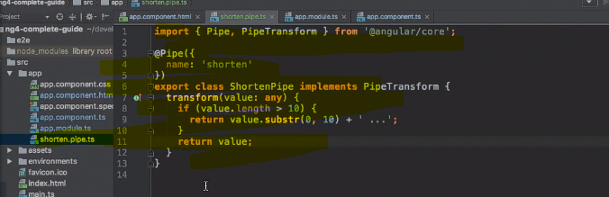

Add pipe references in app component and

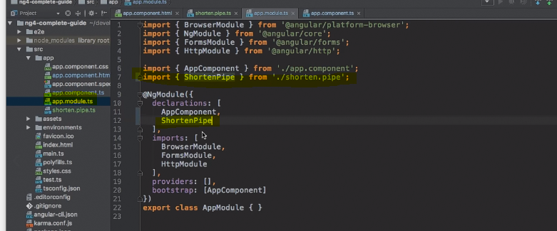

custom pipe with parameterization

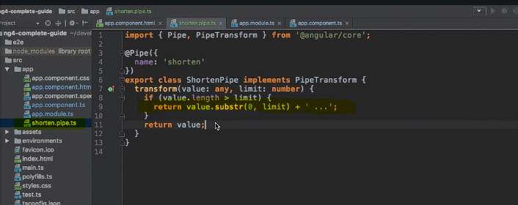

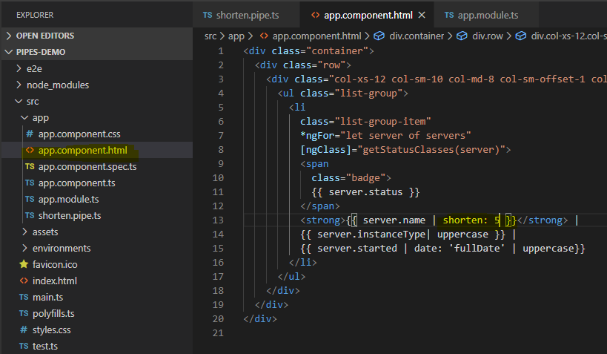

You can create a pipe/filter with the help of CLI -ng g p filter

**Pure and impure pipe – google**

**Async pipe**

this will basically communicate with promises and observer asynchronously.

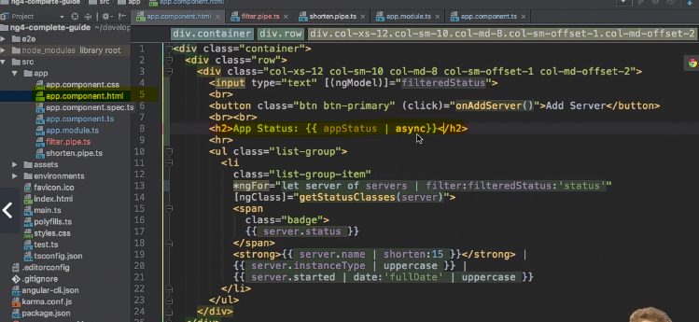

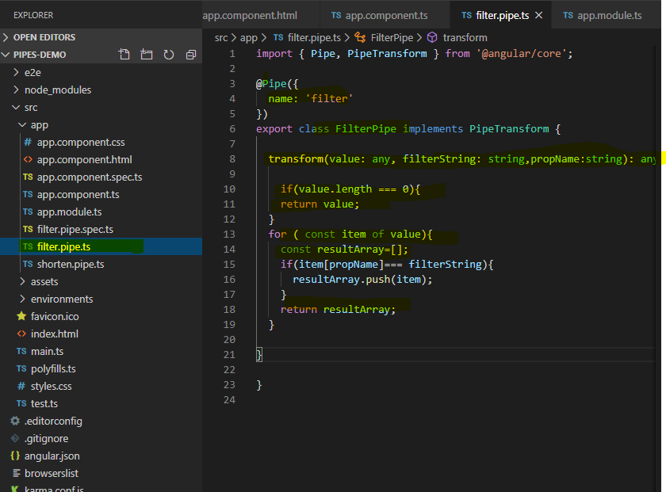

Setting filter in action

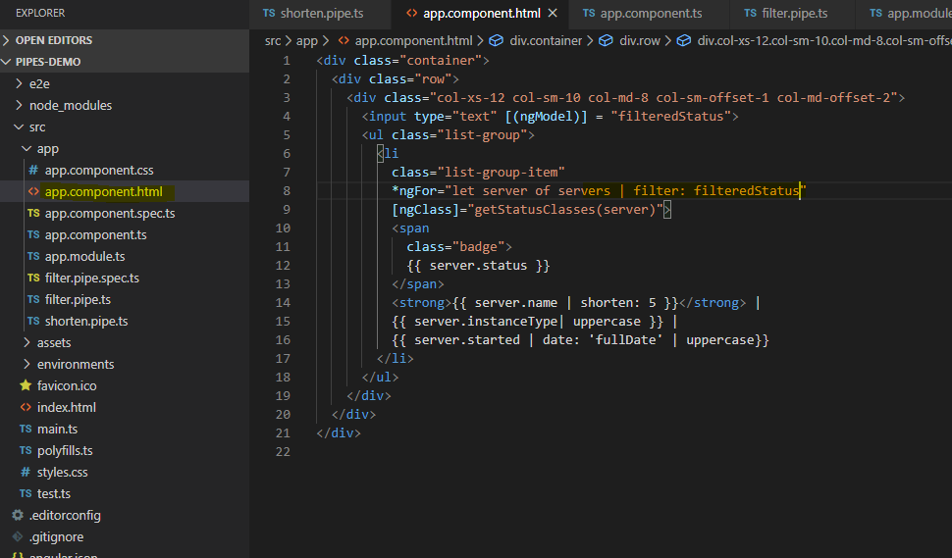

**Pipe sync**

If you use promise in your application, then angular won’t recognize it or we should say that it wont resolve it as a object.

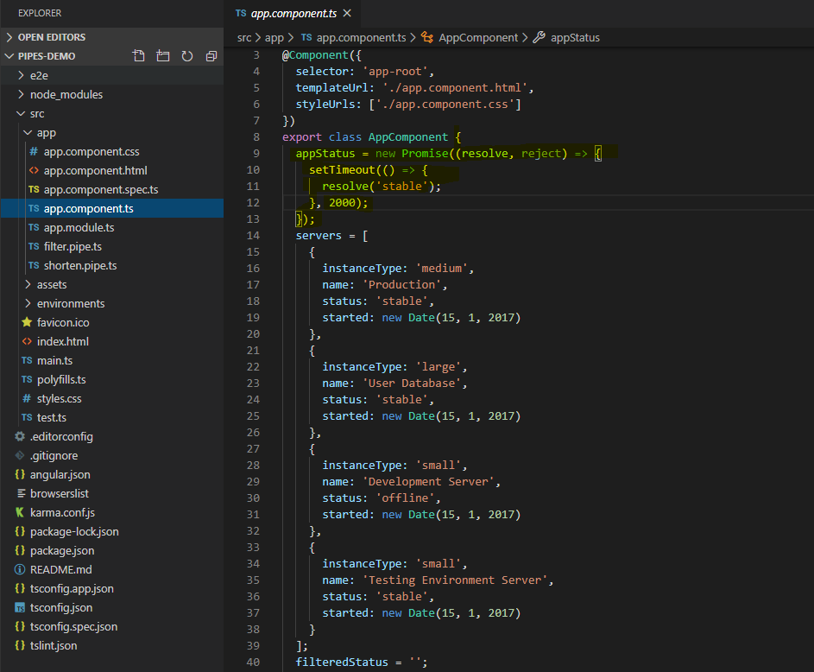

So, in this case we need to use sync pipe which will process the promise in the right way. It will recognize the promise and then resolve it after completing the operation.

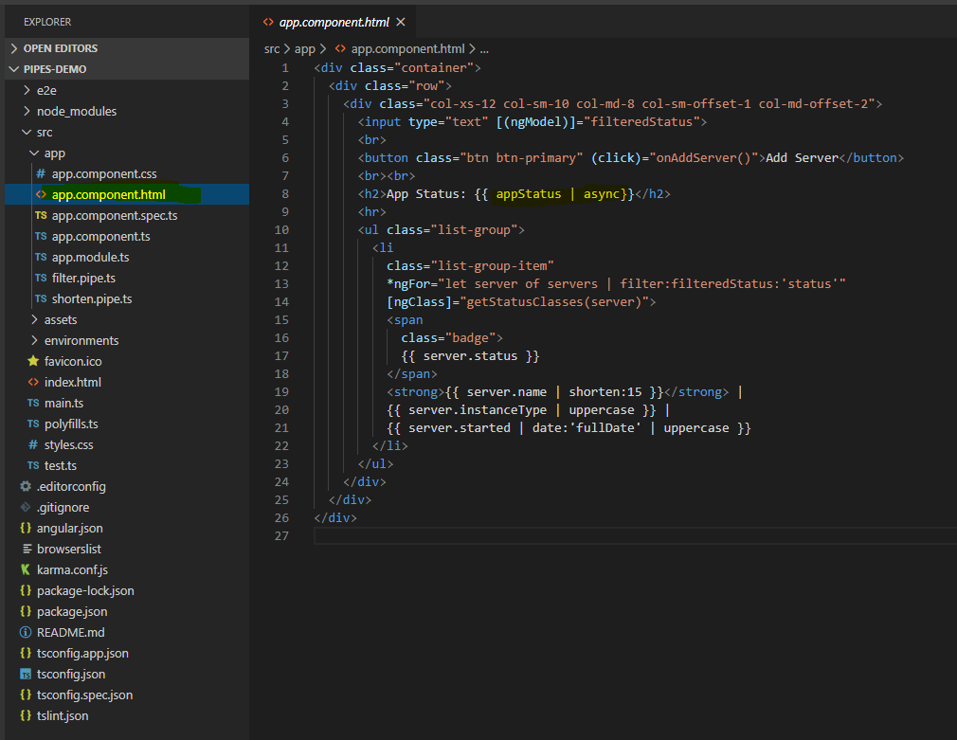

**Http**

Making http requests with angular i.e. HTTP and backend interaction. You should never connect angular to db directly i.e by storing all the credentials in the configuration file directly as its highly insecure. You angular is a front-end application and if you store all the db credentials then user may find it out. Hence, we send all the request to server.

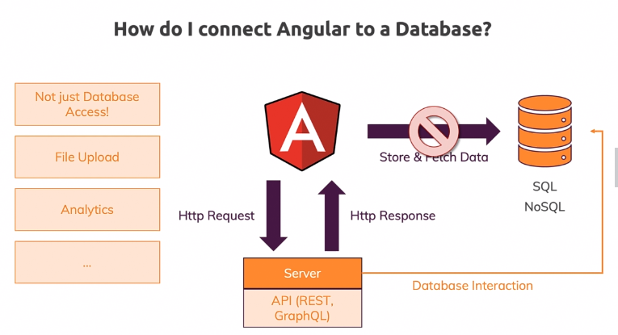

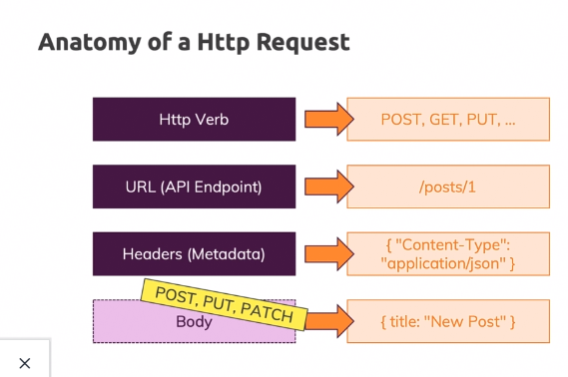

You should not mix server-side coding with angular. For server side you can use node.

For the learning perspective we can use firebase -<https://firebase.google.com/> .

You need to have a google account to use firebase. Simply add a new project and accept all the default settings. Get the project ready. Once your project is ready. Use real-time database with firebase to get more detail information and other details. Start your db in test mode.

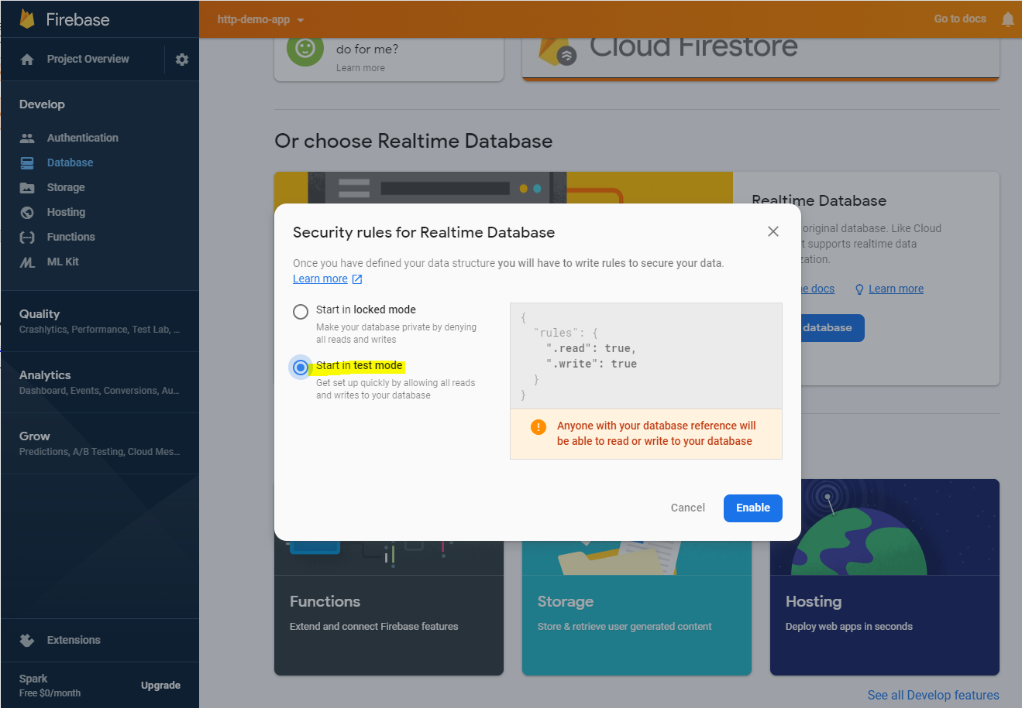

Once you done with that you will get the url which you can use as your api end point. Don’t turn on the authentication as of now as we will implement it later on.

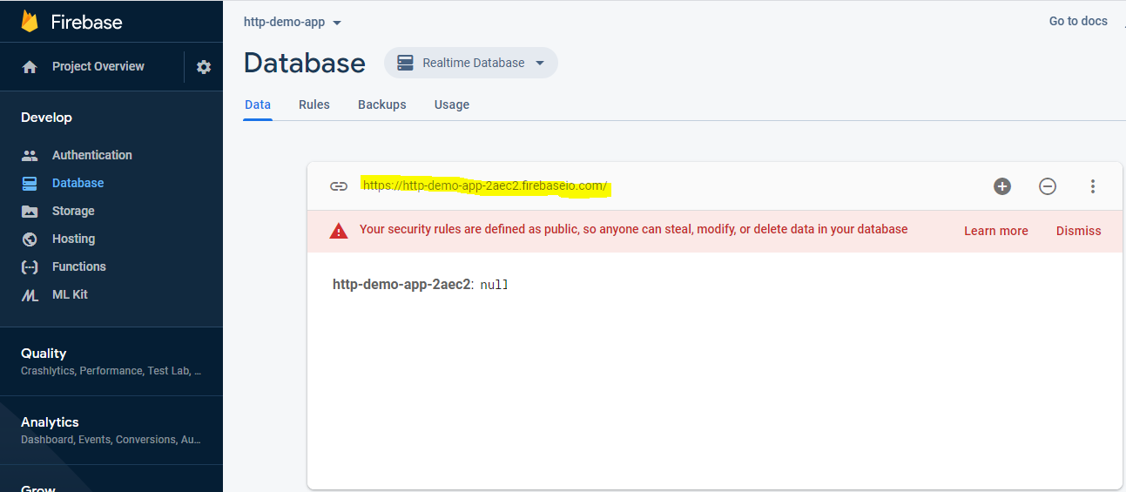

You must import the httpclient In app.module.ts that angular provides so that it can be available to the whole project.

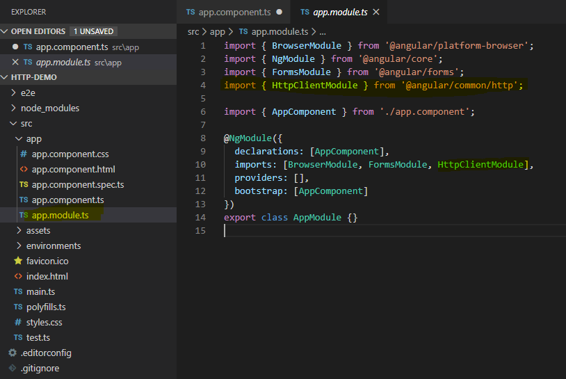

You need to implement httpClient in the constructor of the component that you want to use it in.

If you are using firebase then check the url extensions eg. /posts.json this will create a structure in the firebase. In real life after ‘url /’ you need to provide url end points which will change based on the db structure.

Keep this in mind that http is an observer and similarly post will give you observer. If you don’t subscribe to the observer provided by post, then angular won’t send the request to the database and you wont see any request in the network call.

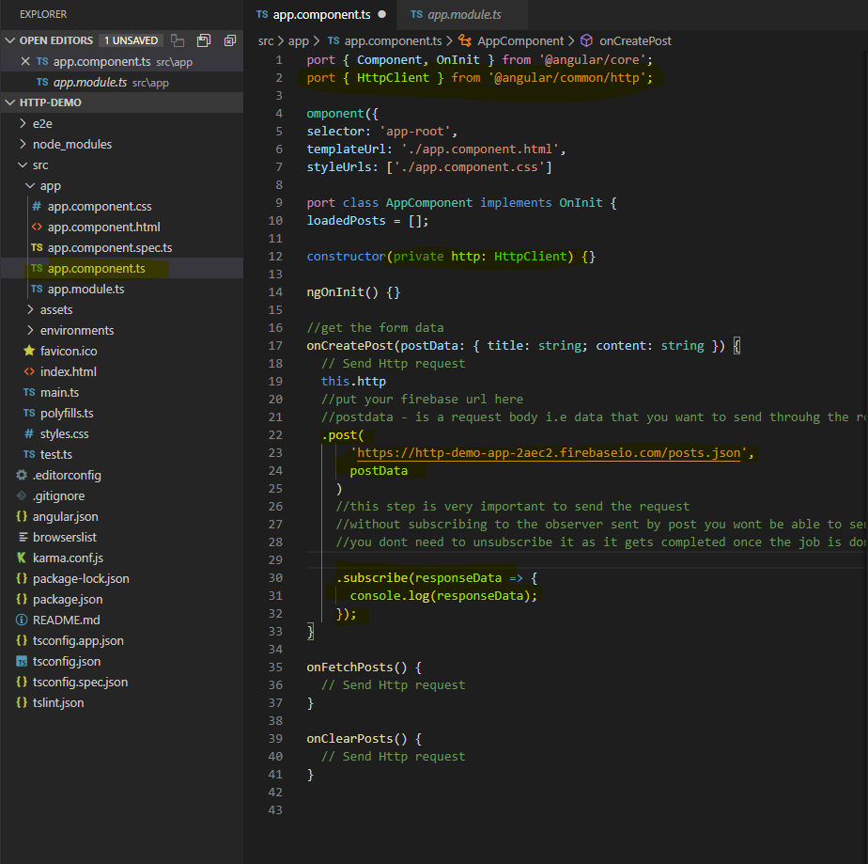

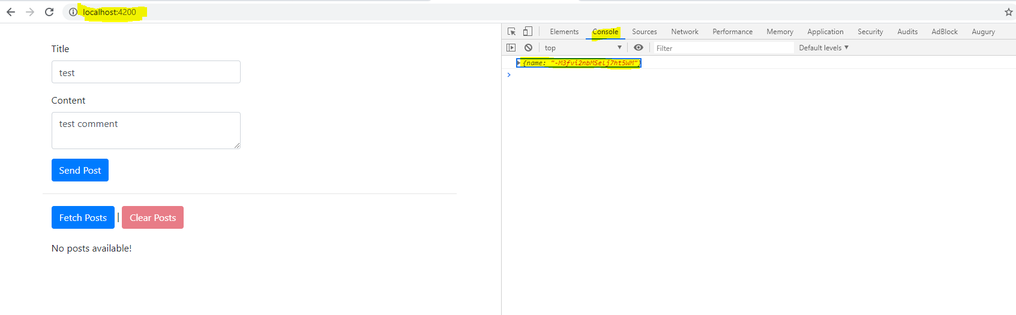

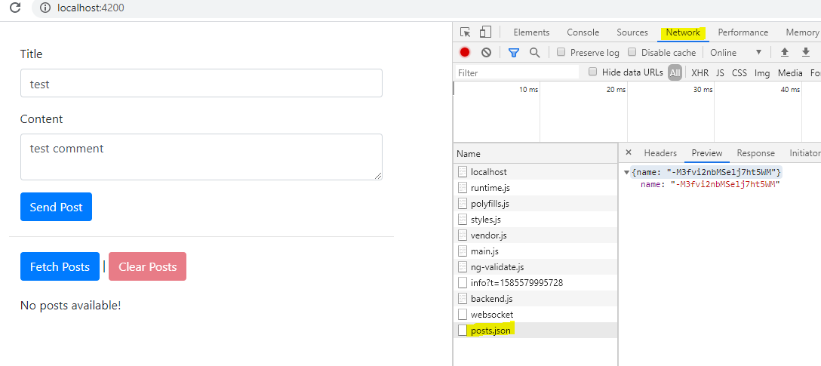

Do not worry about the post id – it’s a unique cryptic key created by firebase.

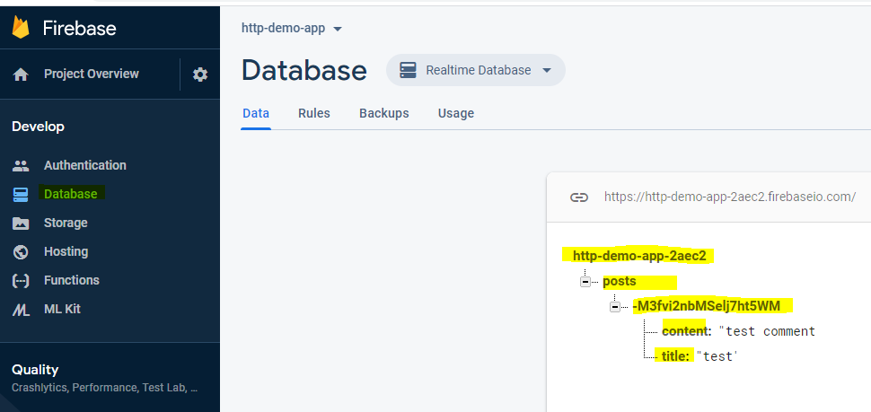

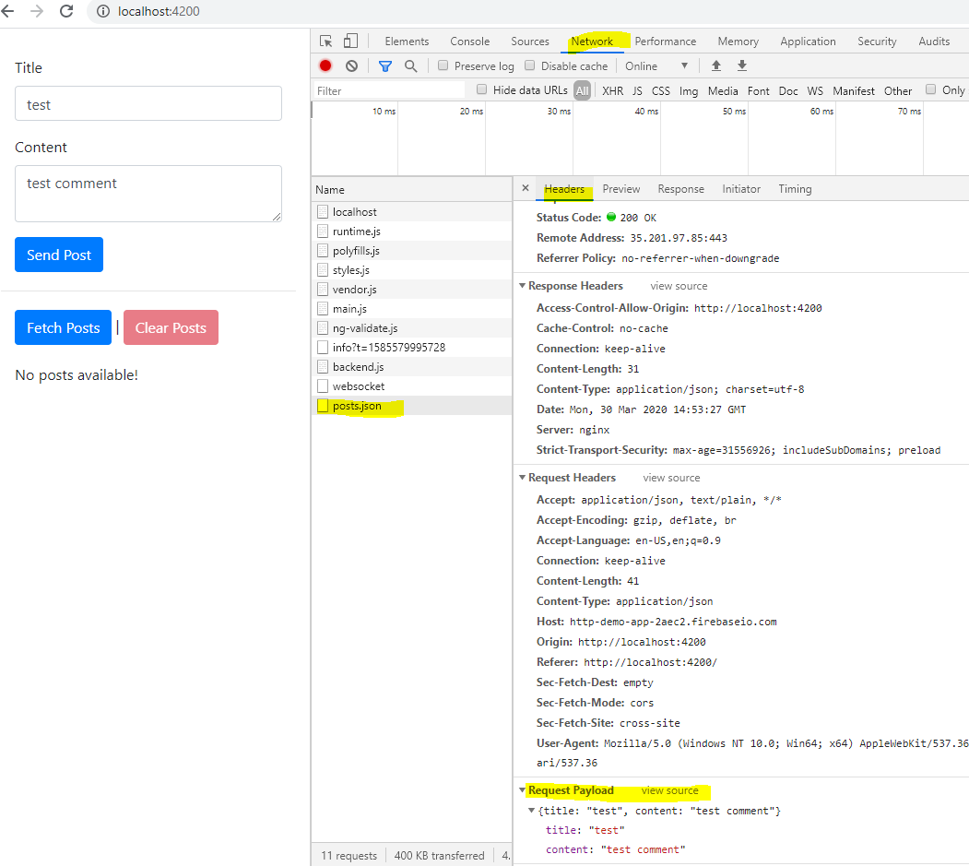

**Getting the data**

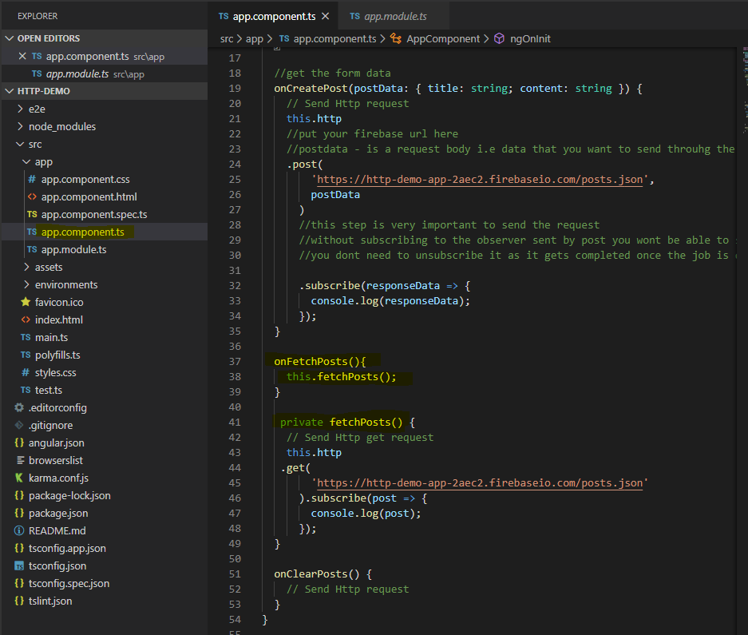

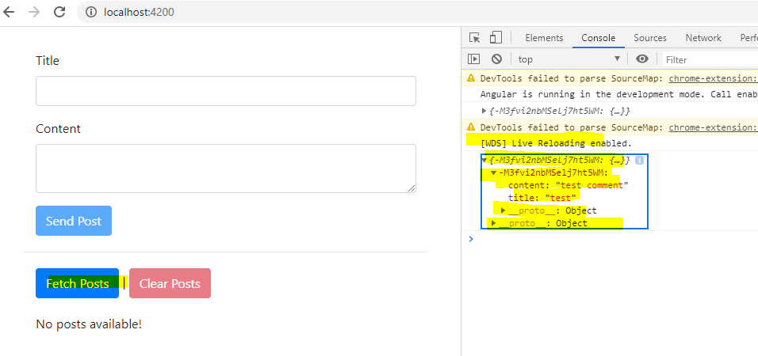

Using pipe to transform the data that we are getting with observables. Here we are using map with pipe which basically get the data and rewrap the data into new format as well as create a new observable which you can subscribe. You need to import map from rxjs

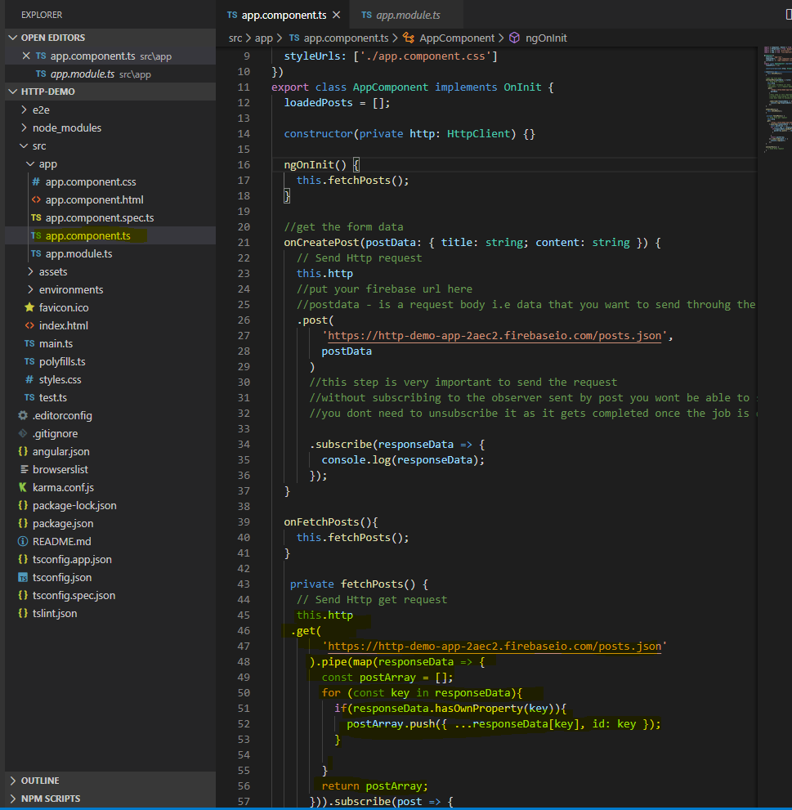

You get the data in the array format

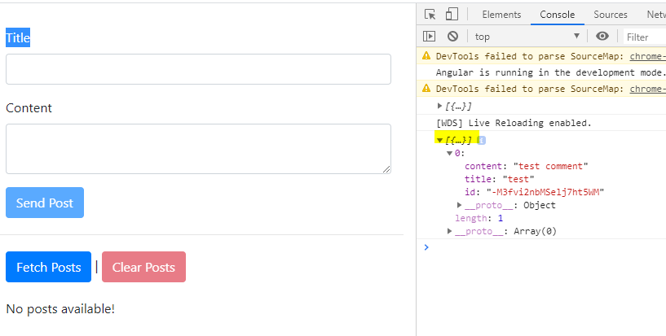

Working with types in https

You must mention the type of data that you are sending through ‘post’ or receiving through ‘get’ otherwise angular will process is of type ‘any’ which is not going to break the application but will not be much of a help.

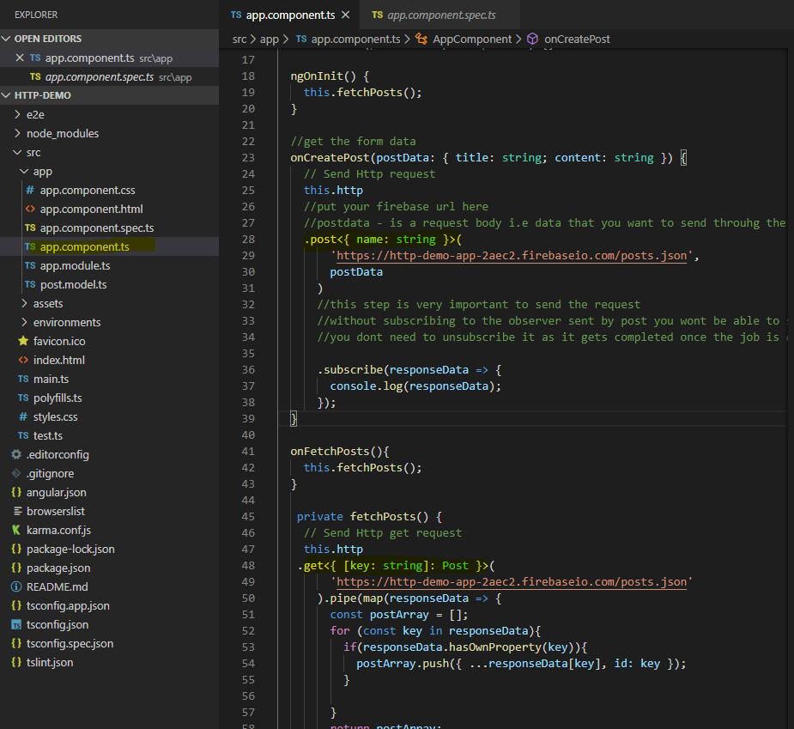

Displaying the data. We can set the array in the app component and set it to the posts.

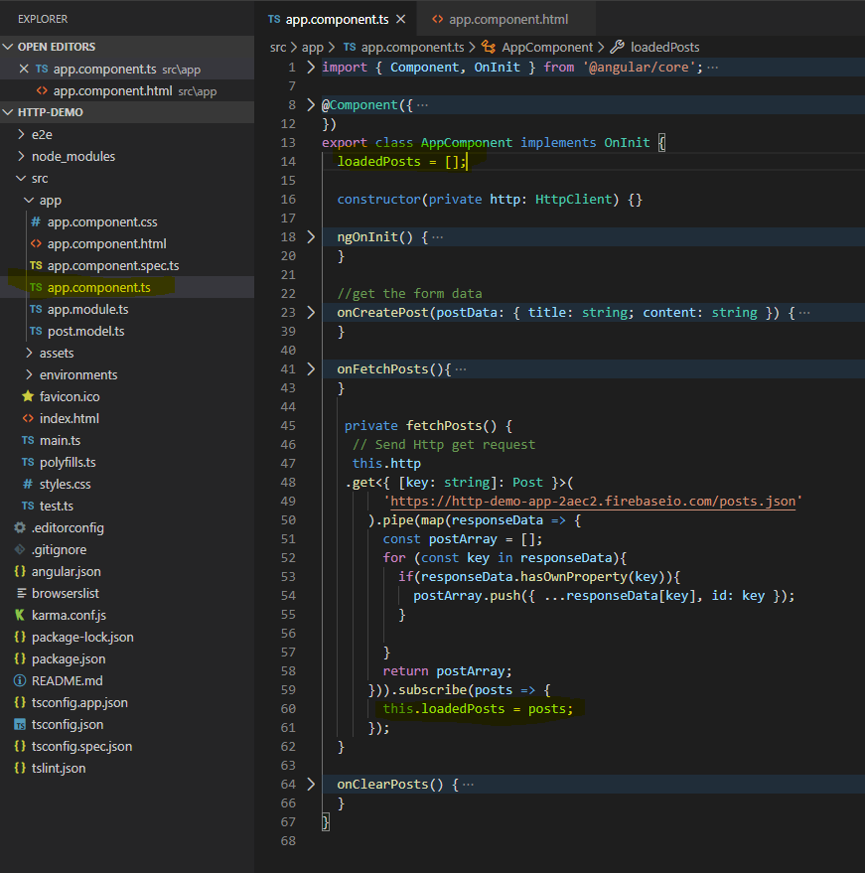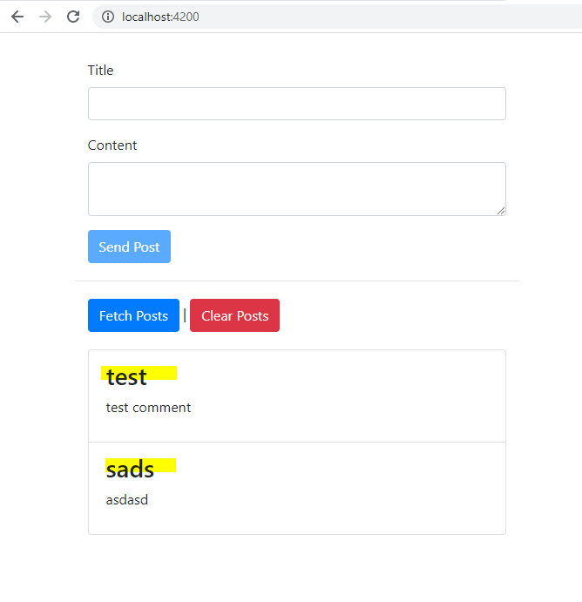

Adding loading message to compensate for delay in the loading data. You can add a variable to determine the status of the data. if it is fetching the data then we can show the status of loading or spinner. You need to make changes in html and corresponding ts file

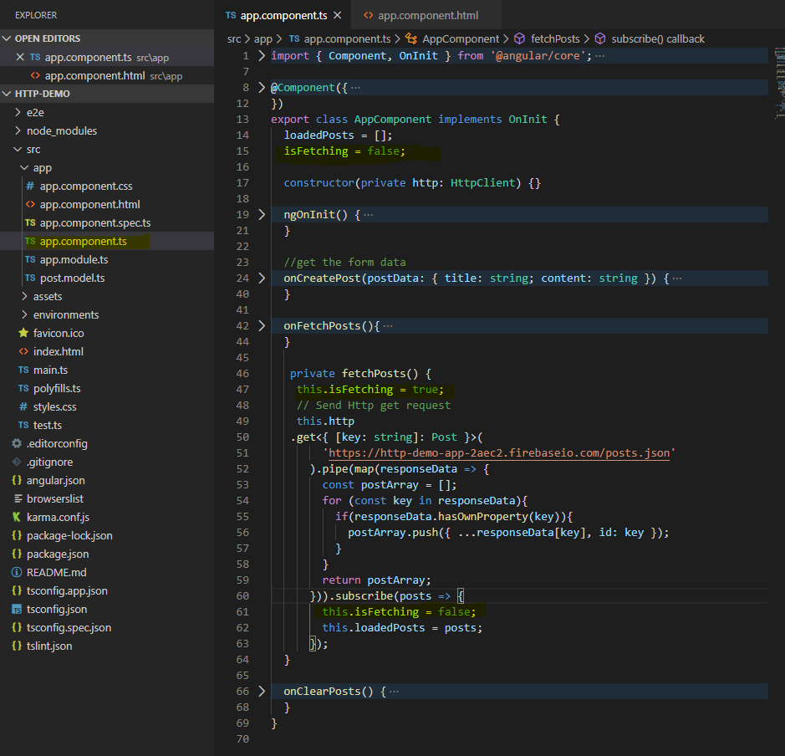

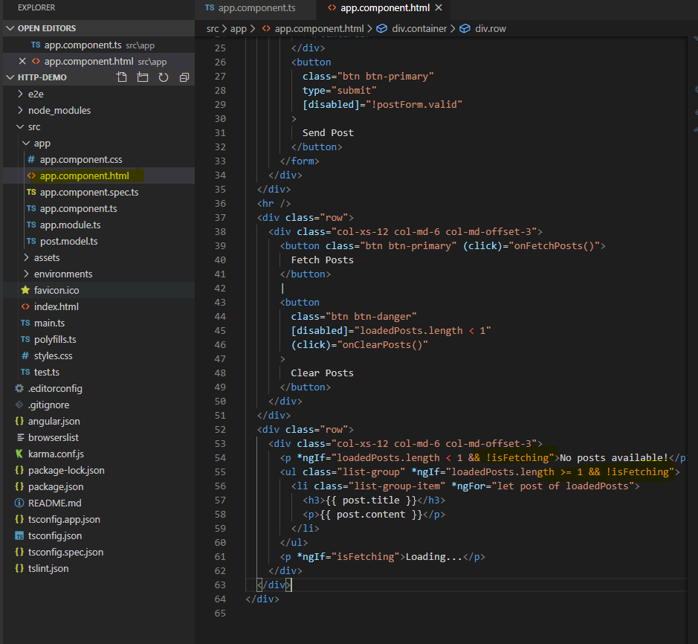

When you have multiple components it’s better to go for service and group up all your http calls over there. It makes your component leaner and easier to manage.

This is another approach to register the service in the app module. It will inject the service in the providers array in the app.module.ts. otherwise you can just the service in the app.module.ts providers array.

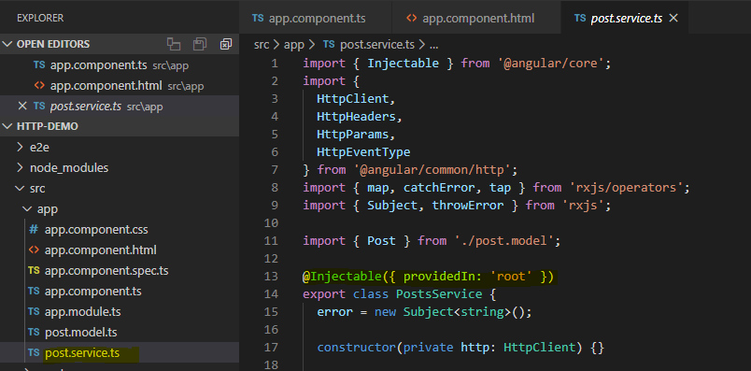

Once you create the service you can either select subscriber or observable. It’s a personal choice as either ways are fine to get the job done.

**Delete request**

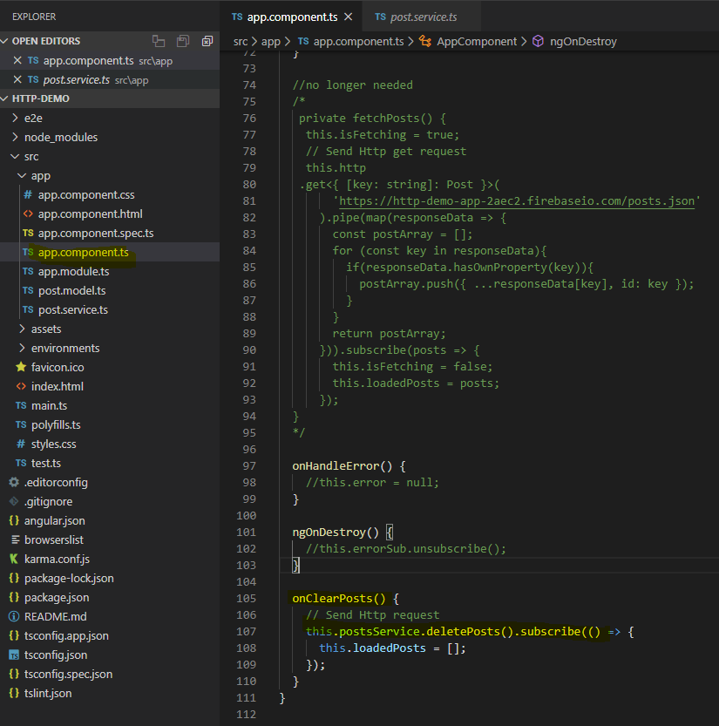

Creating deletepost method in the service file. Error handling is important as it will give better understanding of what exactly is happening behind the scenes.

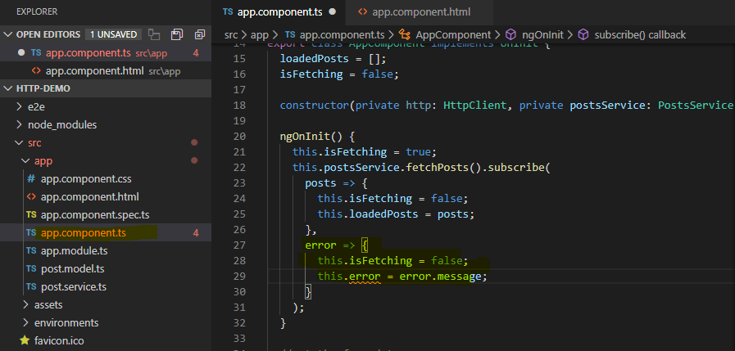

http error message is a json object and has multiple attributes that you can access and use to display more information about the error. You must need to update your html to disaply the error message e.g.

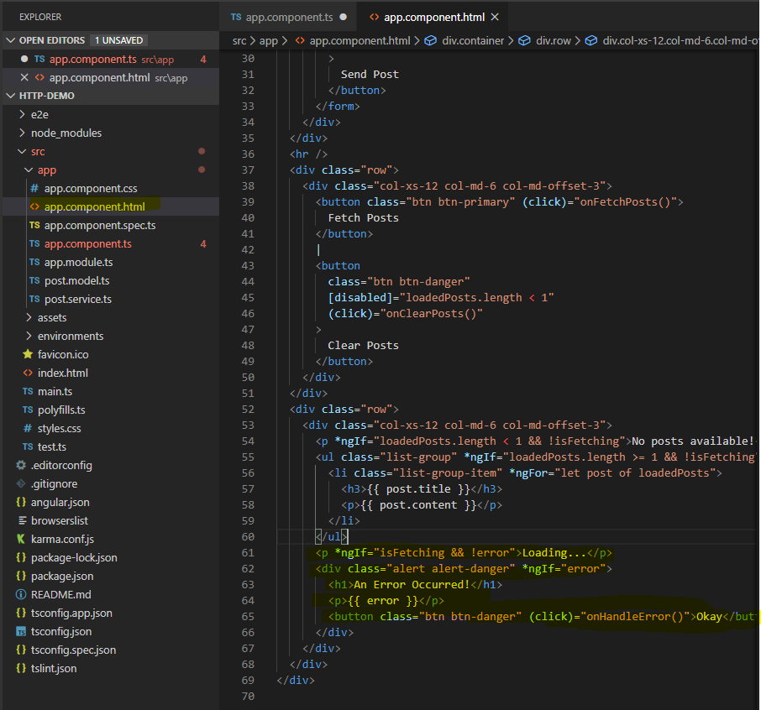

Take a special note here that you are accessing error object as it is without subscribing to any error event.

**Error handling as subject**

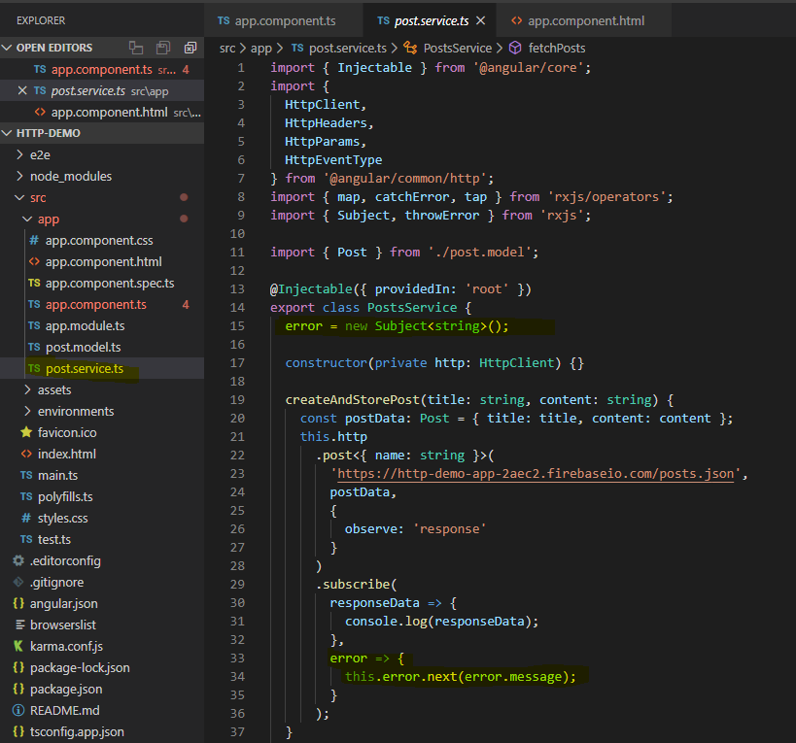

You can subscribe to this event through component

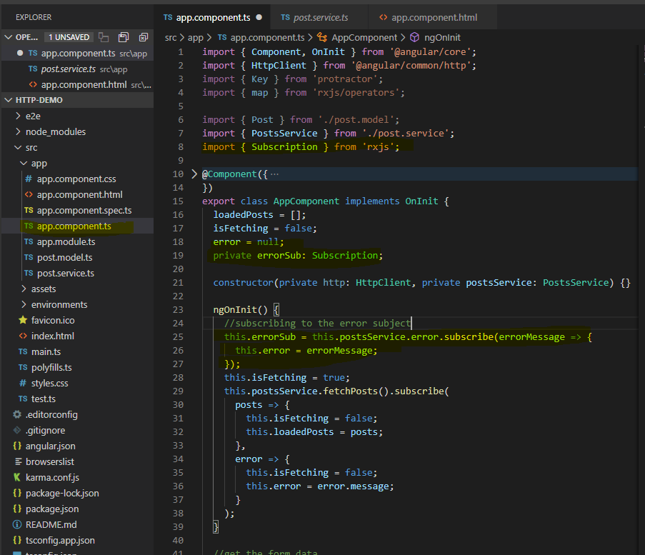

You must implement ngOnDestroy to unsubscribe.

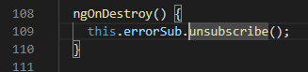

Error handling with Special operator catchError. You need to import catchError from rxjs along with that you need throwError that will yield a new observable by wrapping an error. So we can now throw the error response.

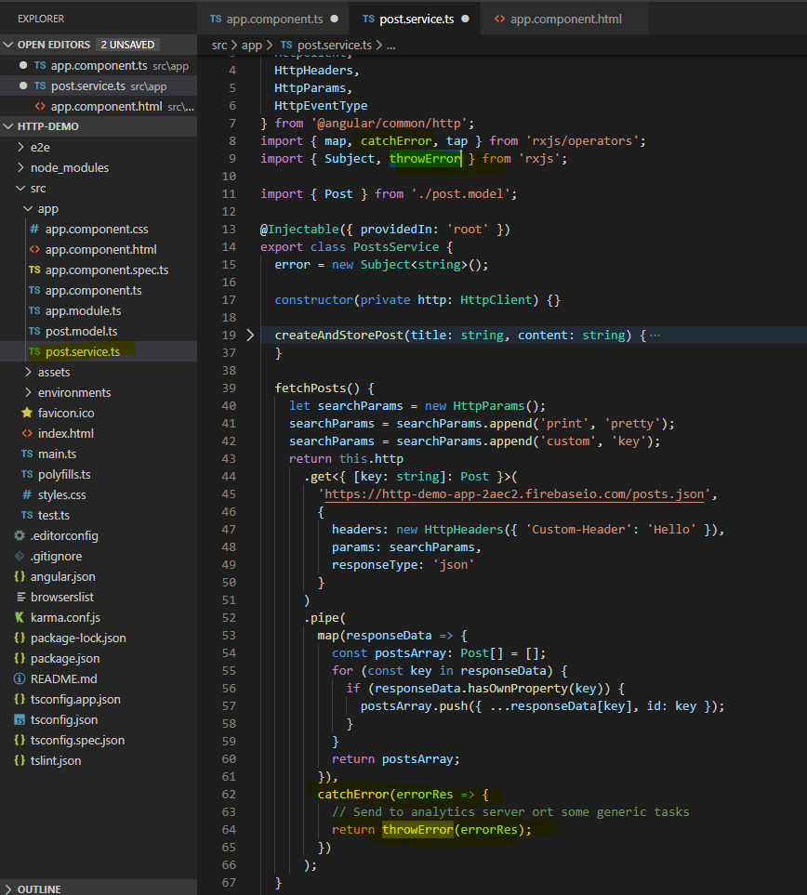

Setting headers for http request. You need to import httpHeaders to use it

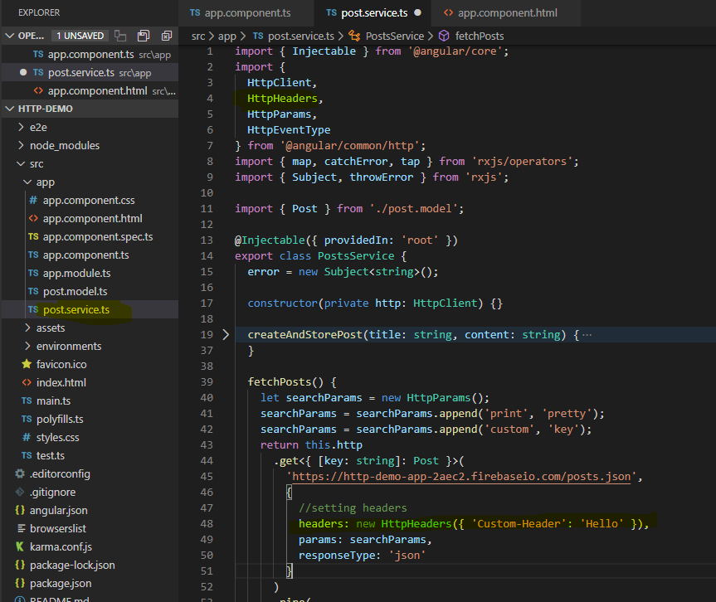

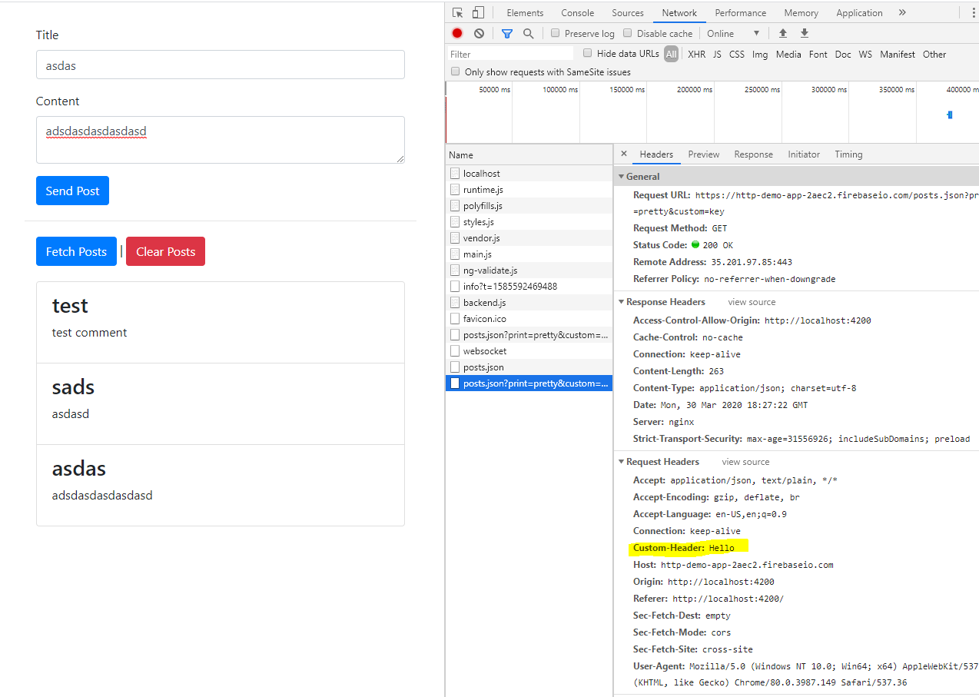

**Setting params to the http request url**

You need to import httpParams and implement it as following. If you have more than one params then you can do it by setting a constant that holds the reference to new param object.

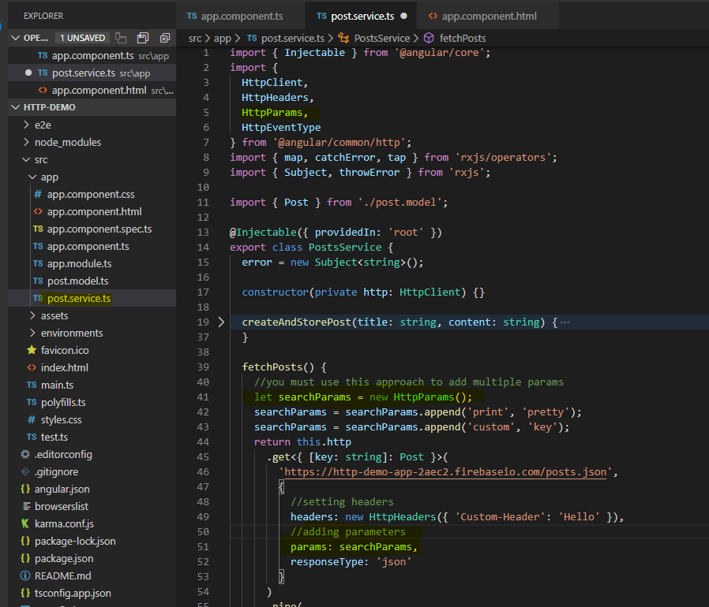

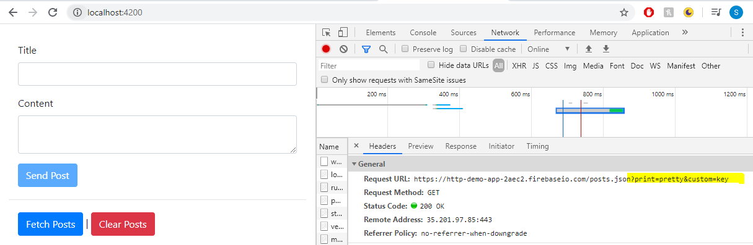

**Observer and tap**

You can use observe to see the response to in the json format.

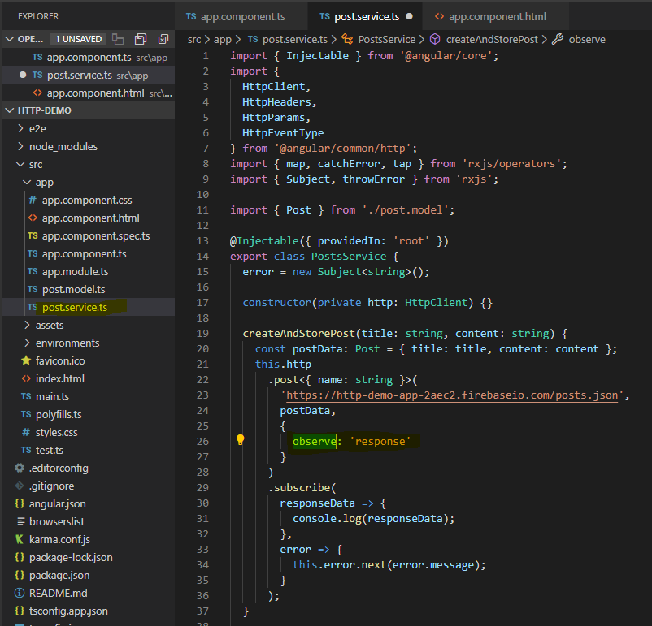

Tap is a rxjs operator which will allow you to tap into events without disturbing the event in general. You must import tap from rxjs.

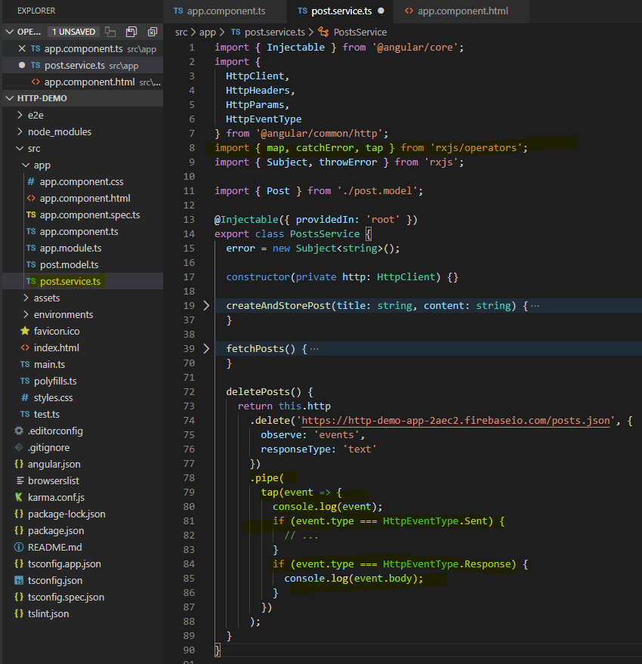

There are multiple types of events which you tap into and they are as following

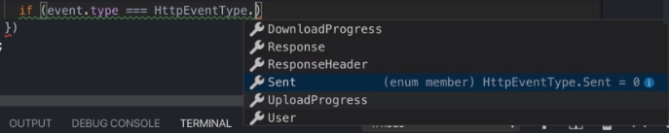

Setting the response types

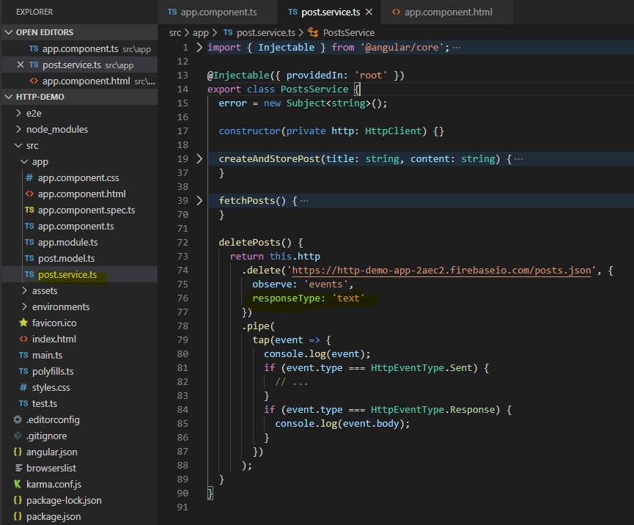

You can set it as ‘json’ or ‘blob’. Stick with json as much as possible.

**Interceptors**

If you want to perform certain actions on every request or want to add certain headers or parameters, then you can go for interceptors. Inceptors plays an important role in implementing authentications. You must implement HttpIntercepters for that and override the intercept.

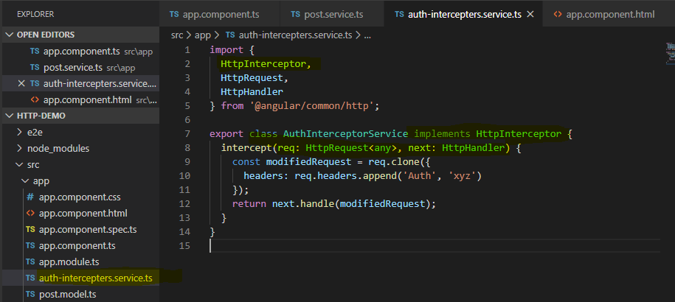

You must register all the interceptors to the app.module.ts to make them available globally .

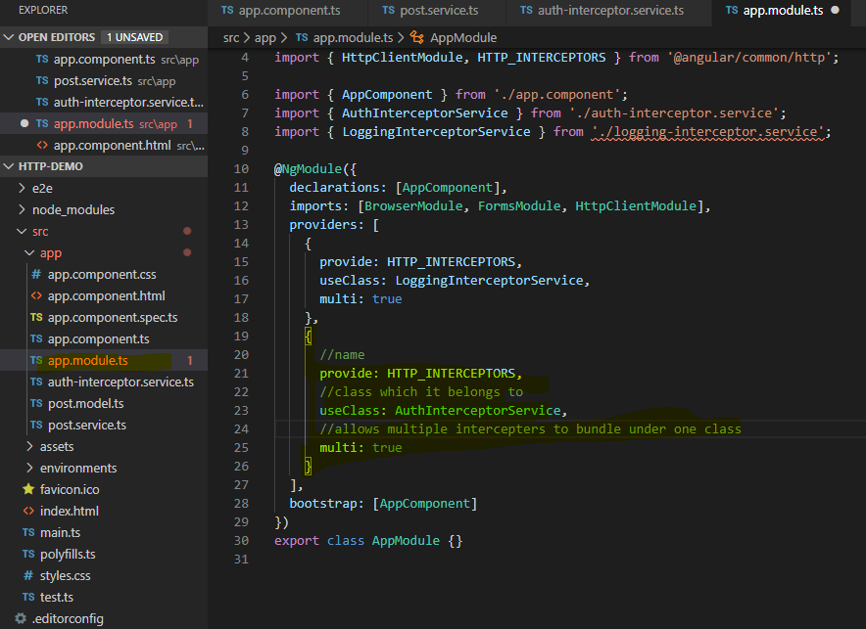

You can implement interceptors to response also.

**Project - sending http requests**

1 - Setup a firebase db for the project application – steps are same as above

2 – implement data storage service which will then save and fetch data and makes the header buttons working

3 – add http client in the app.module.ts

4 – implementing save and fetch method in header component to invoke the methods defined in the dataservice.

5 – fixing the recipe detail component to fetch the data from the backend by implementing recipe-resolver service

Authentication - ways of implementing restrictions or providing part access to user

You should not do validation in the browser as user may disable the js or change the logic of the application to bypass validation. Angular application is decoupled from the server. Since servers are restful which is also true in case of graphql we cannot use sessions.

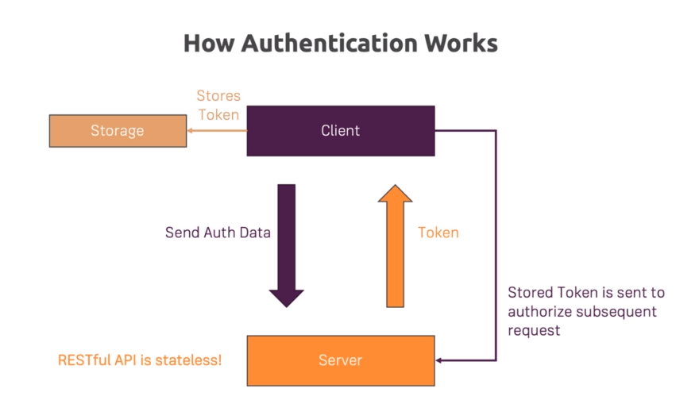

We are not creating a new application here but starting with the project itself

1 – adding auth page to our application. Created separate component to hold it

2 – update header.html and add authentication route to it.

3 – manage the login mode within auth component to check whether user is logged in or not and then manage the active routes within it. First of all we need to check whether user is signing up or login?

4 – using template driven approach to control the form or auth component as well as implement basic authentication and restrictions.

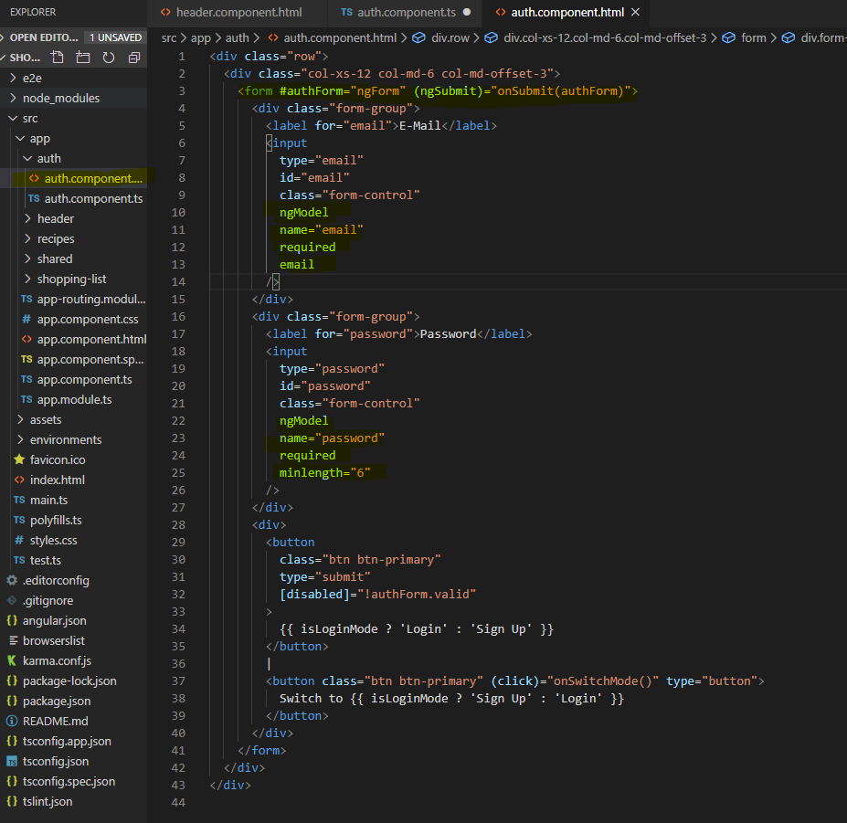

5 – changing database rules to prevent any user from accessing read and write. User can read and write after authenticating.

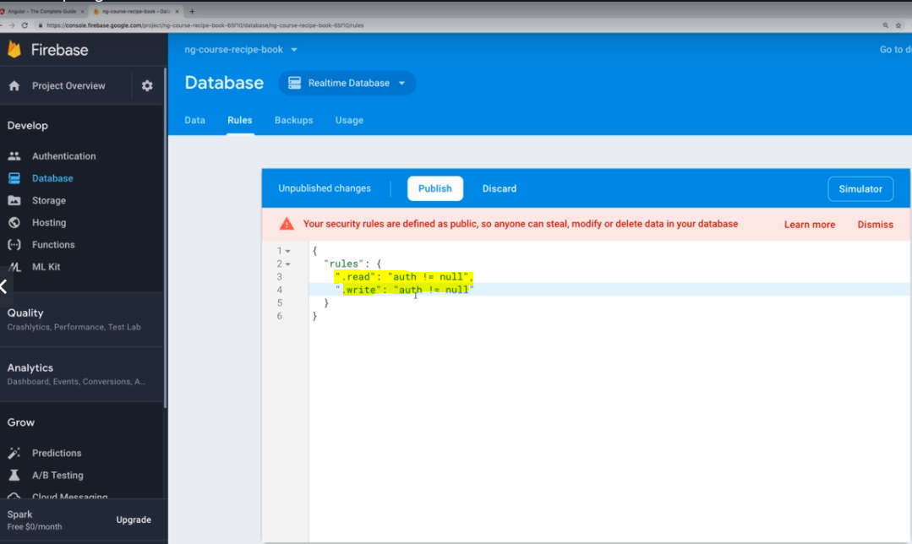

You can see your authenticated users in

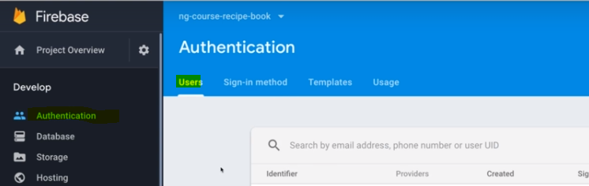

6 – using firebase auth api - <https://firebase.google.com/docs/reference/rest/auth>

You can use auth api to perform multiple authentication actions. For each action api url will be different we are suing login with email/password and signin with email and password.

7 – adding auth service in auth folder to create a service which then works with auth api. While using auth api you must provide the web api key which is unique to your project

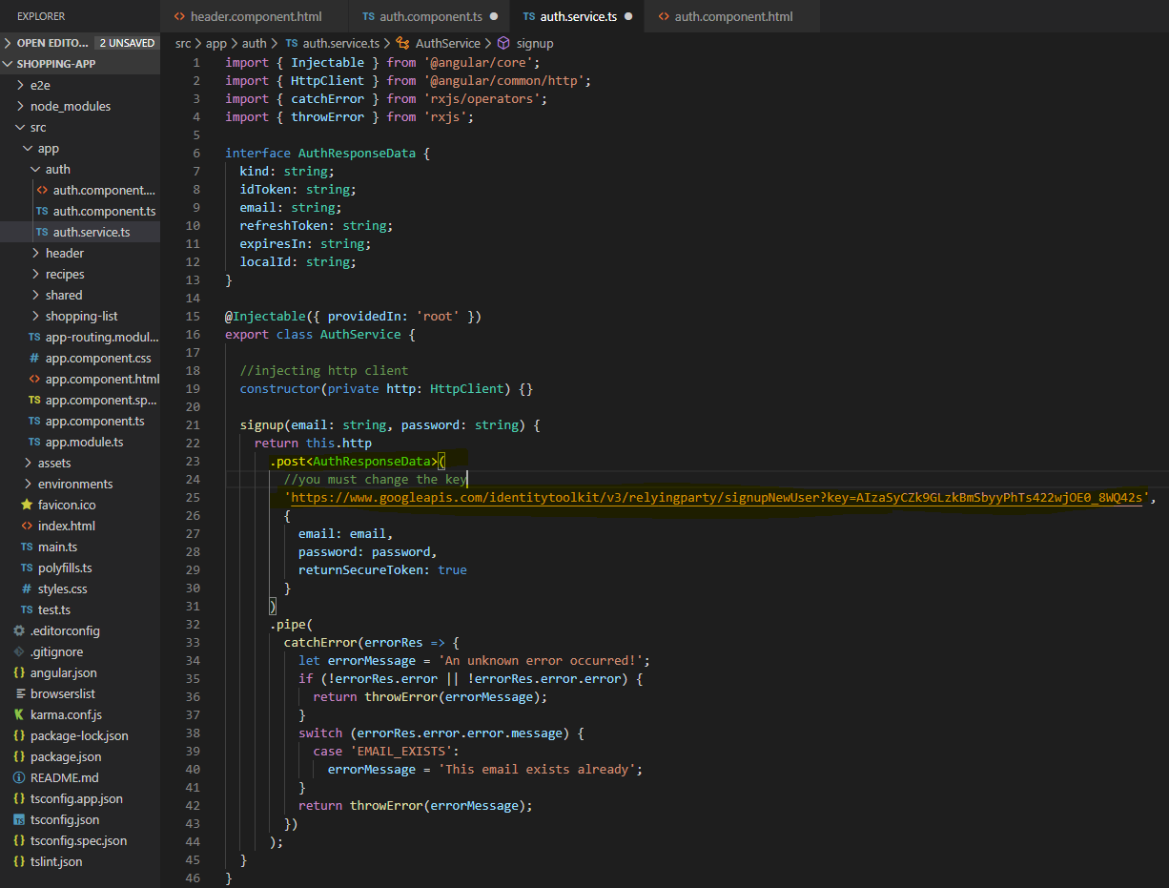

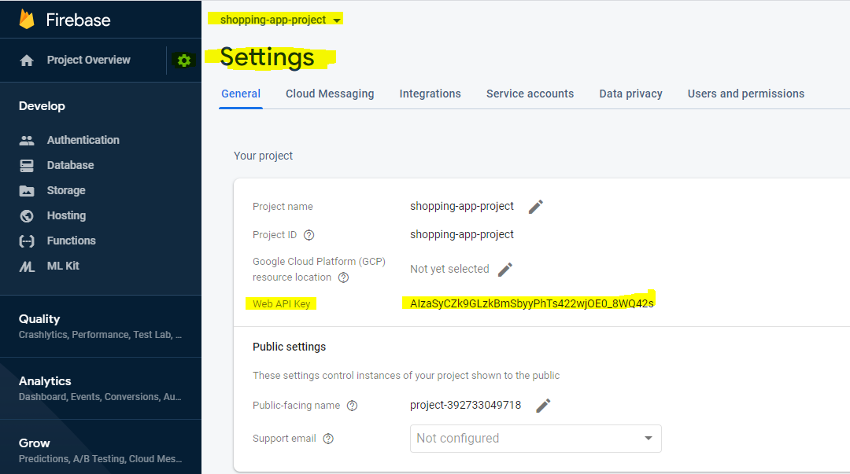

7 – define the auth interface based on the auth api response section

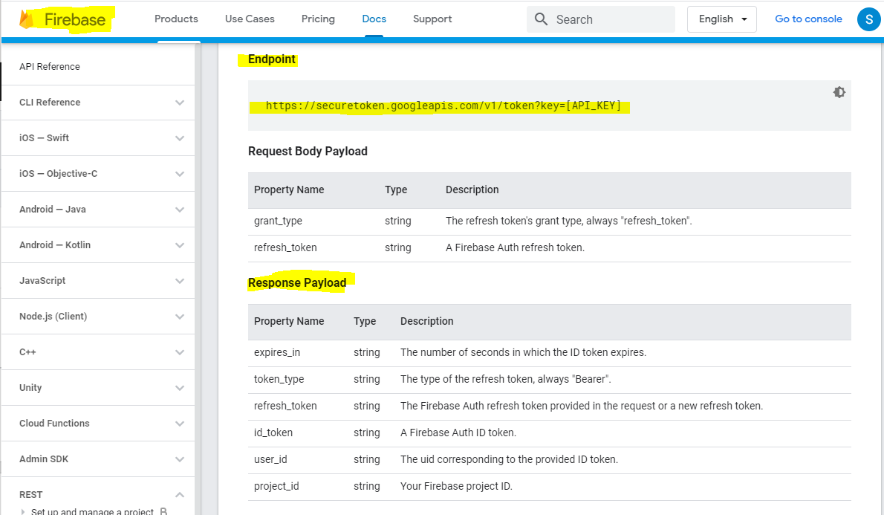

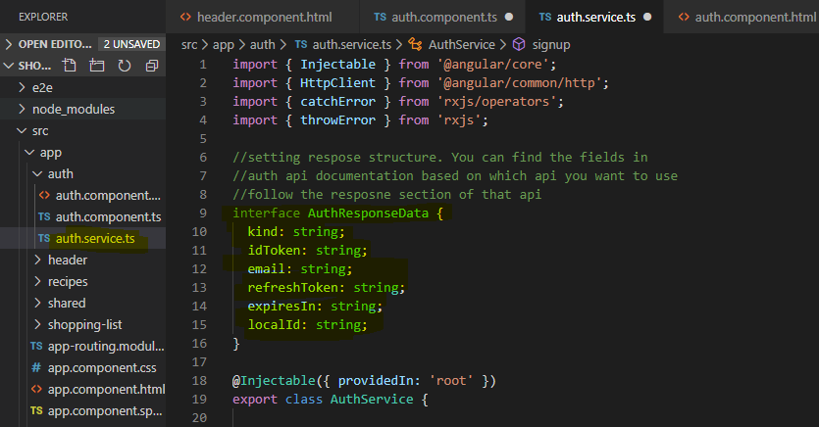

Once you define the interface then you need to pass that to post request as a type.

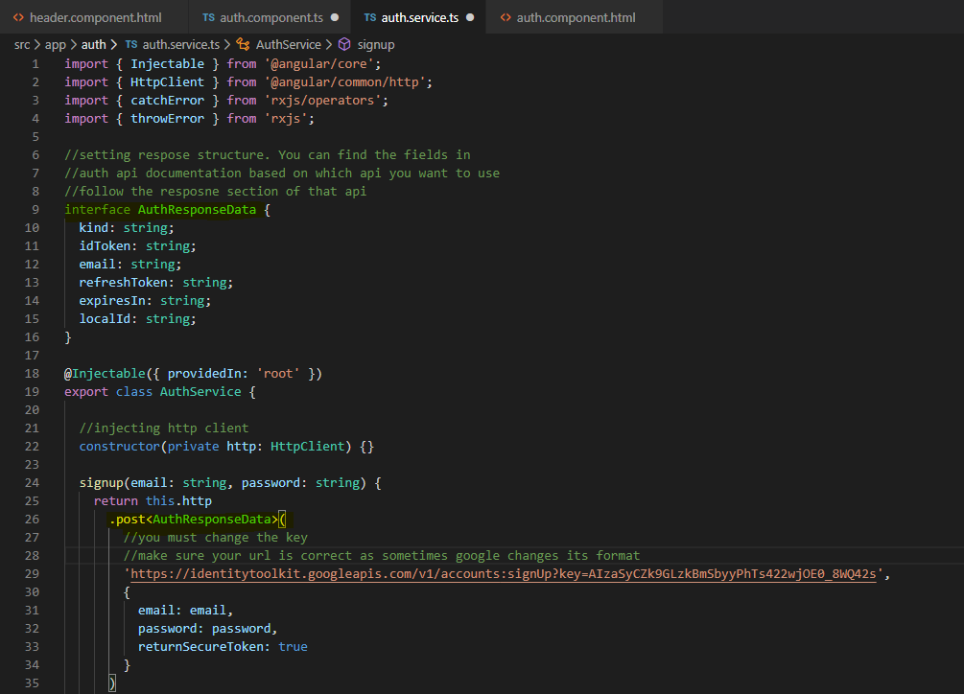

8- updating the status of login, loading and error based on the form data that has been received after submission. Injecting auth service in the auth component

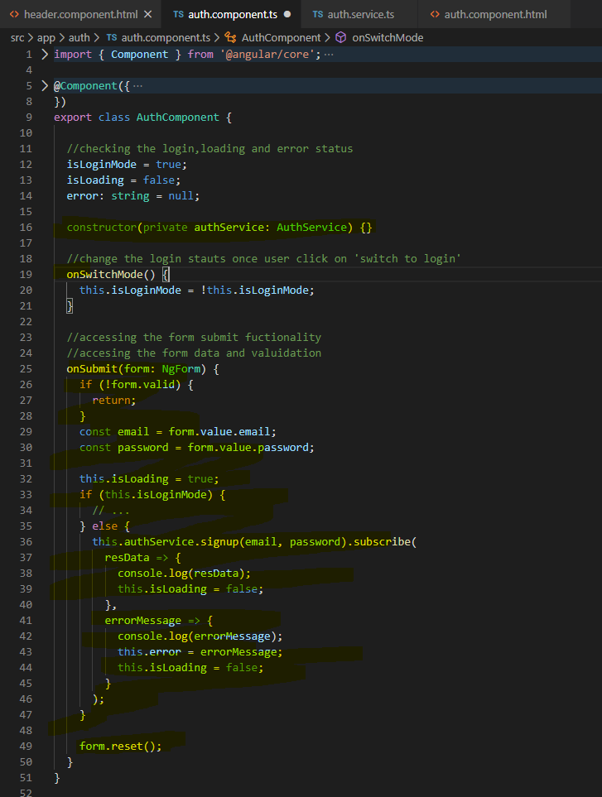

9 – adding loading spinner and error handling logic.

You can get css spinners - <https://loading.io/css/>

Crate a new component in the shared folder and add the css code copied from the above site

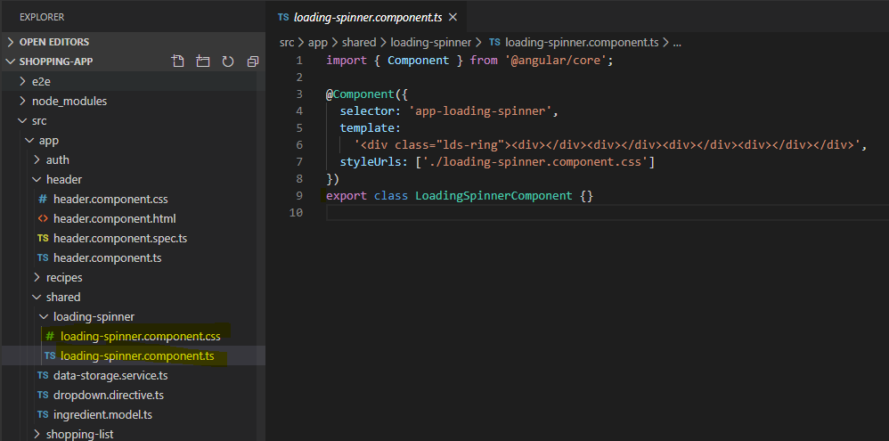

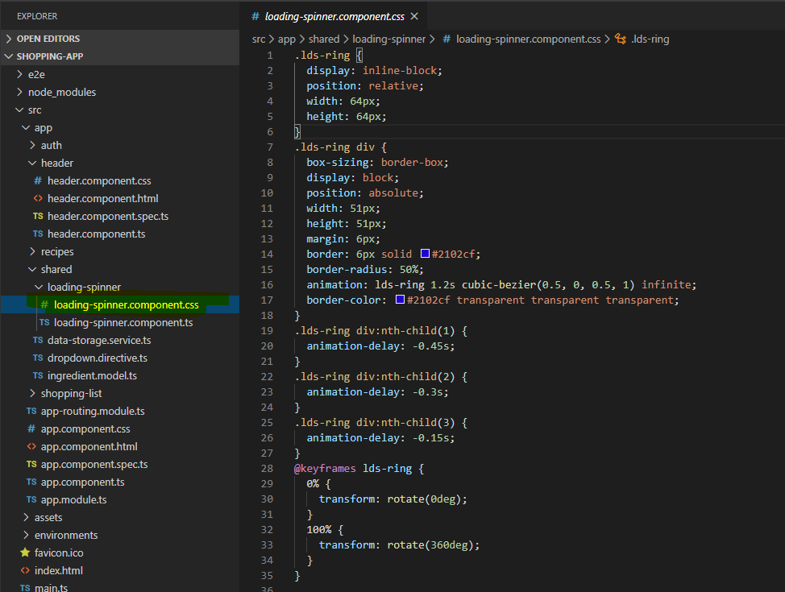

Spinner code sectors. Add css to css file and add html to the component template

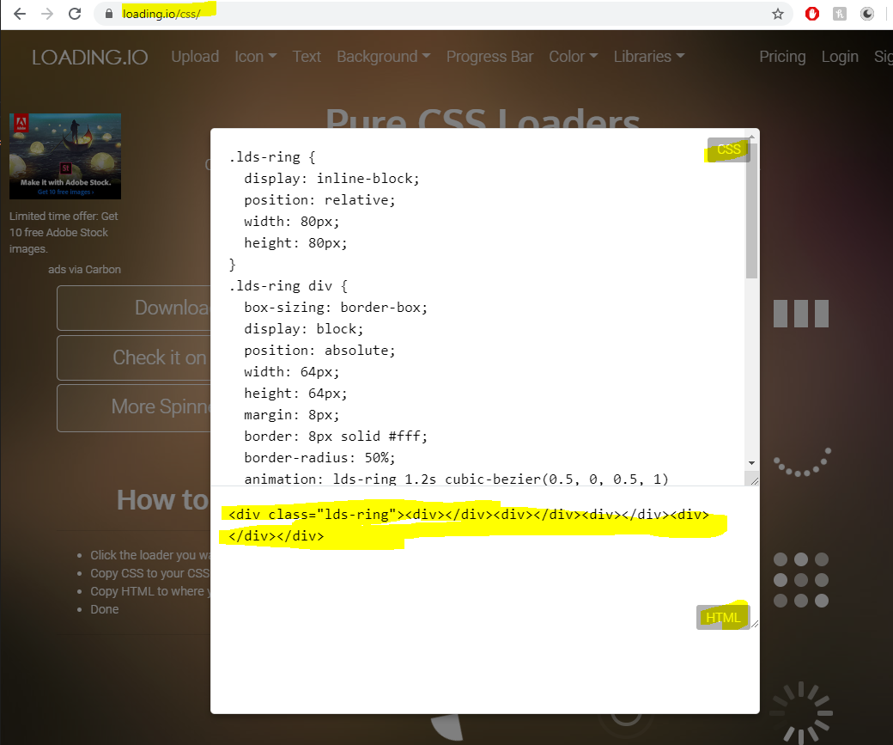

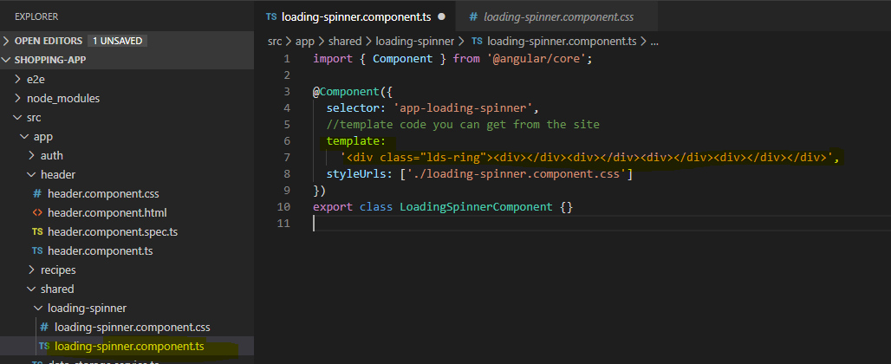

10 – add spinner component to the auth component

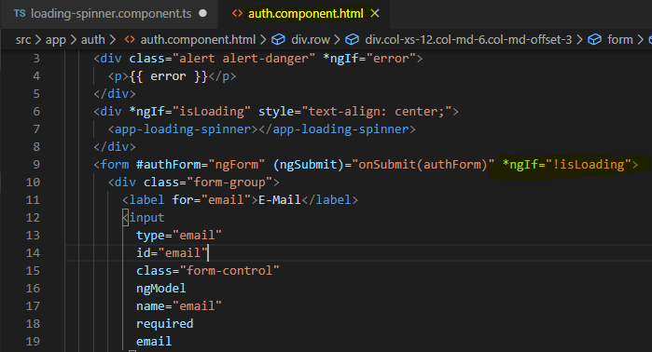

11 – adding error message to auth html and component

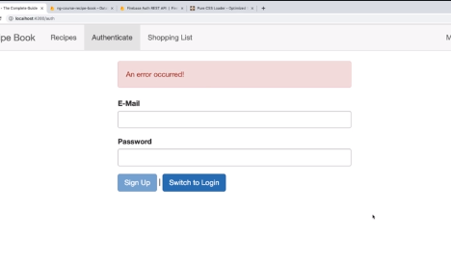

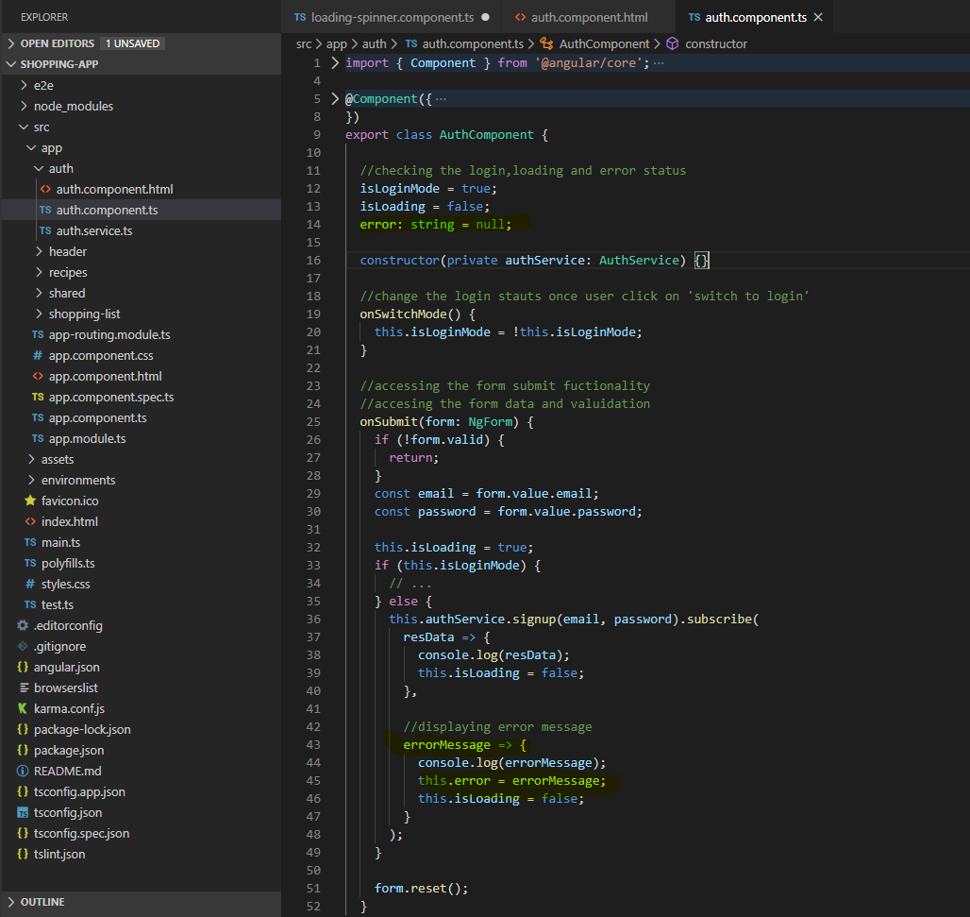

Implementing spinner and error message in

auth css

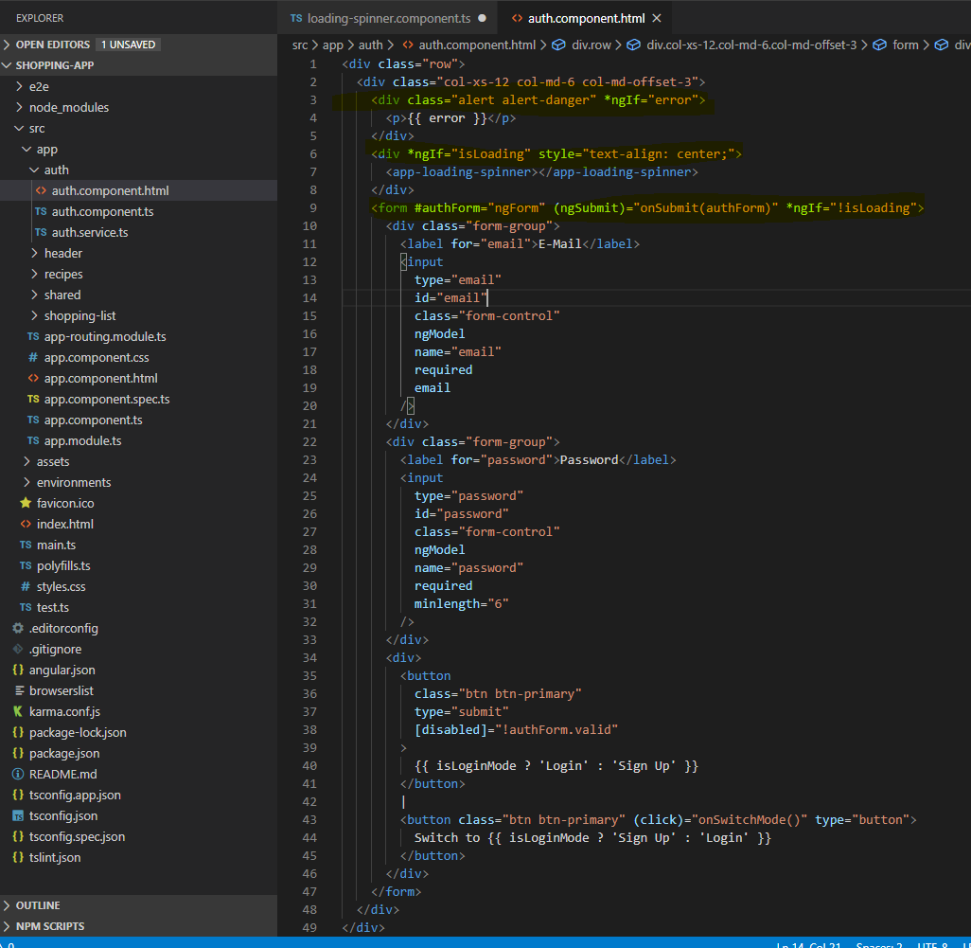

12- redirect the user once he logged authenticated. You can implement these features in both component or service. It totally depends on your preference and you should be comfortable with it

In this case we are using component as we want some logic to be performed before redirecting the user. Which is also called as programmatic navigation.

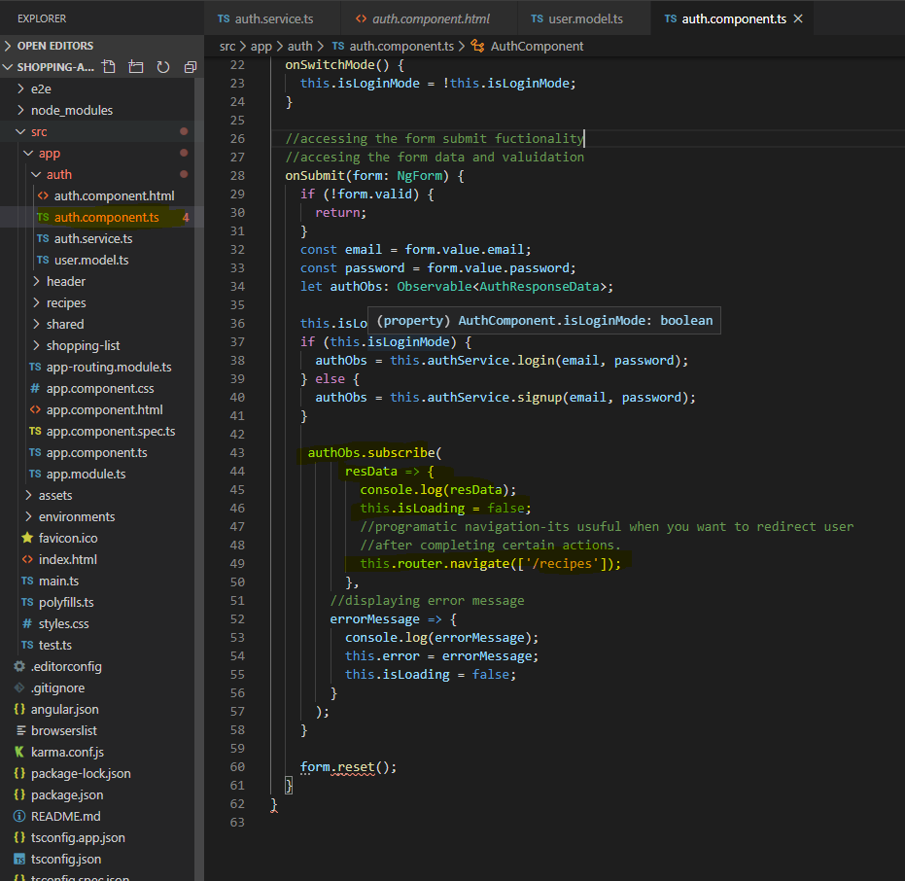

Since all the navigation links are in the header component, we need to change the flow in header.html to show certain links once authenticated.

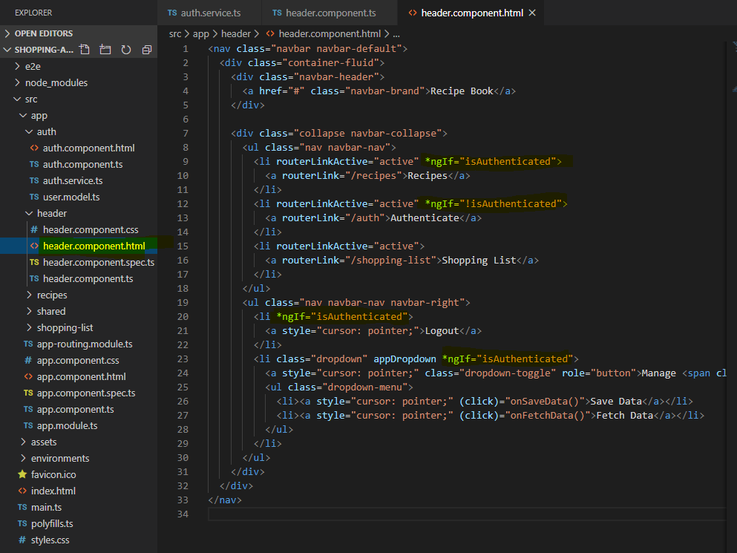

Adding logic to header.ts and header.html to authenticate the user. If user is authenticated, then show recipe and shopping list with mange recipe dropdown working otherwise just show authenticate and shopping list.

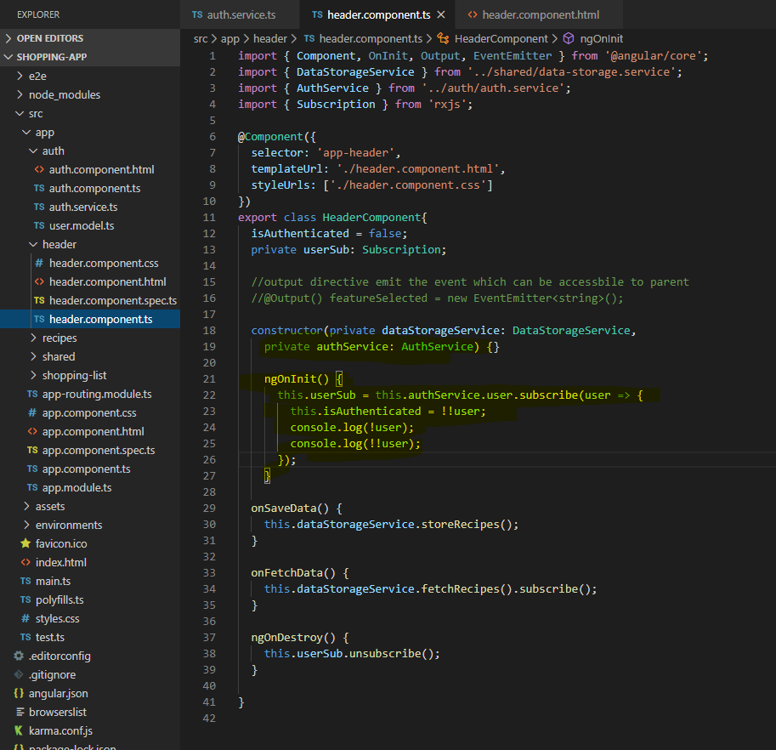

23 – sending token to outgoing request to make dropdown list working. Need to add a token to outgoing request in the dataservice. Subject can give you access to the data when new data is emitted but behaviorsubject can give you access to current next and previously happened event

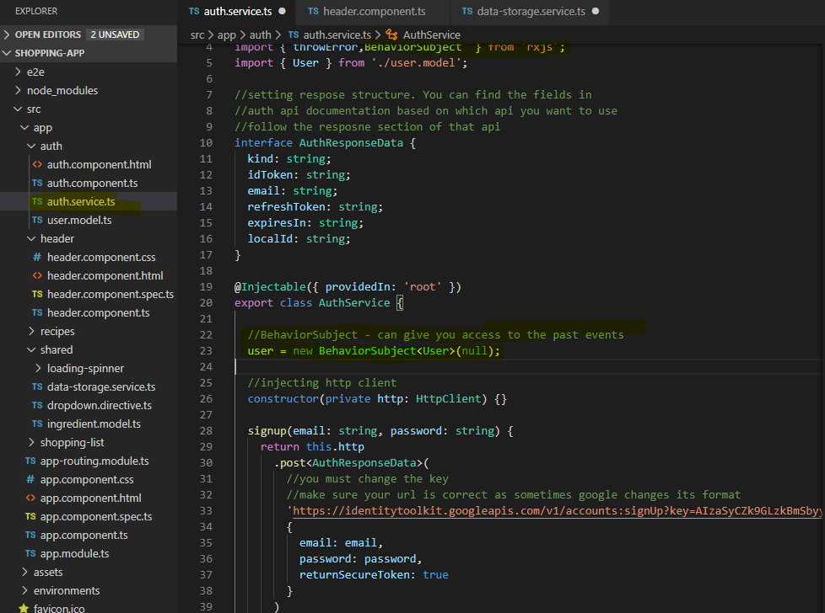

Take is also imported from rxjs/operator and take is called as a function and you simply pass a number to it and I pass one here and what this tells RxJS is that I only want to take one value from that observable and thereafter, it should automatically unsubscribe.

You simply add another operator here to pipe for the user observable and there, we can use exhaustMap. exhaustMap is also imported from rxjs/operators and whilst the name might look strange, it does something very simple. It waits for the first observable, for the user observable to complete which will happen after we took the latest user. Thereafter, it gives us that user, so in exhaustMap we pass in a function, there we get the data from that previous observable and now we return a new observable in there which will then replace our previous observable in that entire observable chain.

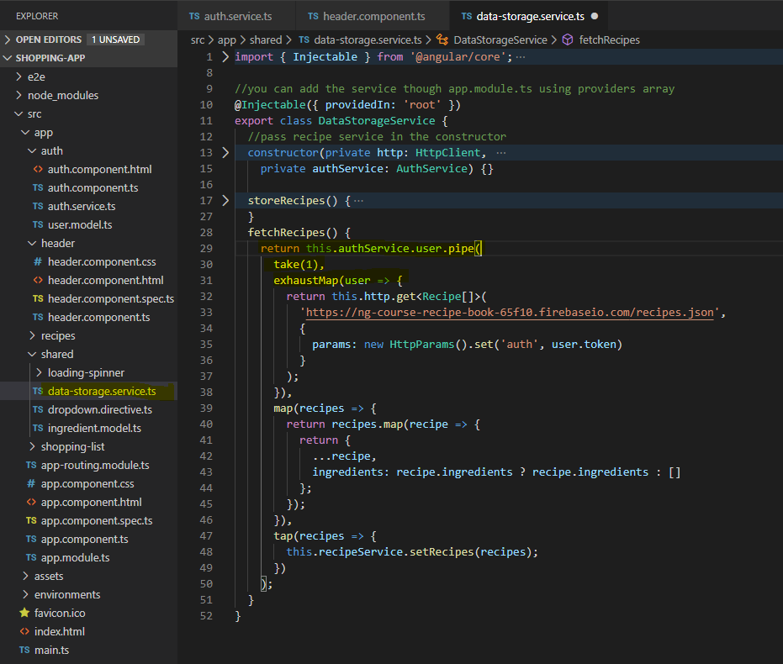

14 – attaching token with an interceptor. This interceptor will add token to all outgoing requests

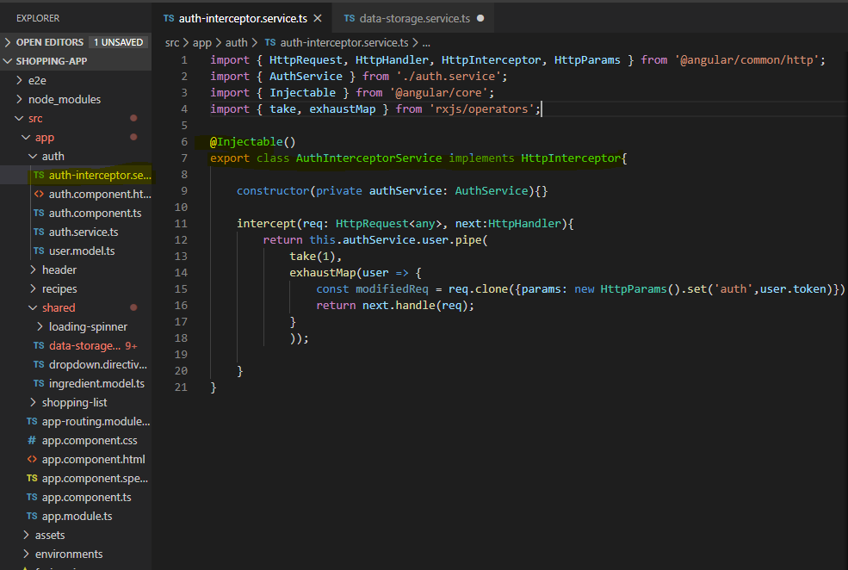

Add the reference in app.module to make it available throughout the application.

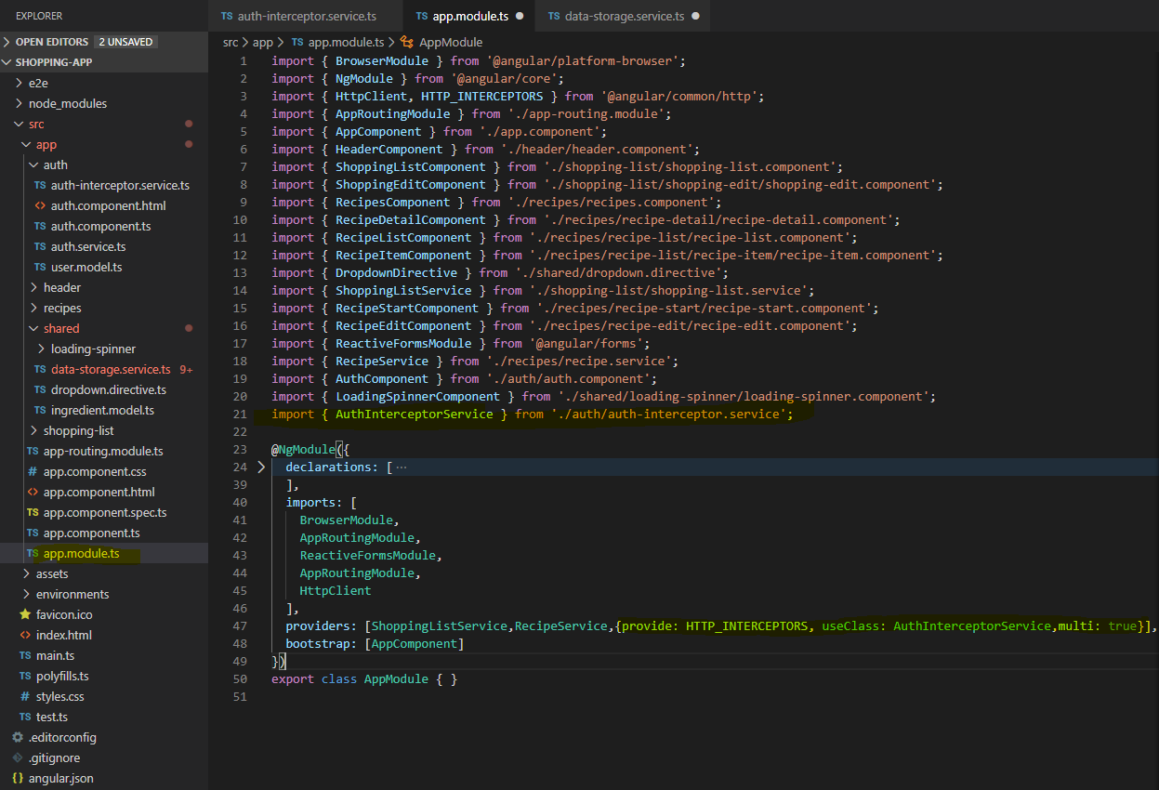

so now we directly return this observable and we simply call pipe there and pass in map and so on into this, this happened because we move that logic to its interceptor.

Now we should use this interceptor for outgoing request.

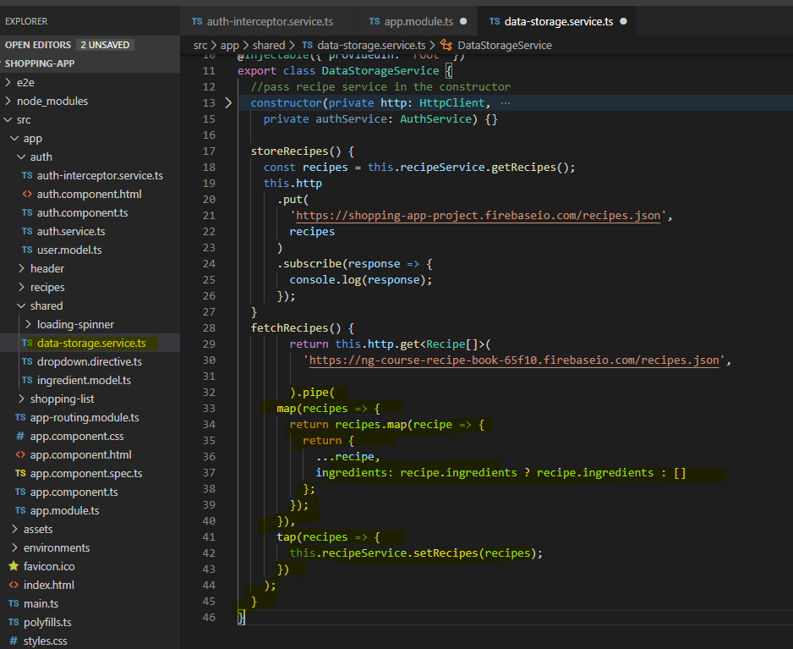

There is one catch though, since we are adding token to every outgoing request when the user is null it will throw an error. To handle this we need to perform check in the interceptor service

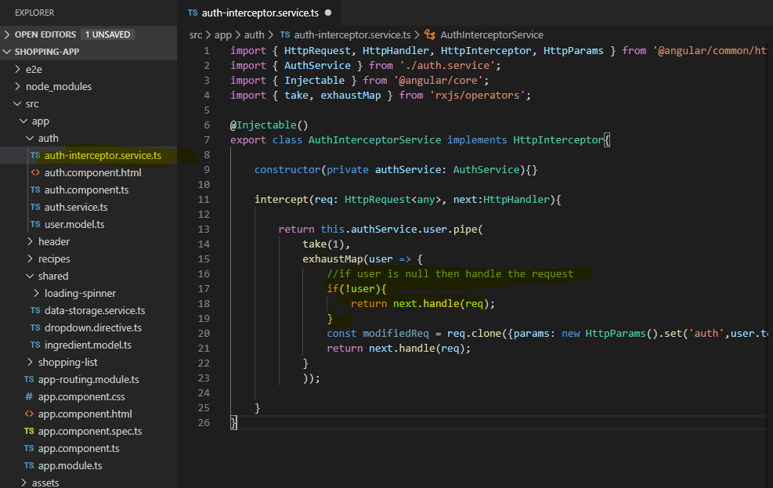

15 – adding logout

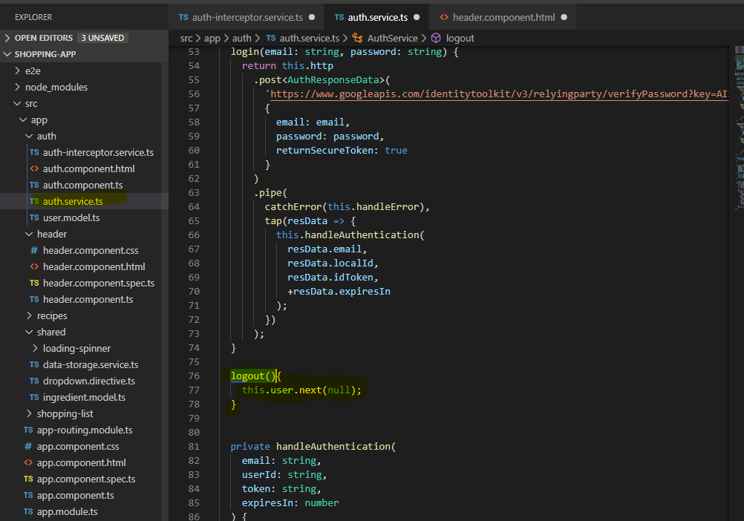

Updating header.html and header.ts files

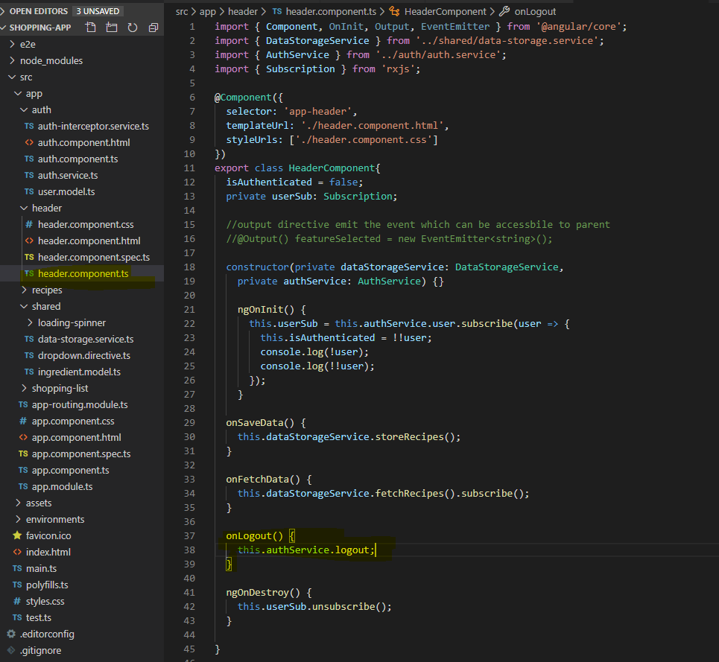

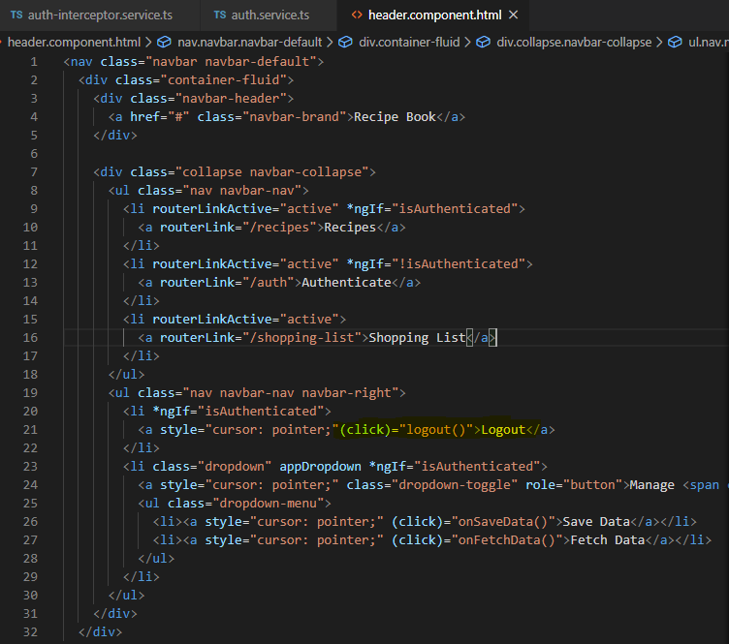

16 – adding auto-login

For this we can take advantage of local storage to store the token. It will use browsers local storage to store the data. It will store all the user data

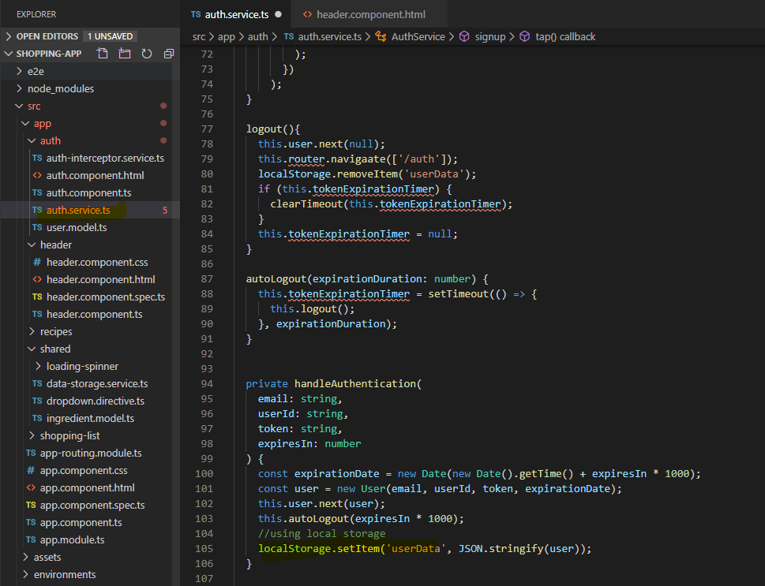

Now since we have all the data, we can load that data when user logs in again

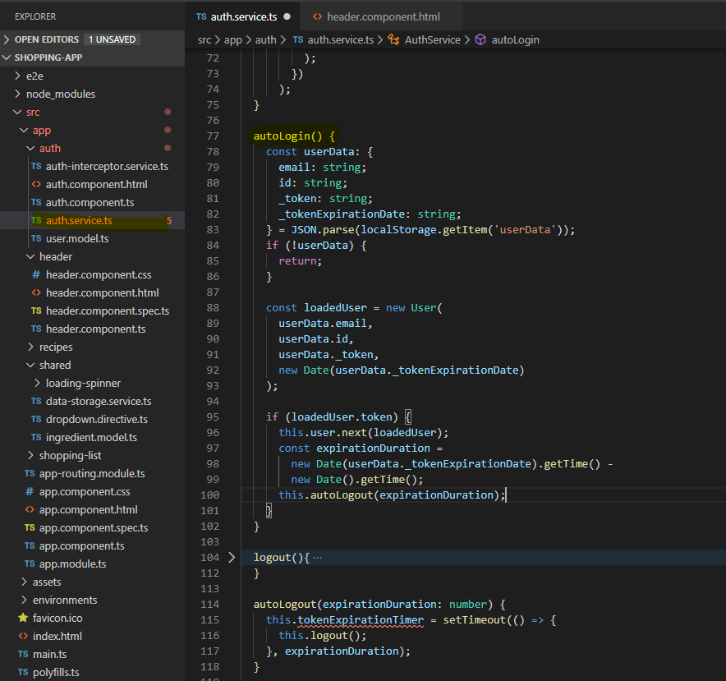

**Implementing autologout**

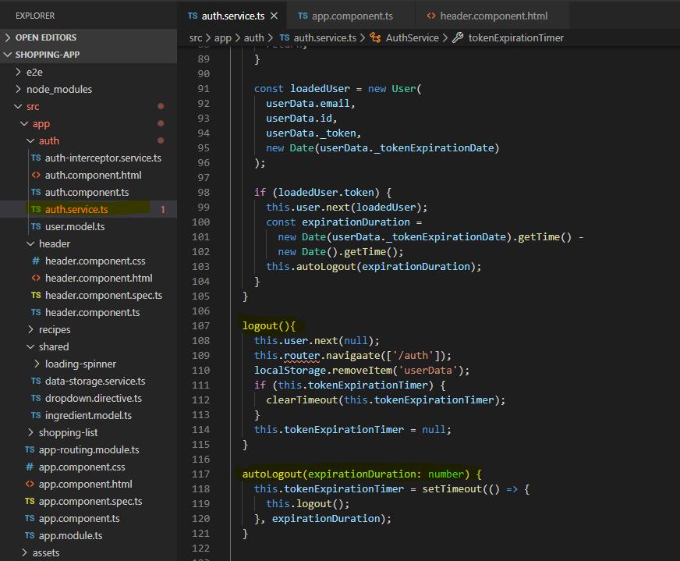

**17 – adding auth guard to support autologin and auto logout functionality**

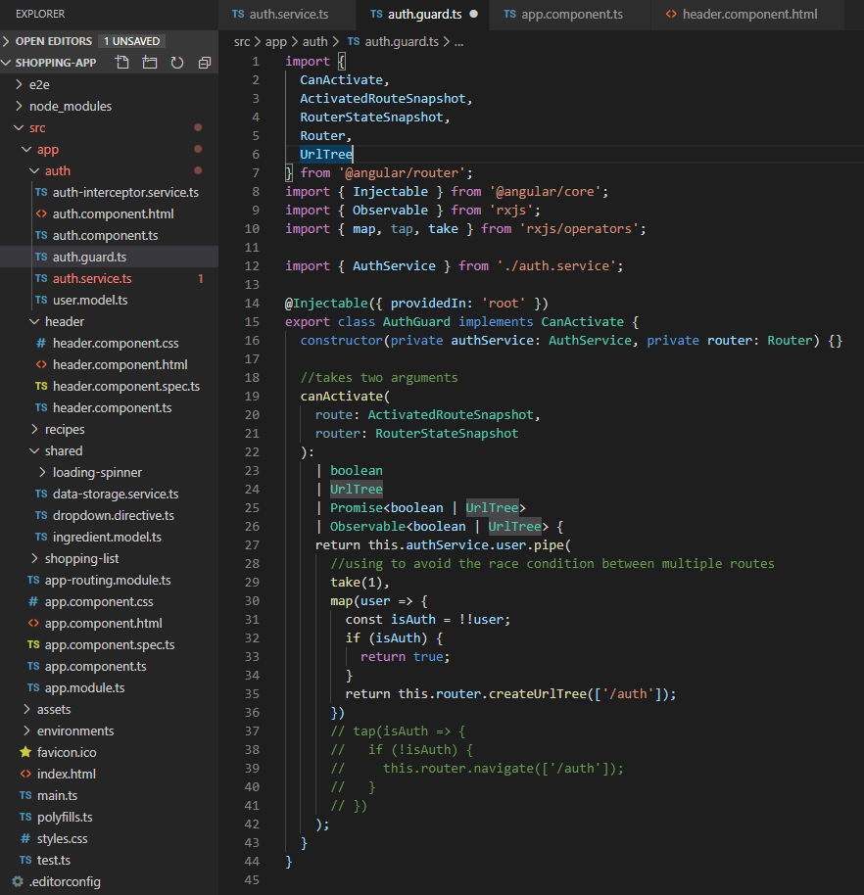

Dynamic components i.e. overlaying component

Project

1 – adding overlay for incorrect login alert – adding alert component in shared folder

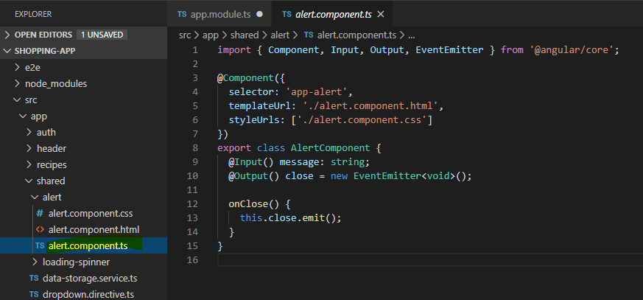

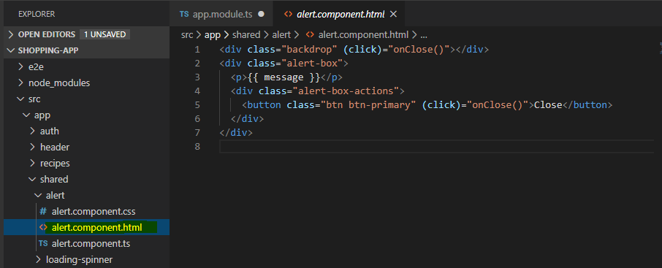

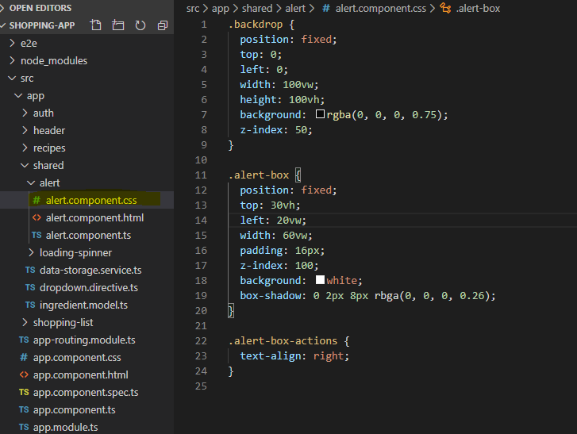

Since we are displaying the error message through authentication page we must have to update the auth html for that

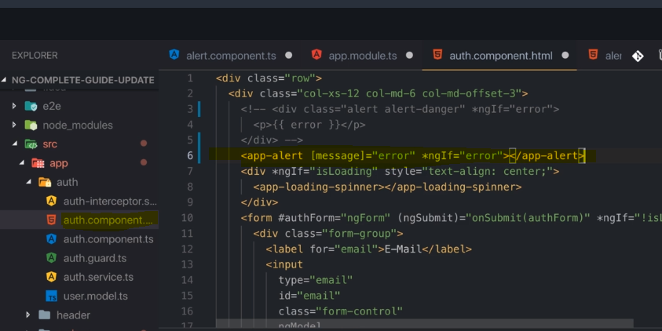

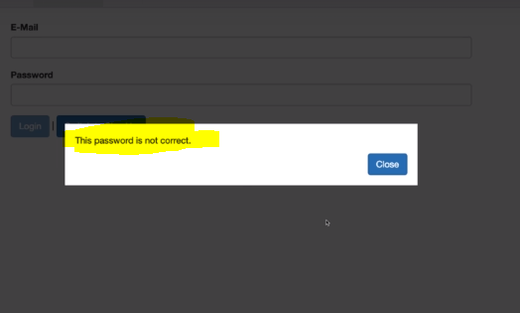

**Dynamic Components**

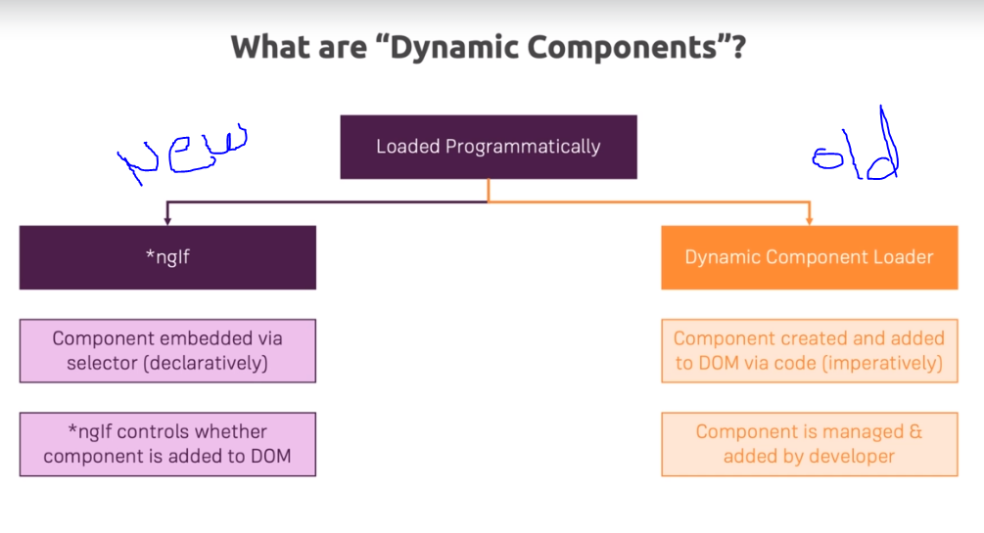

You must use the new approach with *ngif always as it’s a better way to handle alternate scenarios.Creating dynamic component with componenetfactory.

Angular needs a view container ref which you might remember from the directives deep dive section. A view container ref is essentially an object managed internally by Angular, which gives Angular a reference, a pointer to a place in the DOM. you could say, with which it can interact, and this object has more than just like the coordinates where it sits,

Now to get access to such a view container reference, there is a nice trick or not a hack, it's the official approach for getting access to it, we can create a helper directive. Now that directive could be named placeholder, we created placeholder component for viewcontaineref. Here we set the public property of viewcontainerref so that we can use it from anywhere within the application.

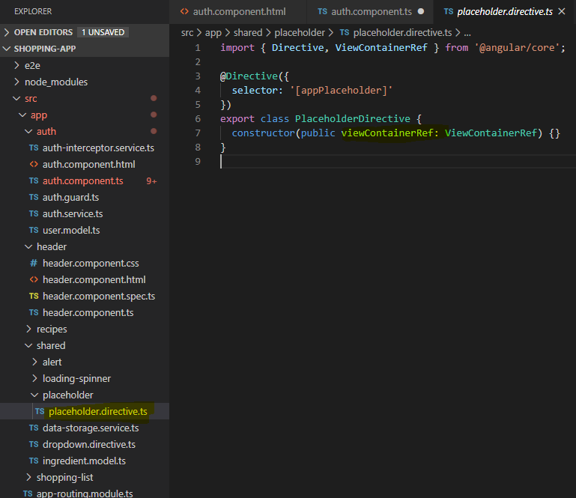

Now before placing placeholder in the auth html we need to implement it in the component through viewchild

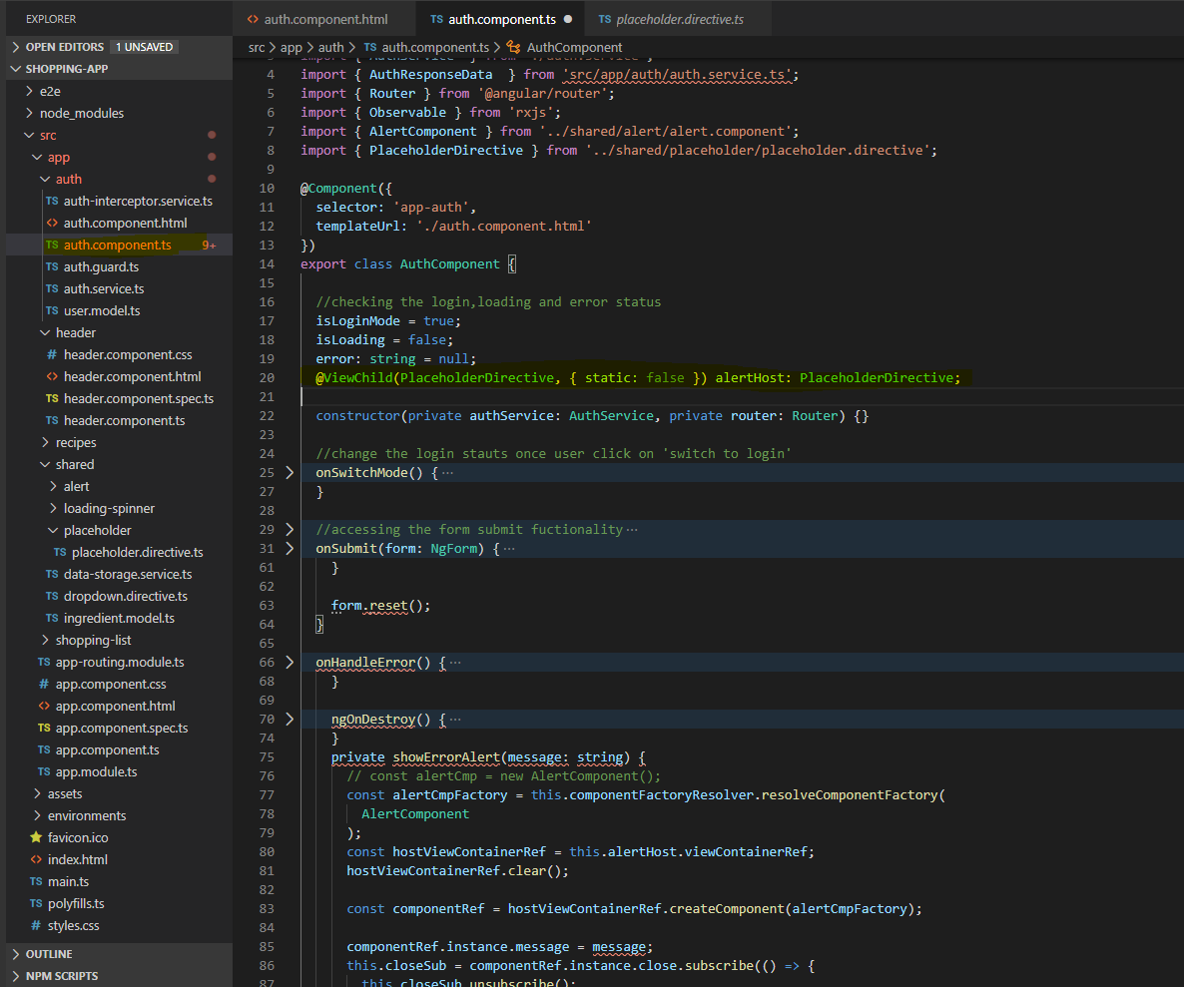

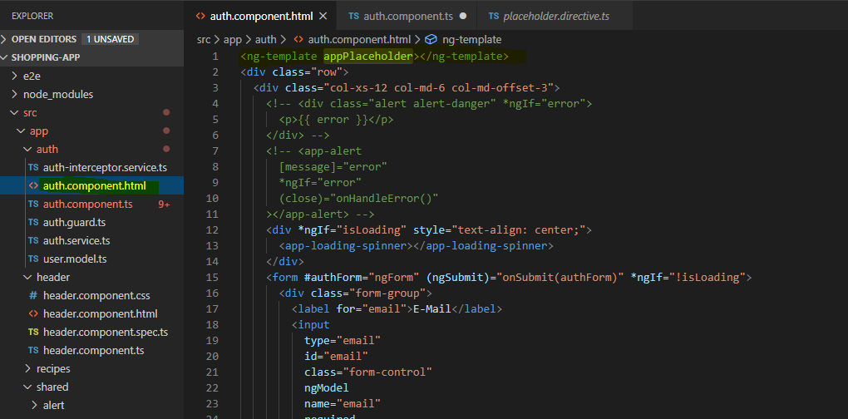

Now you finish the implementation in the auth componenet file

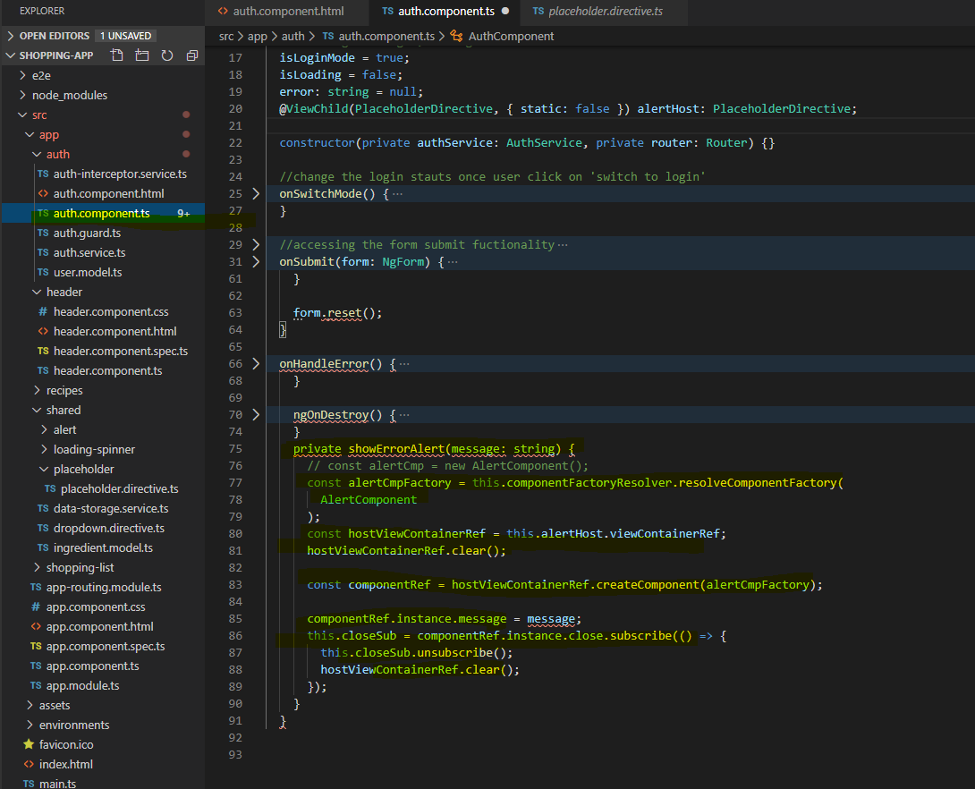

You can’t find the error – which won’t there anymore for angular version 9 or higher.

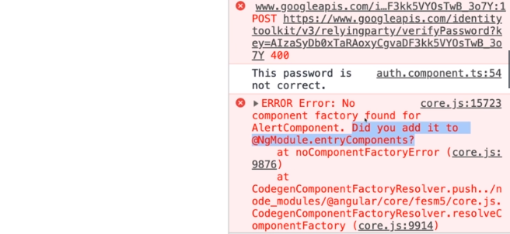

Otherwise you can do as following

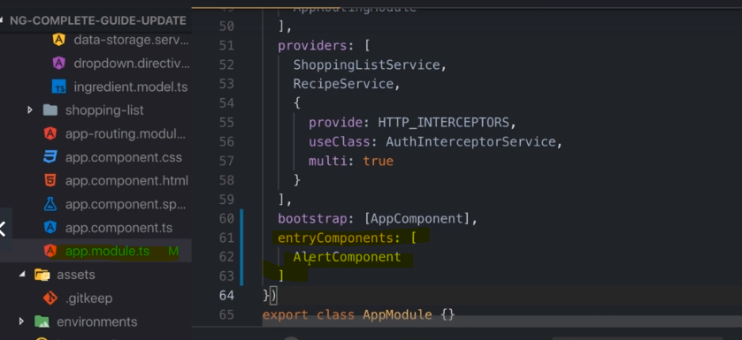

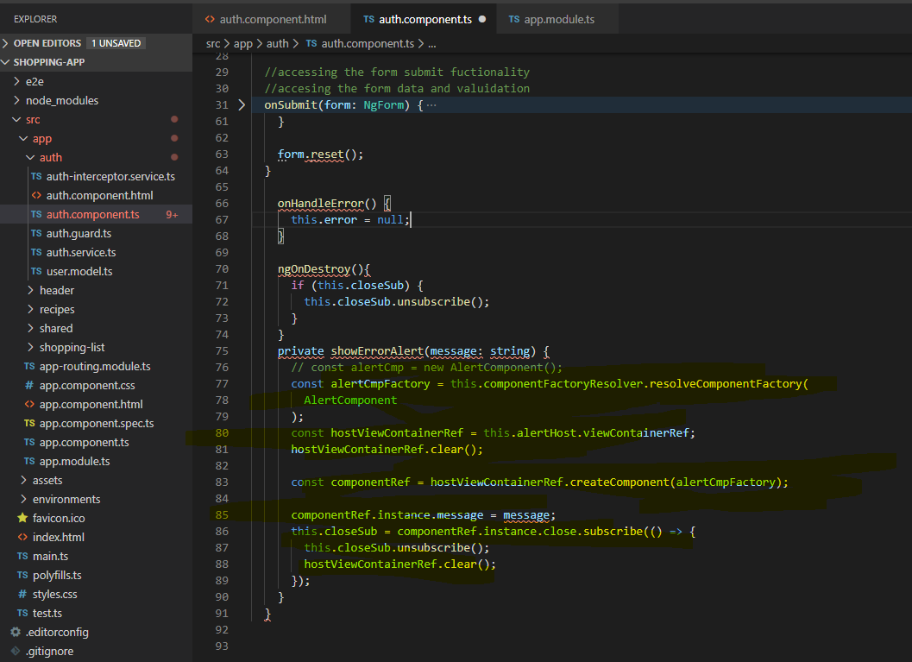

Always use ngif approach to render the component as programmatic approach is bit tricky.

**What are angular modules and how-to optimization angular application**

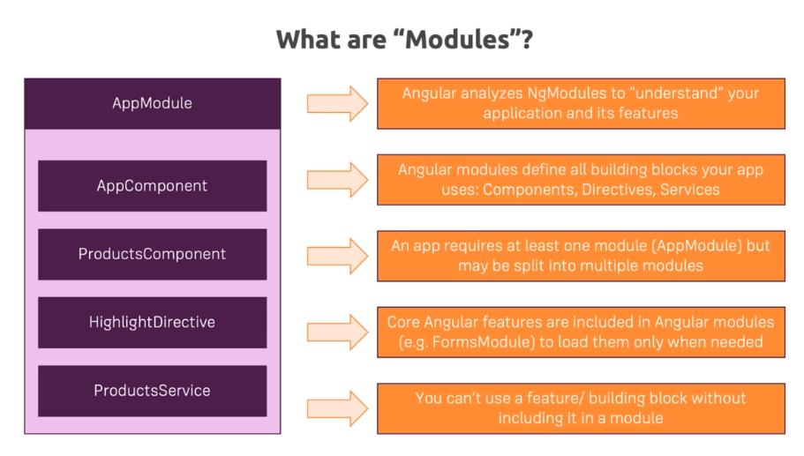

App module.ts has following component

Declaration – registers all the components and custom pipes being used in the application

**Imports** – it allows you to use other modules into your app.module.ts and through that within your entire application. You can also create your own module like we did with app-routing module which you need to add in your imports.

**Providers** – you must register your service here which then available application wide.

**Bootstrap** – it’s the starting point of your application and you should not put more than one component over there since it will make your app slow.

**Approuting** – handles app routing

Adding recipe module in recipe folder

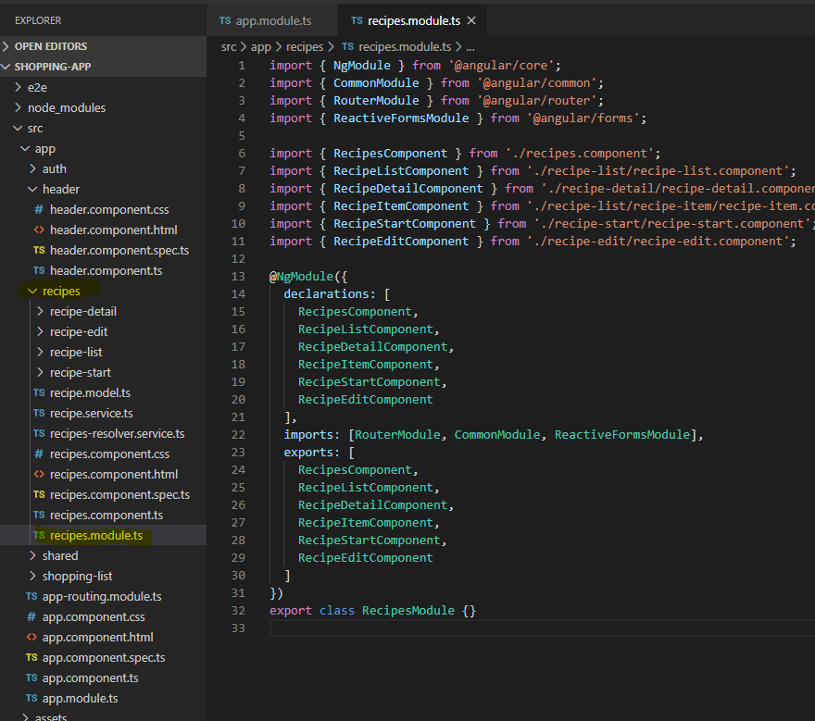

You need to add this module in a app.module.ts

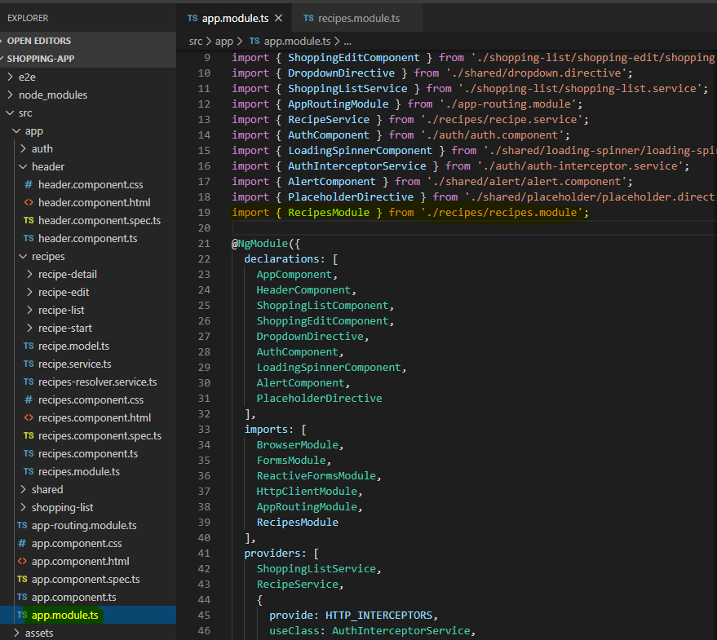

**Splitting module correctly**

If you are planning to split the app.module then make sure that you do it correctly. In this case, you must import all the modules that part of your application ( for which you created another module) needed otherwise it will break the application. Ex/ recipe module required RouterModule, CommonModule, ReactiveFormsModule so we imported them in that module

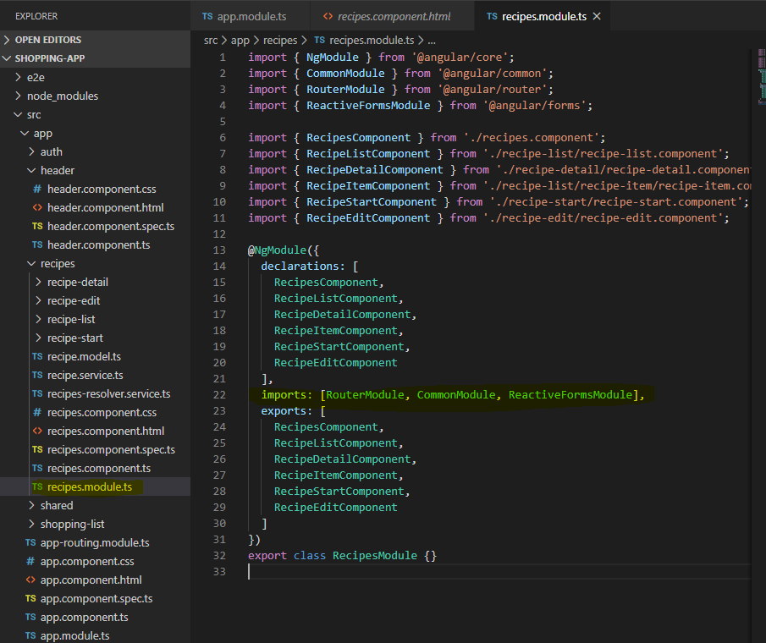

Arranging component specific routes to its corresponding route file

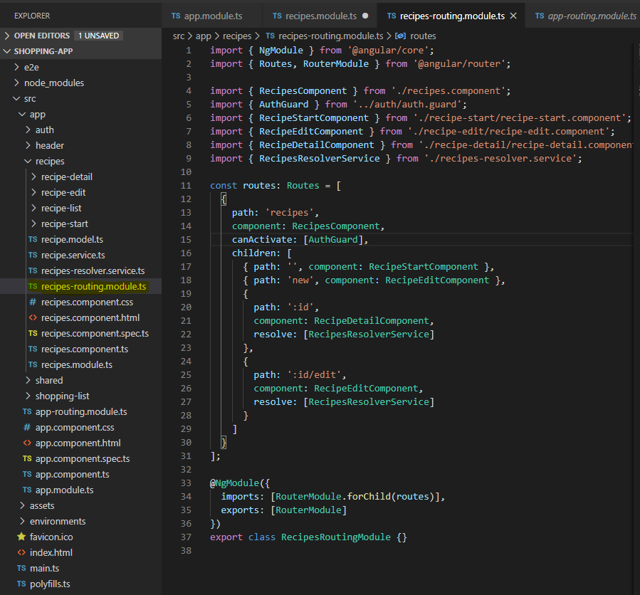

Once you create a new routing-module file then update your recipe.module.ts

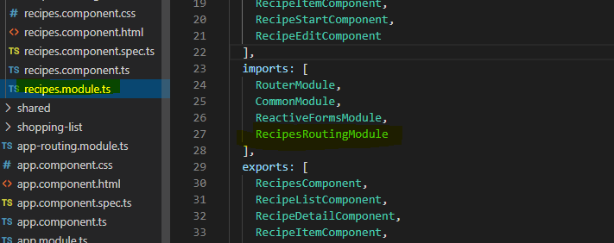

**Now remove all the routes from the app-routing.module since we moved them to the recipe module**

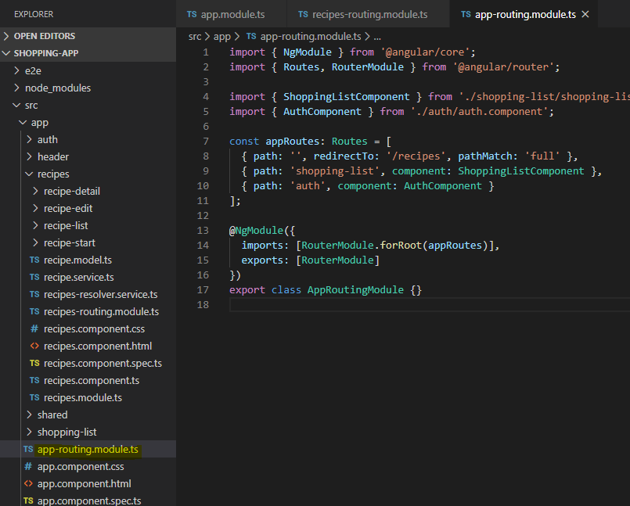

Even though you have components defined in the routemodule file of a componenet. Still you need to mention those components in the component’s app-module file otherwise it will throw an error.

Similarly, you can update shopping list and shared module as well The core module. The main objective of core module is to make app module leaner. You may follow the following pattern

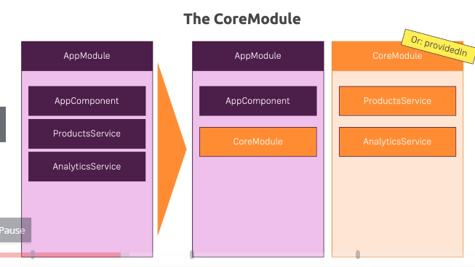

Core module is specific to the services only so keep the above model in view while developing module

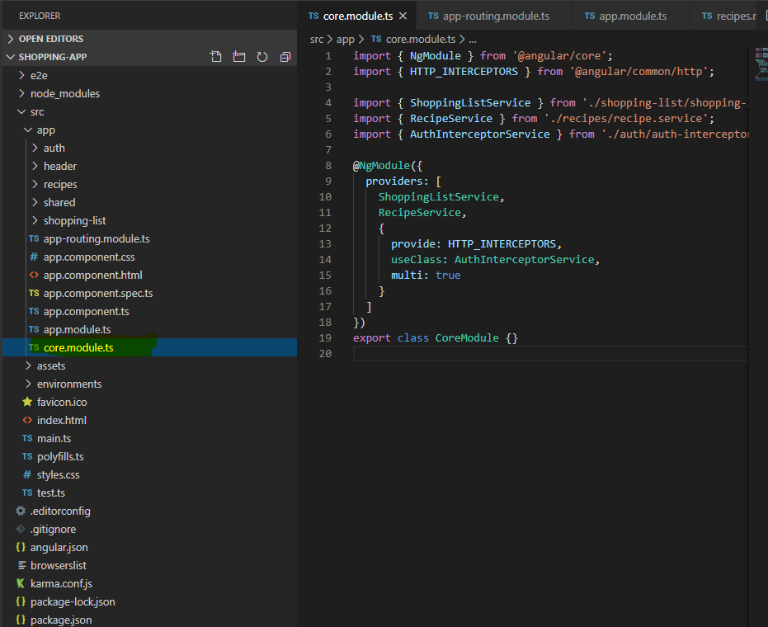

**Lazy loading** – load only when needed

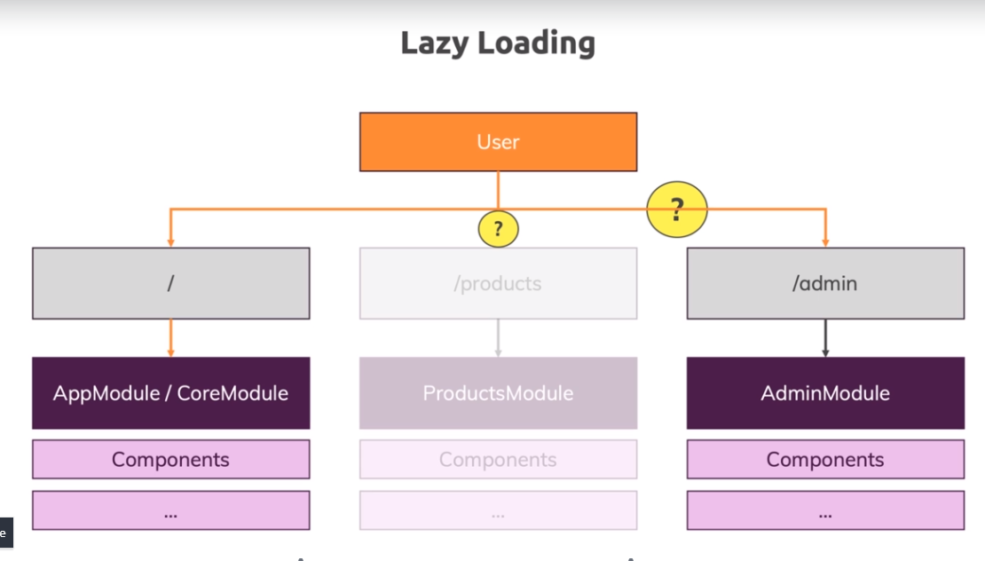

**Project implementing lazy loading**

If you run the project you can see that application is loading 4 js files with different sizes..we can change that with lazy loading

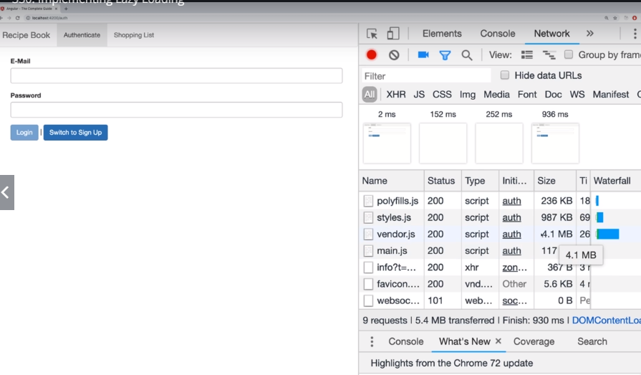

Removing recipe module – currently app is loading recipe module even before authentication here we can implement lazy loading

Removing the recipe path from the recipe-routing

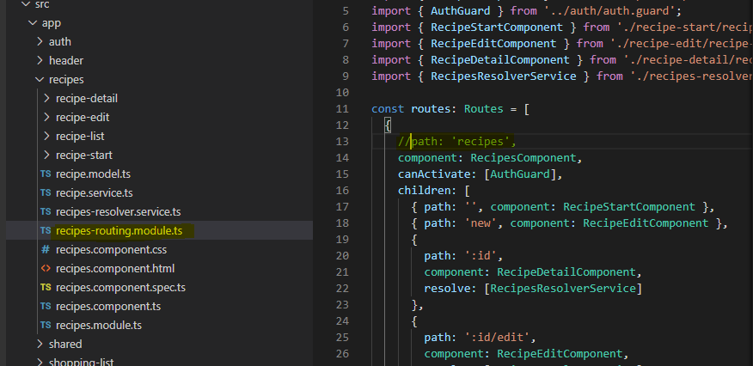

Next you need to update the routes in the app-router

Pay attention to recipe route. It basically loads the recipe and its child component only and only if it got visited otherwise it won’t loaded and thus achieves the goal of lazy loading

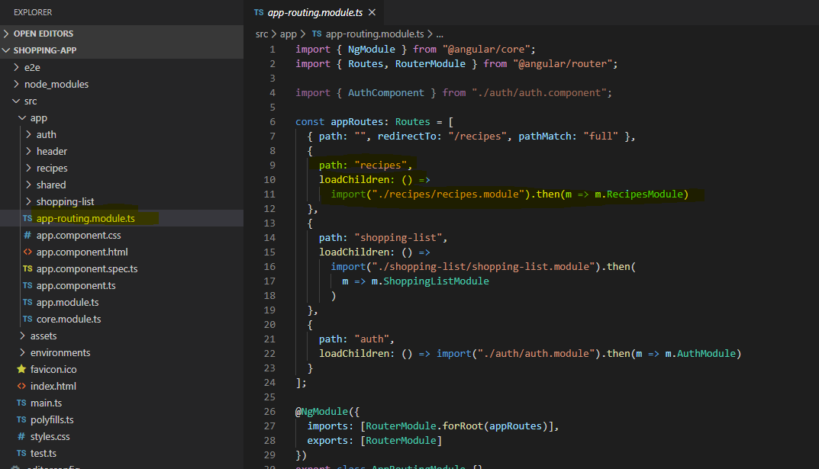

Implement the same for shopping list

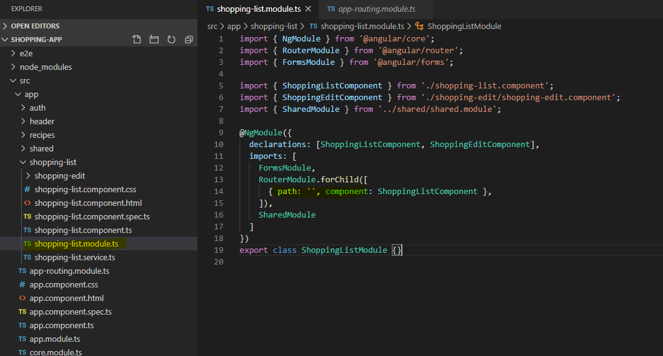

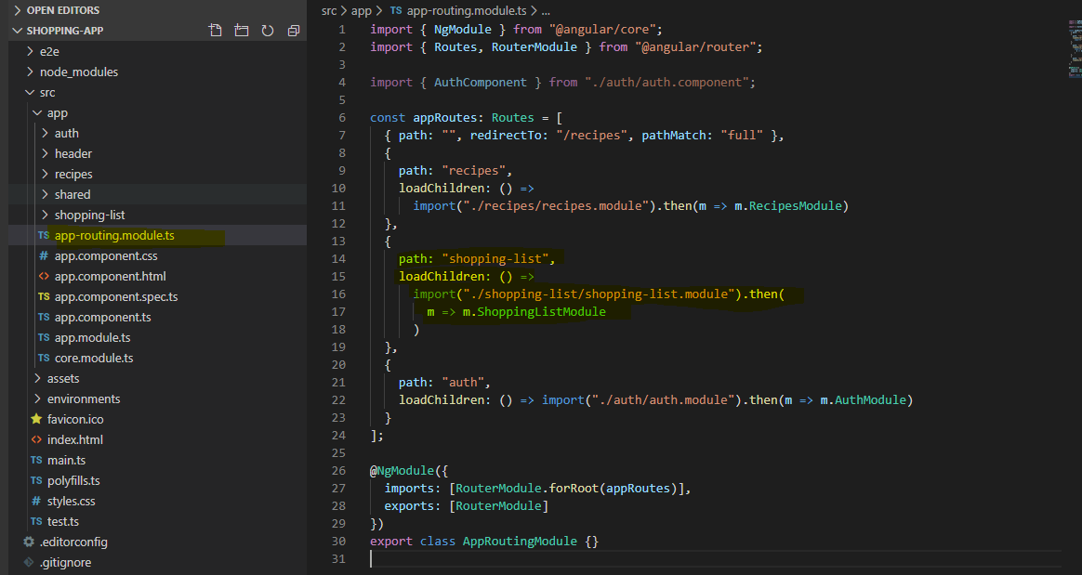

**Deployment**

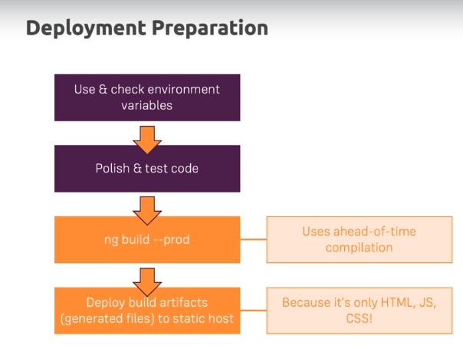

Checking env variable

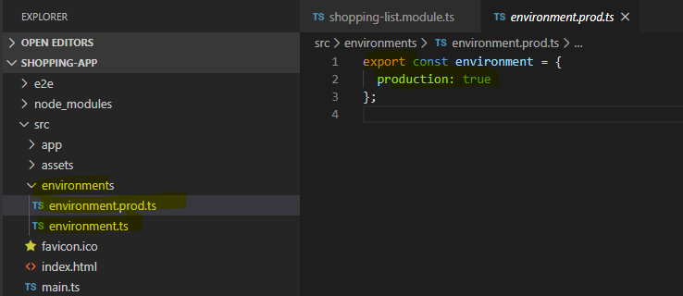

If you are using an api key then you can store it in the environment file instead of defining it everywhere

Eg

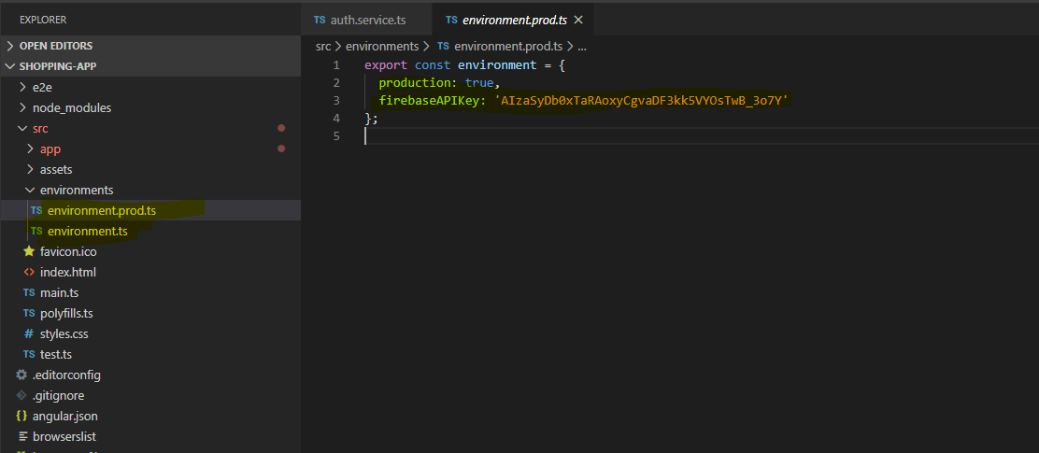

Updating auth service where we need this api key

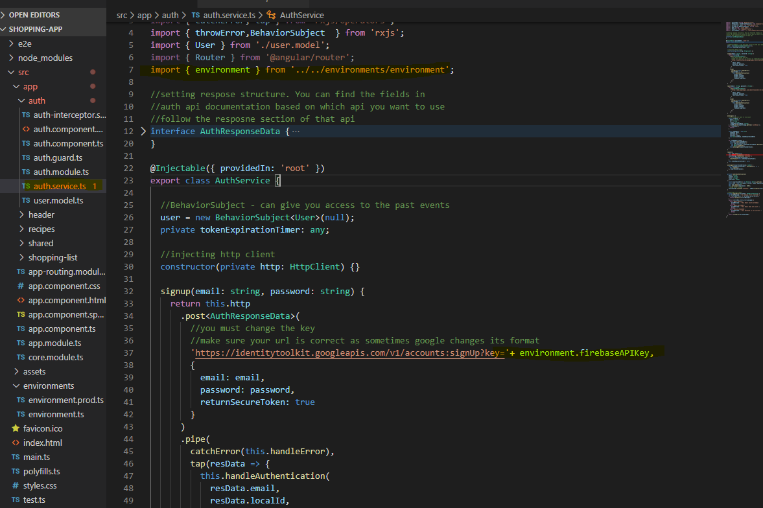

Finally, to build the project you need to use the command

Ng build --prod